Heywood Pride in Place Capital Grants

Guidance Notes
The Rochdale Communities Fund is a mutual fund to invest in and strengthen Voluntary Community Faith Social Enterprise sector (VCFSE) organisations across the borough. It funds groups and projects which directly benefit local people and communities, delivered by VCFSE organisations with roots in the borough.

As part of Heywood Pride in Place, which is working with the local community to shape a long-term vision for the town from new investment and housing to jobs, green spaces, and better transport, Action Together have set up the Heywood Pride in Place Capital Grants programme. It will support the sector’s resilience and enable VCFSE organisations that are locally rooted and active in Heywood to contribute positively to the Heywood Plan. Grants are available for capital expenditure on physical spaces in Heywood where people come together.
Priorities
The aim of the fund is to support capital expenditure on physical community spaces in Heywood where people come together and that enable the lives of Heywood residents to be improved.

Applications should be for projects that meet one or more of the following priorities:

- Thriving Places: create attractive spaces and opportunities to meet, play, learn, visit and for personal growth
- Stronger Communities: build on our strong community spirit, rich heritage and culture, and ensure all members of the community feel safe
- Taking Back Control: improve the aspirations of all residents through improved access to training and employment within a thriving local economy

Grant Amount: Grants of up to £30,000 or £180,000 are available. Please review our guidance below to understand what your application must consider if you are applying for over £30,000.
*Depending on your project, staged payments may be applied where we will create a bespoke payment plan to suit your project.

What do we mean by capital expenditure?
By capital expenditure we mean the costs associated with the purchase, refurbishment or development of land or buildings. Please note this Grant Programme excludes the purchase of vehicles and equipment not related to the purchase, refurbishment or development of land or buildings.

This can include the costs associated with such expenditure including:
- Professional fees
- Surveys
- Project planning
- Contingency fees up to 10% of the total project cost
For a more detailed explanation of what we mean please refer to our separate guide on capital expenditure which you can find here.

What can’t you spend the money on?
We  CANNOT  fund: |   - Loans, endowments or interest  - Paying someone to write your bid for you  - Profit making or fundraising activities  - VAT you can reclaim  - Statutory activities  - Expenses that have already been incurred – retrospective costs  - vehicles  - Other equipment not related to the purchase, refurbishment or development of land or buildings  This list is not exhaustive, so if you are not sure please contact us (contact details below)

Who is the funding for:
- You are a voluntary, community, faith and social enterprise (VCFSE) group locally rooted or actively working in Heywood; and
- You are a member of Action Together CIO (you can register for free to become a member here)
- You are formally constituted, Incorporated and/or charities commission/companies house registered, or your group is an exempted charity such as a place of worship
- You have at least £10m Public Liability Insurance cover and £5m Employers Liability Insurance in place.
- Have at least three people on your board or committee who are not related; and
- Have a bank account in your organisation’s name requiring at least two unrelated signatories; and
- If you are applying for over £10,000 and are not yet incorporated, we will need to discuss your governance arrangements with you in more detail and it may be a condition of your grant, if you are successful, that you become incorporated during the grant period.
- For schemes requesting above £75,000, we will expect you to appoint a lead building professional. You may wish to use an Architect, Landscape Architect, Project Manager or Civil/Structural Engineer to help you develop the proposals if applying for above this amount
- Below is a map of the eligible areas in Heywood for Pride in Place funding

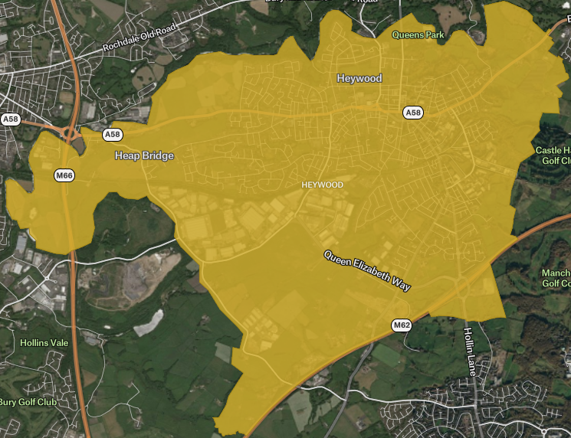

Action Together members can apply for our funding if you have already received funding through the Rochdale Communities Fund as long as:
- The applications are for different projects, OR you can show the project needs to continue
- You have submitted all monitoring for previous projects
- You are in contact with your Community Development Worker
Application process: Stage 1
Complete the Expression of Interest form

- Submit a short Expression of Interest (EOI) and an indicative budget any time before Monday 30 November
- EOI forms will then be reviewed for eligibility and feasibility on a rolling basis.
- Applicants will be notified of the outcome on a rolling basis within a week of submission, between launch date and Monday 30 November.
- Successful applicants will then be sent a final application form to complete.
Application process: Stage 2
- Application forms will be sent to groups on a rolling basis if successful at the EOI stage. Please note: The full application form will ask for details regarding how your project will involve local communities and impact them positively, as well as information regarding your capital project plan concerning ownership, timescales, and approvals.
- Application forms must be completed in full and returned to rochdalecommunitiesfund@actiontogether.org.uk no later than Thursday 7th January, 5pm.
- Due diligence checks will then take place January 2027 – February 2027 by Action Together and Rochdale Borough Council.
- Throughout February and March 2027, Due diligence processes will be conducted for each project before final submission to a Community Panel made up of Pride in Place Board members, Council and VCFSE representatives to make recommendations for funding.
- In March 2027, Projects which are recommended for consideration by the Community Panel will be discussed and approved by the Pride in Place board, who hold final decisions concerning which projects will be successful.
- In March 2027, Action Together will share decisions with the successful groups and complete grant agreements
- From March 2027, Action Together’s Heywood Community Development Worker will continue to support successful projects with check-ins to ensure progress

Please note:
- You may not apply for a grant if you are an organisation that can pay profits to directors, shareholders or members.
- To have your application considered, any outstanding monitoring information required by Action Together relating to other grant funding must have been completed before the final submission deadline of Thursday 31st December.
- Action Together is an accredited Living Wage Funder. This means we encourage organisations that employ staff to become an accredited Living Wage Employer.
- You may only apply for to this Heywood Pride in Place Capital Grants Programme once.
- You may however go on to apply for other revenue grants within our Rochdale Communities Fund Programme if you are eligible.

Confirmation of ownership and owner’s permission
As this grant concerns the purchase or improvement of land or buildings there are some specific pieces of information that we will require (you may need legal support to help you with this):

If you already own the space and you have a lease of it, we will need to see a copy of your lease:
- For awards up to £30,000 your lease period should be for at least 5 years (after any work is complete) and should not contain any early termination rights (break clause)
- For awards over £30,000 your lease period should be for at least 5 years (after any work is complete) and it should:
  - not contain any early termination rights (break clause)
  - be freely transferrable
  - not allow for an automatic return of land and buildings to the landlord in the event your organisation becomes insolvent
If you own the freehold of your space, you will need to provide a copy of your land registry title

If you plan to buy the freehold title of your space, you will be asked to provide:
- a description of the space you plan to buy
- an independent surveyor’s report on the condition of the land or buildings and its current / open market value which is less than 6 months old (with any restrictions on use noted) and whether it is suitable for the intended grant purpose
- details of any potential issues such as access to the site
- evidence that Heads of Terms have been agreed
- a timetable for the purchase
If you need the landowner’s permission to carry out any work the space, you will be asked to provide a copy

For any acquisition of land we might want security. This security will be in the form of a deed that restricts the use of the asset to the use approved by the grant and limits your ability to dispose of the asset without our consent. You will need to instruct solicitors to ensure the security is in place. It will remain in place for at least 5 years after the completion of your capital project.

If you are successful
To help us understand the impact of this funding, successful applicants will:
- be contacted at regular intervals by a member of our team (at least quarterly) to discuss the progress of their project
- be offered further support from one of our community development workers throughout and beyond the project,
- be asked to provide a report and case study to Action Together at the end of their project. You will receive an example of the questions that we will be asking once you have submitted your grant agreement so that you can plan how to capture the story of your project as soon as it starts; and
- be offered the opportunity to participate in networks of groups and organisations to be able to share expertise and experience.
If you do not already have an up to date Quality in Action Award from Action Together or have not yet worked through a Health Check with your community development worker, you may be asked to work towards completing one with our support as a condition of your grant.

If you are unsuccessful
You will be offered further support from one of our community development workers and the funding team would be happy to discuss your application and give you feedback about your application.

Monitoring from previous applications:
Please note: To have your application considered, any outstanding monitoring information required by Action Together relating to other grant funding must have been completed before the final submission deadline of Thursday 31st December. If you have any queries regarding your monitoring, please email: rochdalecommunitiesfund@actiontogether.org.uk
Monitoring:
Monitoring will be requested at the Interim stage (6 months) and end of project. We will ask you to fill out a monitoring form to tell us:
- The story of your project
- Impact on social value in your area?
- How many people benefitted
- Any other plans you have for your community following the project
- Photos, feedback sheets, promotional materials or anything else relevant to the project.

This may be subject to change depending on the funder’s requirements.

The use of AI within your application
We recognise that AI can be a valuable tool in various aspects of project development, such as brainstorming or editing responses. However, we strongly discourage its use for the drafting of answers within funding applications, as it can compromise the integrity of the application process.
It is often clear when an organisation uses AI to draft their application as we notice similar or identical language and content within numerous funding applications. Strong applications help us understand your organisation and your community, but when they are drafted by AI the generic language which is used makes it hard to understand what your organisation is planning to do and why.
AI written responses often claim to have taken certain steps to develop their project idea, such as a needs assessment, focus groups or consultation with users. Unless the group includes statistics and quotes in their bid, it raises doubt about whether these steps have actually happened. This can affect the decision-making process and an outcome of an application as the authenticity of the application can be called into question.
Where there is doubt about if your application has been drafted by AI, we will ask for some additional information to support your application.
We would like you to share your funding success news though your social media channels. To support this, we have provided a set of graphics which we would ask you to use when acknowledging the funding you have received through Action Together and Heywood Pride in Place.
If using AI tools to share the news about your funding, please ensure that any logos, branding and information are correct. AI tools can alter or hallucinate information and change logos, and we will not share any social media posts or other communications where the provided information has been changed. We will provide the Heywood Pride in Place logo along with other materials and information in this pack, and they should not be amended in any way.
Please also consider the environmental impact and any potential accessibility issues before sharing AI-produced designs.

Contact us

If you need help completing the application or becoming a member please contact your Community Development Worker.
If you are not sure who that is please email development@actiontogether.org.uk.
If you have any questions about the application process or whether you are eligible to apply please contact
rochdalecommunitiesfund@actiontogether.org.uk or call 0161 339 2345 and ask to speak to a member of the Funding Team.
Please email your final application to rochdalecommunitiesfund@actiontogether.org.uk

