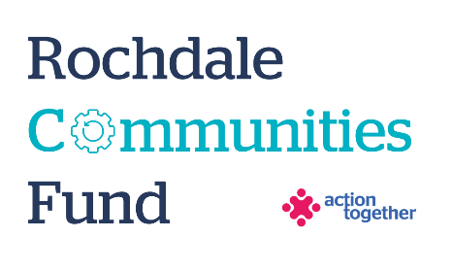
Live Well Fund: Centres, Spaces and Offers
Expression of Interest Form

Thanks to funding from the GM Live Well Implementation Fund, Action Together are offering Live Well: Centres, Spaces and Offers grants to local Voluntary, Community, Faith and Social Enterprise (VCFSE) organisations in the Rochdale borough.
Please complete this Expression of Interest form in full to be considered for this grant.
Responses to this EOI can be written form, video or voice note to the Action Together Grant WhatsApp number 07362 474200.
The written EOI should be around 600 words and can be submitted to laura.augustine@actiontogether.org.uk
The video /voice note should be no longer 8 minutes. If you choose this option, please take care to include the same level of description that would be expected in a written format.
Section One: Your Organisation
Name:
Name of Organisation:
Address of Organisation:

Mobile Number:
Email address:

 | Yes | No
Are you a member of Action Together? (if not, you will need to become a member to access this grant. We can help you with this). | ☐ | ☐

Section Two: Your project
Please tick which one of the following priorities you are applying for:
Live Well Offers | ☐
Live Well Centres | ☐
Live Well Spaces | ☐

In which neighborhood does your core activity take place? Or if your work is Boroughwide, which neighbourhood is your primary focus for this fund?
Rochdale North | ☐
Rochdale South | ☐
Middleton | ☐
Heywood | ☐
Pennines | ☐

What is your project?
Please tell us about the idea you want funding for (150 words or 1-2 minutes spoken response)

How will this project make a difference to people? And how do you know there is a demand and need for it in your community?
Provide an overview of the intended impact of your project, and describe how you know it’s needed in your community (150 words or 1-2 minutes spoken response)

Please take the time read the Live Well Hallmarks document and outline:
How your organisation meets the key features
Explain how your organisation meets the key features of either a Live Well Offer, Centre, or Space (for example, a key feature of Live Well Spaces is ‘Community Power in Action’).
Describe your Organisation’s strengths and give examples where possible.
(Up to 150 words or a 1–2 minute spoken response.)
Areas for Development
Describe where your organisation could develop or innovate further to meet the Live Well Hallmarks.
Describe what you would like to strengthen or do differently in the future.
(Up to 150 words or a 1–2 minute spoken response)

Please provide an indicative budget for the work you would like funding
Please note: if you progress to the full application stage you will be able to make changes to this.
Item | Breakdown (how have you worked out your costings?) | Amount Requested
Total amount requested? |  | £

