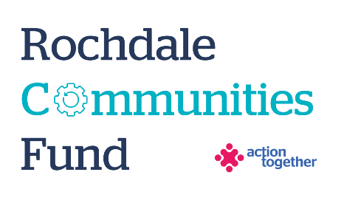
Rochdale Recovery Communities Micro Grant Application Form (up to £1,000)

Section One: Your Organisation
Name:
Address:

Name of Group supporting you in your application:
Contact Details: | Main Contact | Second Contact | Third Contact (RRC partner)
Name:
Position in group:
Telephone Number:
Mobile Number:
Email address:
Address (including postcode):

You need to have at least three individuals who are actively involved in supporting the idea or project - one being from the Rochdale Recovery Communities (RRC) partnership. If you are not associated with an RRC partner, please contact Natasha.schofield@actiontogether.org.uk to be partnered.

 | Yes | No
Are you based or working in the Rochdale Borough with beneficiaries from the area? | ☐ | ☐
Please tick the area (s) that will benefit from this project: | ☐ | ☐
Rochdale North (Central Rochdale, Healey, Norden) | ☐ | ☐
Rochdale South (Balderstone & Kirkholt, Bamford, Castleton, Kingsway and Milkstone & Deeplish) | ☐ | ☐
Heywood | ☐ | ☐
Middleton | ☐ | ☐
Pennines (Smallbridge and Firgrove, Milnrow and Newhey, Littleborough Lakeside and Wardle and West Littleborough) | ☐ | ☐
Are you a member of Action Together? (if not, you will need to become a member to access this grant. We can help you with this). | ☐ | ☐
Does your project involve working with children and / or adults at risk? | ☐ | ☐
Have you received funding from the Rochdale Communities Fund Seed Fund previously? (If so, unfortunately you won’t be eligible to apply for this Micro Grant) | ☐ | ☐
REQUIRED: We collect data about the types of people who benefit from the organisations and activities that we fund through our grants. This is so that we can evaluate whether the grants we award are benefitting a broad cross section of the communities we serve.  Please fill in this form as best you can, focusing on the people you aim to benefit, if successful, from the grant you are applying for: https://forms.cloud.microsoft/e/apmqU82Laa | ☐

Section Two: Your project
Please tick which one of the following priorities your project addresses
- Creating a visible and positive recovery community | ☐
- Reduce inequalities and help more people reach their potential To recognise the importance of early intervention for substance and alcohol use. | ☐
- To end stigma for people who use substances and alcohol | ☐
- To raise awareness of the issues associated with substances and alcohol in a non-stigmatising way | ☐
- To widen out the support available for people in recovery and create shared opportunities for learning and engagement within the wider community | ☐

What is the name of your project?
What is your idea / what will you do with the grant?
We would like to know how your project will help local people and how it fits in with the priorities that you have ticked. Please also tell us how you will deliver the project (where, what methods would you use, who will be involved).
Please explain who will benefit from the project?
How many people will directly benefit from the project?
Please provide an estimated start and end date for your project

Please provide a breakdown of how you will spend the grant
Item | Breakdown (how have you worked out your costings?) | Amount Requested
Total amount requested? |  | £

Section Three: Supporting Documents
All successful applicants will be required to supply a copy of the following information as part of the grant agreement, prior to any funding being released.

Required supporting information
☐ Details of the Rochdale Recovery Community Partners Bank Details (we will require a copy of their bank details either on letter head/paying in slip/bank statement in last 12 months)
☐ Individual Bank Account Form (to be provided upon a successful decision and to be completed by both the RRC partner and Individual applying)

Section Four: Grant Declaration
- I certify that the information contained in this application is correct. I understand that if in any way the information is not correct, the application may be disqualified, or any grant awarded may be repayable on request.
- If the information changes in any way I will inform Action Together as soon as possible.

Main contact for this project (Individual):
Enter name to confirm agreement (instead of a signature)
Date:

Rochdale Recovery Communities Partner Contact:
Role within your organisation:
Enter name to confirm agreement (instead of a signature)
Date:

