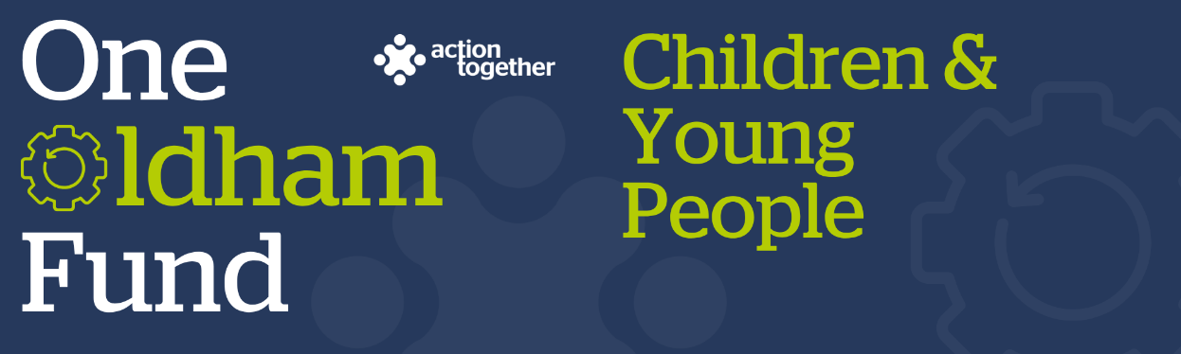
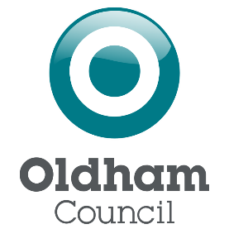

One Oldham Fund Children and Young People Grant 2025
Application (up to £200)
Please read the guidance notes carefully before starting to complete this form
Section One: About you
Name of Group:
Companies House/Charity Reg. number (if you have one):
Address of Organisation:

Website / social media details:
Contact Details: | Main Contact | Second Contact
Name:
Position in group:
Telephone Number:
Mobile Number:
Email address:

 | Yes | No
Are you based, working or volunteering in the Oldham Borough?
Please tick the area (s) that will benefit from your help
- Oldham Central St Marys, Alexandra and Coldhurst (Central)
- Chadderton, Werneth (West)
- Royton, Shaw & Crompton (North)
- Saddleworth, Lees, St James, Waterhead (East)
- Failsworth, Hollinwood, Medlock Vale and Fitton Hill (South)
Do you have a set of rules about how you will work together? (It’s ok if you’re a newly formed group and don’t have this.)
Are you a member of Action Together? (if not, you will need to become a member to access this grant. You can apply to become a member here. We can help you with this.)
Do you have a bank account in the group’s name with at least two unrelated signatories? (we can find a solution if you don’t)
Are you a non-profit making group where all surplus is re-invested back into the community?
Does your project involve working with children and / or at risk adults?

If you have received a One Oldham Fund Children and Young People Grant before, has that project been completed?
Where did you hear about this grant?

Section Two: Your project
What is the name of your project?
What is your idea / what will you do with the grant?
Please tell us who you will be helping and what you will spend the money on? You may also send us a short video or some pictures to support your application. If you wish to send a video please contact funding@actiontogether.org.uk as it is not possible to send this by e mail.
How many people will directly benefit from the project?
How much money are you applying for? (the mximum amount that you can apply for is £200)
When will your project take place? Please include an approximate start and end date.
The maximum length for a project is one year.
Which of the following for children, young people and families does your project aim to improve for children, young people and their families? (please tick up to two)
Mental and physical health
Secure housing
Financial Stability
Promoting recovery and reducing harm from substance abuse
Family relationships
Children safe from abuse and exploitation
Crime prevention and tackling crime
Safe from domestic abuse
Getting a good education
Good early years development

Section Three: Supporting Documents
If you have not recently received funding from Action Together, please provide a copy of the following documents that you have. If they are not easily available, they can be sent after your application. Dependant on the nature of your set up or activities we may need to help you to get these in place if you don’t already have them.
If you have recently received funding from us, we will look at the supporting documents that you have previously provided and will only ask for further information where necessary.

Supporting information
☐ Details of a bank account in the organisation’s name with at least two unrelated signatories
☐ Insurance details (if applicable) (public liability and employers’ liability)
☐ Safeguarding policy

Section Four: Grant Declaration
- I certify that the information contained in this application is correct. I understand that if in any way the information is not correct, the application may be disqualified, or any grant awarded may be repayable on request.
- If the information changes in any way I will inform Action Together as soon as possible.

Main contact for this project:
Role within organisation:
Enter name to confirm agreement (instead of a signature)
Date:

Other senior contact for the organisation
Role within organisation:
Enter name to confirm agreement (instead of a signature)
Date:

Please send this application and any supporting documents to funding@actiontogether.org.uk

