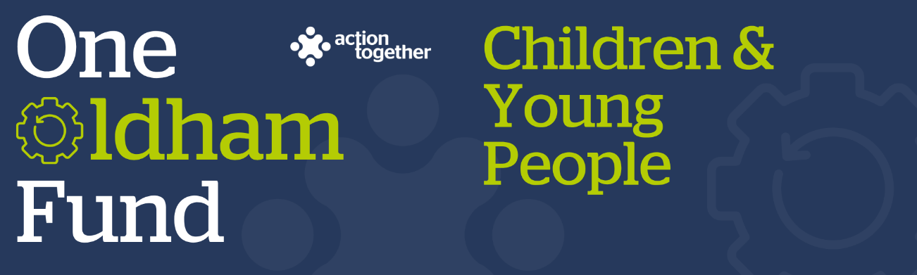
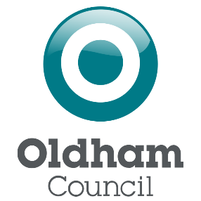
One Oldham Fund Children and Young People Grant 2025
Application (up to £1,000)
Please read the guidance notes carefully before starting to complete this form
Section One: Your Organisation
Name of Organisation:
Companies House/Charity Reg. number (if you have one):
Address of Organisation:

Website / social media details:
Contact Details: | Main Contact | Second Contact
Name:
Position in group:
Telephone Number:
Mobile Number:
Email address:

 | Yes | No
Are you locally rooted or actively working in the Oldham Borough with beneficiaries from the area?
Please tick the area (s) below that will benefit:
- Oldham Central St Marys, Alexandra and Coldhurst (Cenral)
- Chadderton, Werneth (West)
- Royton, Shaw & Crompton (North)
- Saddleworth, Lees, St James, Waterhead (East)
- Failsworth, Hollinwood, Medlock Vale and Fitton Hill (South)
Are you a member of Action Together? (if not, you will need to become a member to access this grant. We can help you with this.)
Do you have a governing document?

Do you have a bank account in the organisation’s name with at least two unrelated signatories?
Are you a non-profit organisation where all surplus is re-invested back into the community?
Does your project involve working with children and / or adults at risk?
If you have received a One Oldham Fund Children and Young People Grant before, has that project been completed?
Where did you hear about this grant?

Section Two: Your project
Which of the following outcomes for children, young people and families does your project aim to improve? (please tick up to two)
Mental and physical health
Secure Housing
Financial stability
Promoting recovery and reducing harm from substance abuse
Family relationships
Children safe from abuse and exploitation
Crime prevention and tackling crime
Safe from domestic abuse
Getting a good education
Good early years development
What is the name of your project?
What is your idea / what will you do with the grant?
We would like to know how your project will improve the lives of children, young people and families in Oldham and how it fits in with the priorities that you have ticked.
Please also tell us how you will deliver the project (where, what methods would you use, who will be involved).
You may also send us a short video or some pictures to support your application. If you wish to send a video please contact funding@actiontogether.org.uk as it is not possible to send this by e mail.
How many people will directly benefit from the project?
When will your project take place? Please include an approximate start and end date.
The maximum length for a project is one year.

Please provide a breakdown of how you will spend the grant (the maximum amount of the grant available is £1,000)
Please refer to the guidance notes to check the types of things that can and cannot be funded.
Item | Breakdown (how have you worked out your costings, for example no. of hours x hourly rate, no. of sessions?) Where available, please provide copies of quotes or links to the item online for larger items of expenditure? | Amount Requested
Total amount requested? |  | £

Section Three: Supporting Documents
If you have not recently received funding from Action Together, please provide a copy of the following documents that you have. If they are not easily available, they can be sent after your application. Dependant on the nature of your set up or activities we may need to help you to get these in place if you don’t already have them. We will need to see copies of these documents before funding can be released.
If you have recently received funding from us we will look at the supporting documents that you have previously provided, and will only ask for further information where necessary.
Required supporting information
☐ A copy of your governing document
☐ Details of a bank account in organisation’s name with at least two unrelated signatories (we will require a copy of a bank statement)
☐ Insurance details (if applicable) (public liability and employers’ liability)
☐ Safeguarding policy

Section Four: Grant Declaration
- I certify that the information contained in this application is correct. I understand that if in any way the information is not correct, the application may be disqualified, or any grant awarded may be repayable on request.
- If the information changes in any way I will inform Action Together as soon as possible.

Main contact for this project:
Role within organisation:
Enter name to confirm agreement (instead of a signature)
Date:

Other senior contact for the organisation
Role within organisation:
Enter name to confirm agreement (instead of a signature)
Date:

Please send this application and any supporting documents to funding@actiontogether.org.uk

