
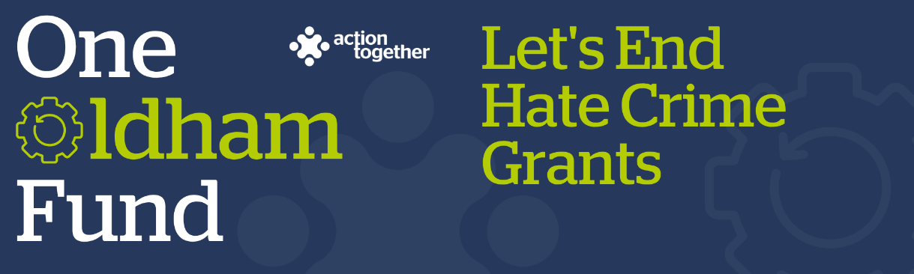


Let’s End Hate Crime Grant Application 2025-2026
Please read the guidance notes carefully before starting to complete this form
Section One: Your Organisation
Name of Organisation:
Companies House / Charity Reg. Number (if you have one)
Address of Organisation:

Website / Social media details:
Contact Details: | Main Contact | Second Contact
Name:
Position in group:
Telephone Number:
Mobile Number:
Email address:

 | Yes | No
Are you locally rooted or actively working in the Oldham Borough with beneficiaries from the area?
Please tick the area(s) below that will benefit
- Oldham Central St Marys, Alexandra and Coldhurst (Central)
- Chadderton, Werneth (West)
- Royton, Shaw & Crompton (North)

- Saddleworth, Lees, St James, Waterhead (East)
- Failsworth, Hollinwood, Medlock Vale and Fitton Hill (South)
Are you a member of Action Together? (If not, you will need to become a member to access this grant. You can find out how to become a member here. We can help you with this)
Do you have a governing document?
Do you have a bank account in the organisation’s name with at least two unrelated signatories?
Are you a non-profit organisation where all surplus is re-invested back into the community?
Have you received Let’s End Hate Crime Funding in the previous financial year?
Are you available to attend an in person Hate and how to effectively challenge Session on Thursday 29 January 2026, 9.30am to 11.30am

Section Two: Your project
What is the name of your project?
Which of the following priorities does your project mainly fit with (you can tick up to two)
Improving education around hate crime
Prevention and early intervention around hate crime
Bringing communities together to tackle hate crime
Increasing communication and awareness of hate crime and its consequences
Increasing the confidence to report hate crime
Improving support for victims of hate crime
What is your idea?
We would like to know how your project will help local people by helping to build confident and cohesive communities and promoting awareness of hate crime and how to report it?
- Please give us a brief summary of your ideas and how you arrived at them
- What, where and when will the activities be
- Please also explain how this will link with the priorities that you have identified above
- You may also send us a short video or some pictures to support your application. If you wish to send a video please contact funding@actiontogether.org.uk as it is not possible to send this by e mail.
How many people will directly benefit from this project?
When will your project take place? Please include an approximate start and end date.
If your project will not take place during Greater Manchester Hate Crime Awareness Week, please explain why

Please provide a breakdown of how you will spend the grant (the maximum amount of the grant available is £1,000)
Please refer to the guidance notes to check the types of things that can and cannot be funded
Item | Breakdown (how have you worked out your costings? for example no. of hours x hourly rate, no. of sessions?) Where available, please provide copies of quotes or links to the item online for larger items of expenditure | Amount Requested
Total amount requested from the Hate Crime Awareness Fund? |  | £

Section Three: Supporting Documents
If you have not recently received funding from Action Together please provide a copy of any of the following documents that you have. If they are not easily available they can be sent after your application. Dependant on the nature of your set up or activities we may need to help you to get these in place if you don’t already have them. We will need to see copies of these documents before funding can be released.
If you have recently received funding from us we will look at the supporting documents that you have previously provided, and will only ask for further information where necessary.

Required supporting information
☐ A copy of your governing document
☐ Details of a bank account in organisation’s name with at least two unrelated signatories (we will require a copy of a bank statement)
☐ Insurance details (if applicable) (public liability and employers’ liability)
☐ Safeguarding policy (if applicable)

Section Four: Grant Declaration
- I certify that the information contained in this application is correct. I understand that if in any way the information is not correct, the application may be disqualified, or any grant awarded may be repayable on request.
- If the information changes in any way I will inform Action Together as soon as possible.

Main contact for this project:
Role within organisation:
Enter name to confirm agreement (instead of a signature)
Date:

Other Senior contact for the organisation
Role within organisation:
Enter name to confirm agreement (instead of a signature)
Date:

Please send this application and any supporting documents to funding@actiontogether.org.uk

