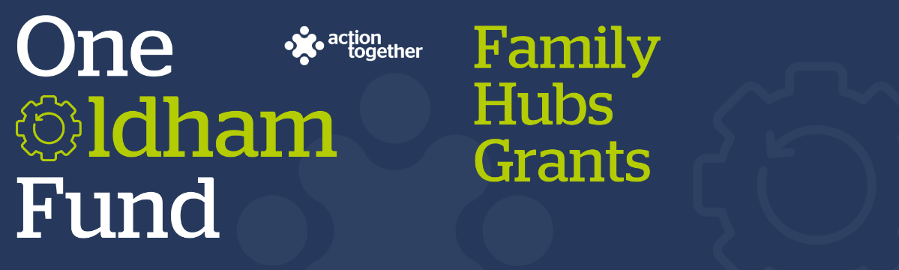


One Oldham Fund Family Hubs Grant Application
(up to £6,000)
Please read the guidance notes carefully before you complete this application
Section One: Your Organisation
Name of Organisation:
Companies House/Charity Reg. number (if you have one): | Company House/Charity Registration number if applicable
Address of Organisation:

Website / social media details:
Contact Details: | Main Contact | Second Contact
Name:
Position in group:
Telephone Number:
Mobile Number:
Email address:

 | Yes | No
Are you locally rooted or actively working in the Oldham Borough with beneficiaries from the area?
Please tick the area(s) below that will benefit:
- Oldham Central St Marys, Alexandra and Coldhurst (Central)
- Chadderton, Werneth (West)
- Royton, Shaw & Crompton (North)
- Saddleworth, Lees, St James, Waterhead (East)
- Failsworth, Hollinwood, Medlock Vale and Fitton Hill (South)
Are you a member of Action Together? (if not, you will need to become a member to access this grant. We can help you with this.)
Do you have a governing document?
Do you have a bank account in the organisation’s name with at least two unrelated signatories?
Are you a non-profit organisation where all surplus is re-invested back into the community?
Does your project involve working with vulnerable children and / or at risk adults?
Has your organisation completed a Quality In Action Award with Action Together?

Section Two: Your project
Which of the following priorities does your project mainly fit in with? Please refer to the guidance notes for a more detailed explanation (you can tick up to two)
Activities aimed at families with children agreed 0-3 that are rarely heard
Activities at families with children aged 0-3 in parks and community spaces
Activities aimed at new and expectant parents less likely to use Family Hubs
Virtual spaces for new parents to access virtual peer support
What is the name of your project?
Do you already have a connection or work with a Family Hub? If so please let us know which Hub and provide more details of your connection with them.
What is your idea / what will you do with the grant?
We would like to know how your project will help people by allowing families to access community led projects that deliver family hubs services or activities at family hubs or outreach sites
Please also tell us how you will deliver the project (for example, where, what methods would you use, who will be involved) and how you have involved your community in designing the project.
You may also send us a short video or some pictures to support your application. If you wish to send a video please contact funding@actiontogether.org.uk as it is not possible to send this by e mail.
How many people will directly benefit from the project?
When will your project take place? Please include an approximate start and end date
What changes or difference will your project make to the people taking part?
What will you do to find this out?

Please provide a breakdown of how you will spend the grant (the maximum amount that you can apply for is £6,000) Please check the guidance notes for what you can and can’t use the funding for
Item | Breakdown (how have you worked out your costings, for example no. of hours x hourly rate?) Where available, please provide copies of quotes or links to the item online for larger items of expenditure | Amount Requested
Total amount of grant requested? |  | £
Total cost of project |  | £
If relevant where is the rest of the money coming from?

Section Three: Supporting Documents
If you have not recently received funding from Action Together please provide a copy of the following documents that you have. If they are not easily available they can be sent after your application. Dependant on the nature of your set up or activities we may need to help you to get these in place if you don’t already have them. We will need to see copies of these documents before funding can be released.
If you have recently received funding from us we will look at the supporting documents that you have previously provided, and will only ask for further information where necessary.

Required supporting information
☐ A copy of your governing document
☐ Details of a bank account in organisation’s name with at least two unrelated signatories (we will require a copy of a bank statement)
☐ Insurance details (if applicable) (public liability and employers’ liability)
☐ Safeguarding policy (if applicable)
☐ If your project involves building work please provide copy quotes, evidence of your right to occupy the building and, if necessary, a copy of the building owners’ permission to carry out the work and planning permission.

Section Four: Grant Declaration
- I certify that the information contained in this application is correct and I am authorised to sign this application. I understand that if in any way the information is not correct, the application may be disqualified, or any grant awarded may be repayable on request.
- If the information changes in any way I will inform Action Together as soon as possible.
Main contact for this project:
Role within organisation:
Enter name to confirm agreement (instead of a signature)
Date:

Other senior contact for the organisation
Role within organisation:
Enter name to confirm agreement (instead of a signature)
Date:

Please send this application and any supporting documents to funding@actiontogether.org.uk

