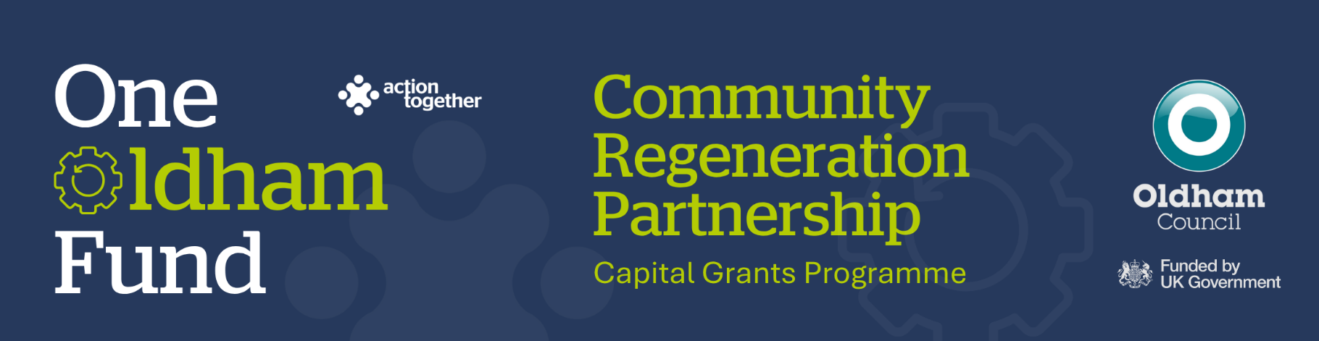

What do we mean by Capital Expenditure?

Capital funding can be used to purchase assets, either new or the significant refurbishment of existing assets.
These must be fixed assets, that is, physical touchable items intended for long term use for the benefit of the community for at least 5 years and are not intended to be resold.
Specific examples of uses for capital expenditure are shown below, grouped into themes:
New buildings and repairs/refurbishment to existing buildings:
- Building of new community use spaces, community halls, sports pavilions, Scout / Guide huts, etc. including purchase of land.
- Significant repairs to the structure / fabric of any permanent building, including items such as drains, roofing, windows, floors, rewiring, insulation, solar panels, heat-pumps and associated professional/planning/installation costs. Especially where this improves the energy efficiency of the building.
- Full or substantial replacement of the roof covering, (not simple repairs including touch-up painting and guttering repairs.)
- Re-tarmacing a community building car park or creating new / additional car parking, that will benefit the building users.
- New/replacement fencing around community building / land (not simple repairs)
- Refurbishment of toilets and changing rooms, especially to improve accessibility for all.
- Replacing / installing new kitchen facilities to a venue, especially where this is to provide a community service such as lunch clubs, day centres, etc.
- Fire alarms, sprinklers, emergency lights, fire extinguishers, fire blankets, stair lifts, hoists, etc. - but not safety inspections
Land, outside space, playgrounds, sports grounds, sports equipment.
- New gardens, allotments, orchards, community farms, etc.
- Wildlife and wildflower meadows
- Community growing: water systems, storage sheds, rotavators, water butts, composters, mowers and other gardening equipment (not consumables such as plants, seeds, sharpening, repairs, etc.)
- New/replacement play equipment - swings, roundabouts, skate ramps, climbing walls, slides, climbing frames, outdoor gym, MUGA, etc. (but not simple repairs to existing equipment)
- New or replacement safety surfacing e.g. under play equipment
- Substantial items of outdoor leisure equipment such as scoreboards, floodlights, goal posts, gym equipment, artificial wickets, line markers, tennis nets – should have an expected lifespan of at least 5 years. Not consumables such as balls, playing kit, whistles, etc.
- Purchase of a lawn mower, grounds maintenance equipment, roller, etc. (must demonstrate wider community benefit)
- Acquisition of land, buildings, monuments and heritage assets for public use / enjoyment.
- Trees, woodlands, trails, paths, fences, gates, improving access, riverbank enhancements, cycle lanes, picnic tables, built BBQs and BBQ areas for public use / enjoyment.
- Permanent finger posts, styles, gates, information boards, Blue plaques, way markers, benches, litter bins, dog bins, recycle bins, etc. (but not emptying on such bins)
- Improvements to local infrastructure in particular improving accessibility including roundabouts, traffic calming measures which support the safety of residents.
Indoor space, community halls, offices, equipment.
- PA and audio/visual systems – new projectors, screens, TV screens, sound systems and their installation.
- New hearing loop systems
- New seating and/or tables for halls
- Desks, chairs and physical items of office equipment (laptops, printers, other IT, one-off purchase of software, etc.) that supports or enhances the running of your organisation - but not stationery or consumables such as printer ink, paper, envelopes, etc.
- Broadband routers, cabling and installation - but not ongoing costs
- Creation of new websites (to further promote your organisation or benefit wider community)
- Substantial items of indoor leisure equipment such as bowls mats, gym equipment, tennis/badminton nets, snooker tables, TV screens – should have an expected lifespan of at least 5 years.
- Purchase of pianos, musical instruments, lighting rigs, fire curtains, etc. to enhance public performances
Other significant purchases:
- CCTV/safety cameras, where having a system helps to protect an asset or provide greater community safety.
- Purchase of marquees, caravans, market stalls, staging, outdoor PA systems, projection/cinema equipment, generators, lighting rigs, portaloos, tents and camping equipment, etc. (not hire of these items). Should have an expected lifespan of at least 5 years.
- Professional fees for creation of documents relating the proposed capital projects, e.g. feasibility studies, business plans, architect’s drawing/plans, etc. that will be used by and benefit an organisation’s development and improve the service they give.

