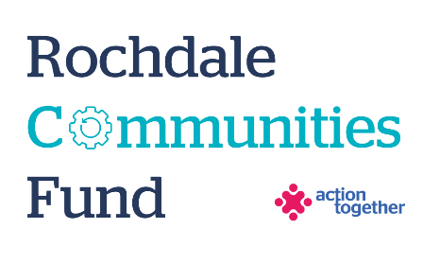
Rochdale Communities Fund –
Stop Smoking Fund
Application Form (up to £1,000)
Section One: Your Organisation
Name of Organisation:
Address of Organisation:

Website/Social media details
Contact Details: | Main Contact | Second Contact
Name:
Position in group:
Telephone Number:
Mobile Number:
Email address:
Address (including postcode):

 | Yes | No
Are you based or working in the Rochdale Borough with beneficiaries from the area? | ☐ | ☐
Please tick the area (s) that will benefit from this project: | ☐ | ☐
Rochdale North (Central Rochdale, Healey, Norden) | ☐ | ☐
Rochdale South (Balderstone & Kirkholt, Bamford, Castleton, Kingsway and Milkstone & Deeplish) | ☐ | ☐
Heywood | ☐ | ☐
Middleton | ☐ | ☐
Pennines (Smallbridge and Firgrove, Milnrow and Newhey, Littleborough Lakeside and Wardle and West Littleborough) | ☐ | ☐
Are you a member of Action Together? (if not, you will need to become a member to access this grant. We can help you with this). | ☐ | ☐
Do you have a governing document? | ☐ | ☐
Do you have a bank account in the organisation’s name with at least two unrelated signatories? | ☐ | ☐
Are you a non-profit organisation where all surplus is re-invested back into the community? | ☐ | ☐
Does your project involve working with children and / or adults at risk? | ☐ | ☐
Has your organisation recently completed a Health Check with a Community Development Worker? | ☐ | ☐

Section Two: Your project
Please can you confirm if your project works with any of the below target groups:
People who are homeless | ☐
People who have a mental health condition | ☐
People accessing drug and alcohol treatment | ☐
People living in social housing accommodation | ☐
People who are unemployed | ☐
People who are working in routine and manual occupations | ☐
Women who are pregnant | ☐
LGBT Community | ☐

What is the name of your project?
What is your idea / what will you do with the grant?
We would like to know how your project will help local people and how it fits in with the priorities that you have ticked. Please also tell us how you will deliver the project (where, what methods would you use, who will be involved).
Please explain who will benefit from the project?
How many people will directly benefit from the project?
Please provide an estimated start and end date for your project

Please provide a breakdown of how you will spend the grant
Item | Breakdown (how have you worked out your costings?) | Amount Requested
Total amount requested? |  | £

Section Three: Supporting Documents
All successful applicants will be required to supply a copy of the following information as part of the grant agreement, prior to any funding being released.

Required supporting information
☐ Details of a bank account in organisation’s name with at least two unrelated signatories (we will require a copy of a bank statement)
☐ A copy of your governing document
☐ Insurance details (public liability and employers’ liability)
☐ Safeguarding policy

Section Four: Grant Declaration
- I certify that the information contained in this application is correct. I understand that if in any way the information is not correct, the application may be disqualified, or any grant awarded may be repayable on request.
- If the information changes in any way I will inform Action Together as soon as possible.

Main contact for this project:
Role within organisation:
Enter name to confirm agreement (instead of a signature)
Date:

Other Senior contact for the organisation
Role within organisation:
Enter name to confirm agreement (instead of a signature)
Date:

