Rochdale Communities Fund
Stop Smoking Fund
Guidance Notes

The Rochdale Communities Fund is a mutual fund to invest in and strengthen Rochdale Borough’s VCFSE sector. It funds groups and projects which directly benefit local people and communities, delivered by VCFSE organisations with roots in the borough.

The Rochdale Communities Fund can support groups to try out a new project or sustain one that already exists. Action Together provides members with development support, training and other infrastructure alongside grant funding.

Thanks to funding from Rochdale Borough Council Public Health team, Action Together is offering grants of up to £1000 for VCFSE organisations to help Rochdale stop smoking by providing support to community members to stop tobacco use. In addition, all applicants are encouraged to identify Smoke Free Champions within their organisation.
What are Smokefree Champions?
Smokefree Champions are asked to:
- Be trained in Very Brief Advice (VBA) on smoking. This training is available online for free any time and can also be delivered in person by our community stop smoking service.
- Act as advocates for stopping smoking and creating a smoke-free future
- Be prepared to present your project outcomes to the Rochdale Borough Tobacco Control Alliance
- Optional: Complete free online training provided by the NCSCT, including the theory behind becoming a smoking cessation practitioner
Smoking is the leading cause of preventable death, illness and disability in the UK. Due to this, the borough of Rochdale has an ambition to become smokefree (defined as a smoking prevalence of 5% or less) by 2030, and the VCFSE sector has the potential to play an important role in helping to achieve this.
We particularly encourage proposals that seek to work with any of the groups listed in the below infographic:
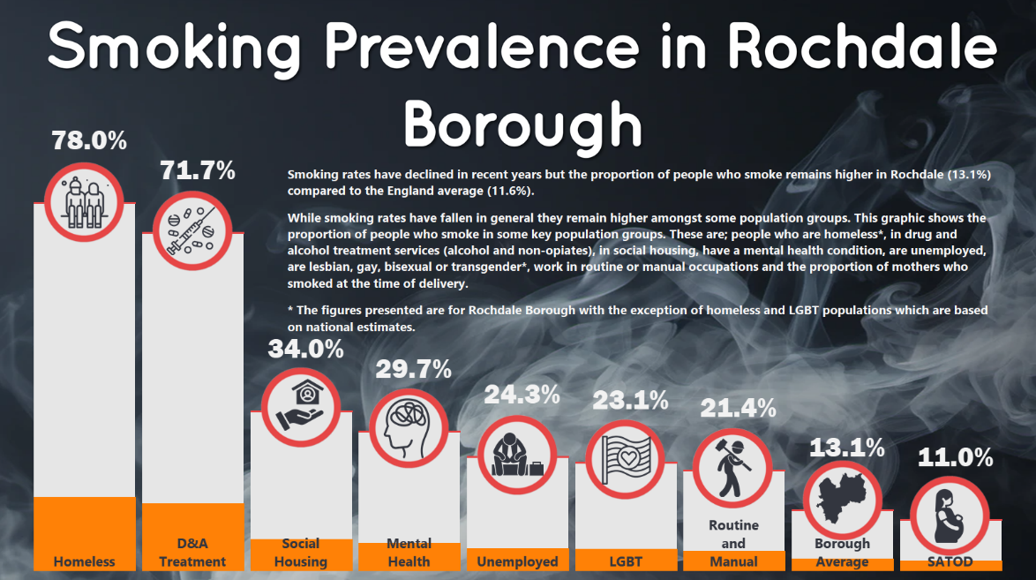

Examples of activities that we can fund:

- Using training to provide basic stop smoking support to those who use your services and, where relevant, referring them to Breathe Well with Living Well
- Raising awareness/marketing campaign of the benefits of stopping and the local stop smoking service, Breathe Well with Living Well
- Holding a stop smoking community event
- Host a drop-in session about stopping smoking
- A community art project about stopping smoking (e.g., a mural)
This list isn’t exhaustive, and we would like to hear your own ideas to reduce smoking in your community.
Niche and smokeless tobacco
Niche and smokeless tobacco are a range of tobacco products not consumed as a cigarette or cigar but that carry similar risks and harms as smoking.
These include shisha, which you smoke, or paan and naswar which are consumed through chewing and placing in your mouth. These products are more likely to be used by the borough’s minority ethnic populations, particularly people of South Asian origin.
We are also open to and encourage organisations who can support people to stop using these products.
Grant amount: Grants of up to £1,000 are available
Deadline: Sunday 16th March 2025
What we can fund:
We can fund:
- Equipment, project resources and running costs
- Staff time and staff and volunteer expenses

Who is the funding for:
- you are a voluntary, community, faith and social enterprise (VCFSE) group locally rooted or actively working in the borough of Rochdale; and
- you are a member of Action Together CIO (you can register for free to become a member here)
- you are formally constituted.
Decision making process:
The grant decisions will be made by Action Together and representatives from Public Health and Living Well.
Decisions will be made once the fund has closed for applications. You may be asked for further information or to redevelop aspects of your proposal.
All applications must be sent to hayley.tomlinson@actiontogether.org.uk and you will receive the decision via email.
Please note:
- We will only accept applications from organisations who have completed monitoring for any previous funds received from Action Together. If you have any queries about monitoring please email hayley.tomlinson@actiontogether.org.uk
- Action Together is an accredited Living Wage Funder. This means we encourage organisations that employ staff to become an accredited Living Wage Employer.
Monitoring:
At the end of your project, we will ask you to fill out a monitoring form to tell us:
- The story of your project
- How many people benefitted
- Any other plans you have for your community following the project
- Photos, feedback sheets, promotional materials or anything else relevant to the project.
Our Community Development Workers will check in with you during the project and can help you plan how you want to share the impact and success of your project.

Completing the application form
- Please ensure that ALL boxes on the application form are completed.
- When completing your budget, please clearly evidence how you have arrived at your costings and use exact figures.
- Please ensure you include information in your application about how you will measure the impact and success of your project.
- If you have any queries about the application form or application process, please contact Hayley Tomlinson on 0161 339 2345.
- Please note, we can only accept one application per organisation.
The use of AI within your application
We recognise that AI can be a valuable tool in various aspects of project development, such as brainstorming or editing responses. However, we strongly discourage its use for the drafting of answers within funding applications, as it can compromise the integrity of the application process.
It is often clear when an organisation uses AI to draft their application as we notice similar or identical language and content within numerous funding applications. Strong applications help us understand your organisation and your community, but when they are drafted by AI the generic language which is used makes it hard to understand what your organisation is planning to do and why.
AI written responses often claim to have taken certain steps to develop their project idea, such as a needs assessment, focus groups or consultation with users. Unless the group includes statistics and quotes in their bid, it raises doubt about whether these steps have actually happened. This can affect the decision-making process and an outcome of an application as the authenticity of the application can be called into question.
Where there is doubt about if your application has been drafted by AI, we will ask for some additional information to support your application.

Please note that the Rochdale Communities Fund is ongoing therefore our approach will be under constant review. If there are any changes, these will be communicated appropriately.

