How to log in to your Volunteer Manager account

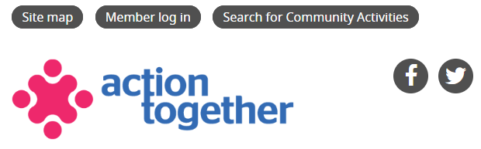

Visit the Action Together website and from the homepage click Member Log In.
If you have forgotten your password, you can request a new one by clicking on the Request a New Password tab.

Your Volunteer Manager Account dashboard

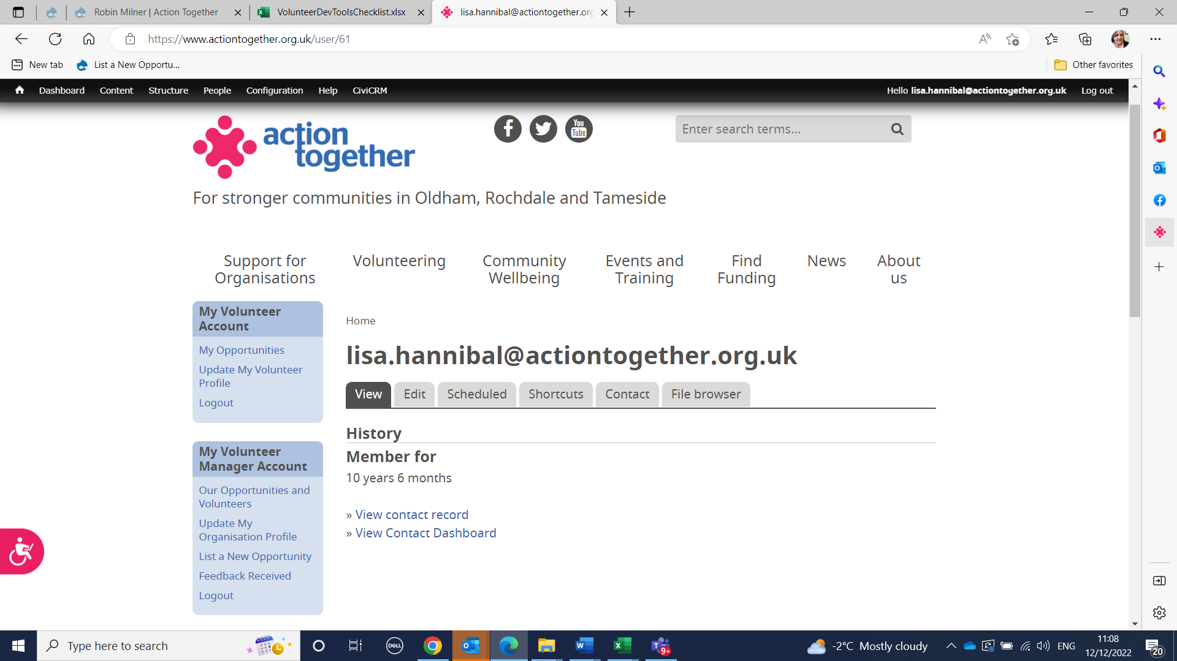

Our opportunities and Volunteers
- View your inactive and inactive volunteer opportunities.
- Edit your volunteer opportunities. Reactivate roles or make them inactive.
- Find the contact details for the people that have expressed an interest in your volunteer opportunities.
Update my organisation profile
- Update your organisation’s contact details.
- Update the description of your organisation and the activities it carries out.
List a new opportunity
- Add new volunteer opportunities to your account and to the Action Together volunteer opportunity directory.

Our Opportunities and Volunteers
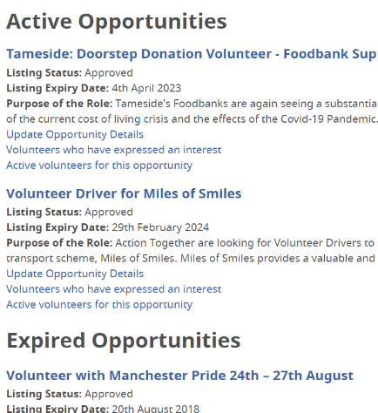

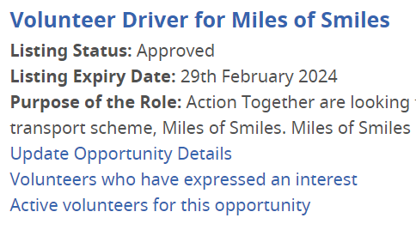
Update Opportunity Details
Edit your opportunities. Update the expiry date.
Volunteers who have expressed an interest
Find the contact details for the people that have expressed an interest in your volunteer opportunities.
Active Volunteers for this Opportunity
View the details of people that have actively volunteered with your organisation.

How to add a new volunteer opportunity
List a new opportunity
- To add a new opportunity to your volunteer manager account and to the action Together website complete the webform.
- Every section with a red Asterix must be completed.
- The expiry date you add will be the date that the opportunity disappears from the Action Together website. The opportunity will still be listed in your volunteer manager account. Add a later date to reactivate it.
- All new volunteer opportunities must be approved by an Action Together member of staff before they appear on the website.
- The email address added to the opportunity webform will the email address that receives the notification when someone expresses an interest in the role. Ideally, the email used should be that of the volunteer manager of your organisation. The person with login details for the volunteer manager account.

Volunteers who have expressed an interest
Volunteers who have expressed an interest
- Each opportunity listed has this link. Click on it to view the names and contact information of the people that have expressed an interest in it.
- They are listed in date order. The newest expression of interest will be at the top.

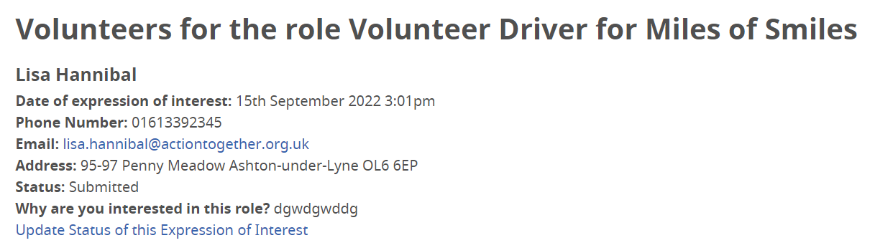

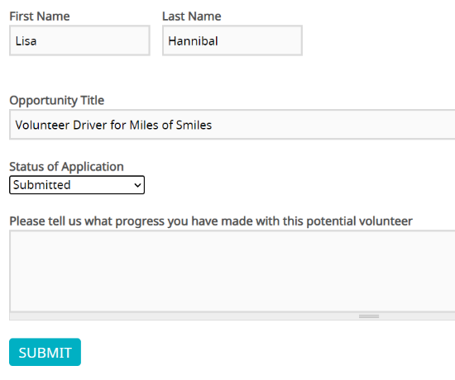
Update volunteer status for this expression of interest
Please tell us what progress you have made with this potential volunteerYou can use this section to add updates on the progress you have
made with this potential volunteer’s application

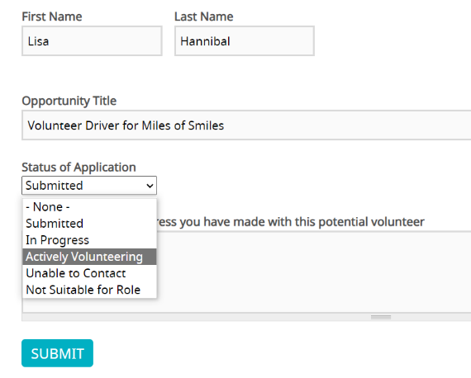
Status of application
Select from the drop-down menu the status of the volunteer’s application.
Actively Volunteering
Please select Actively Volunteering when a person has begun volunteering with your organisation. For recording purposes once selected do not amend this, even if they person no longer volunteers with your organisation

