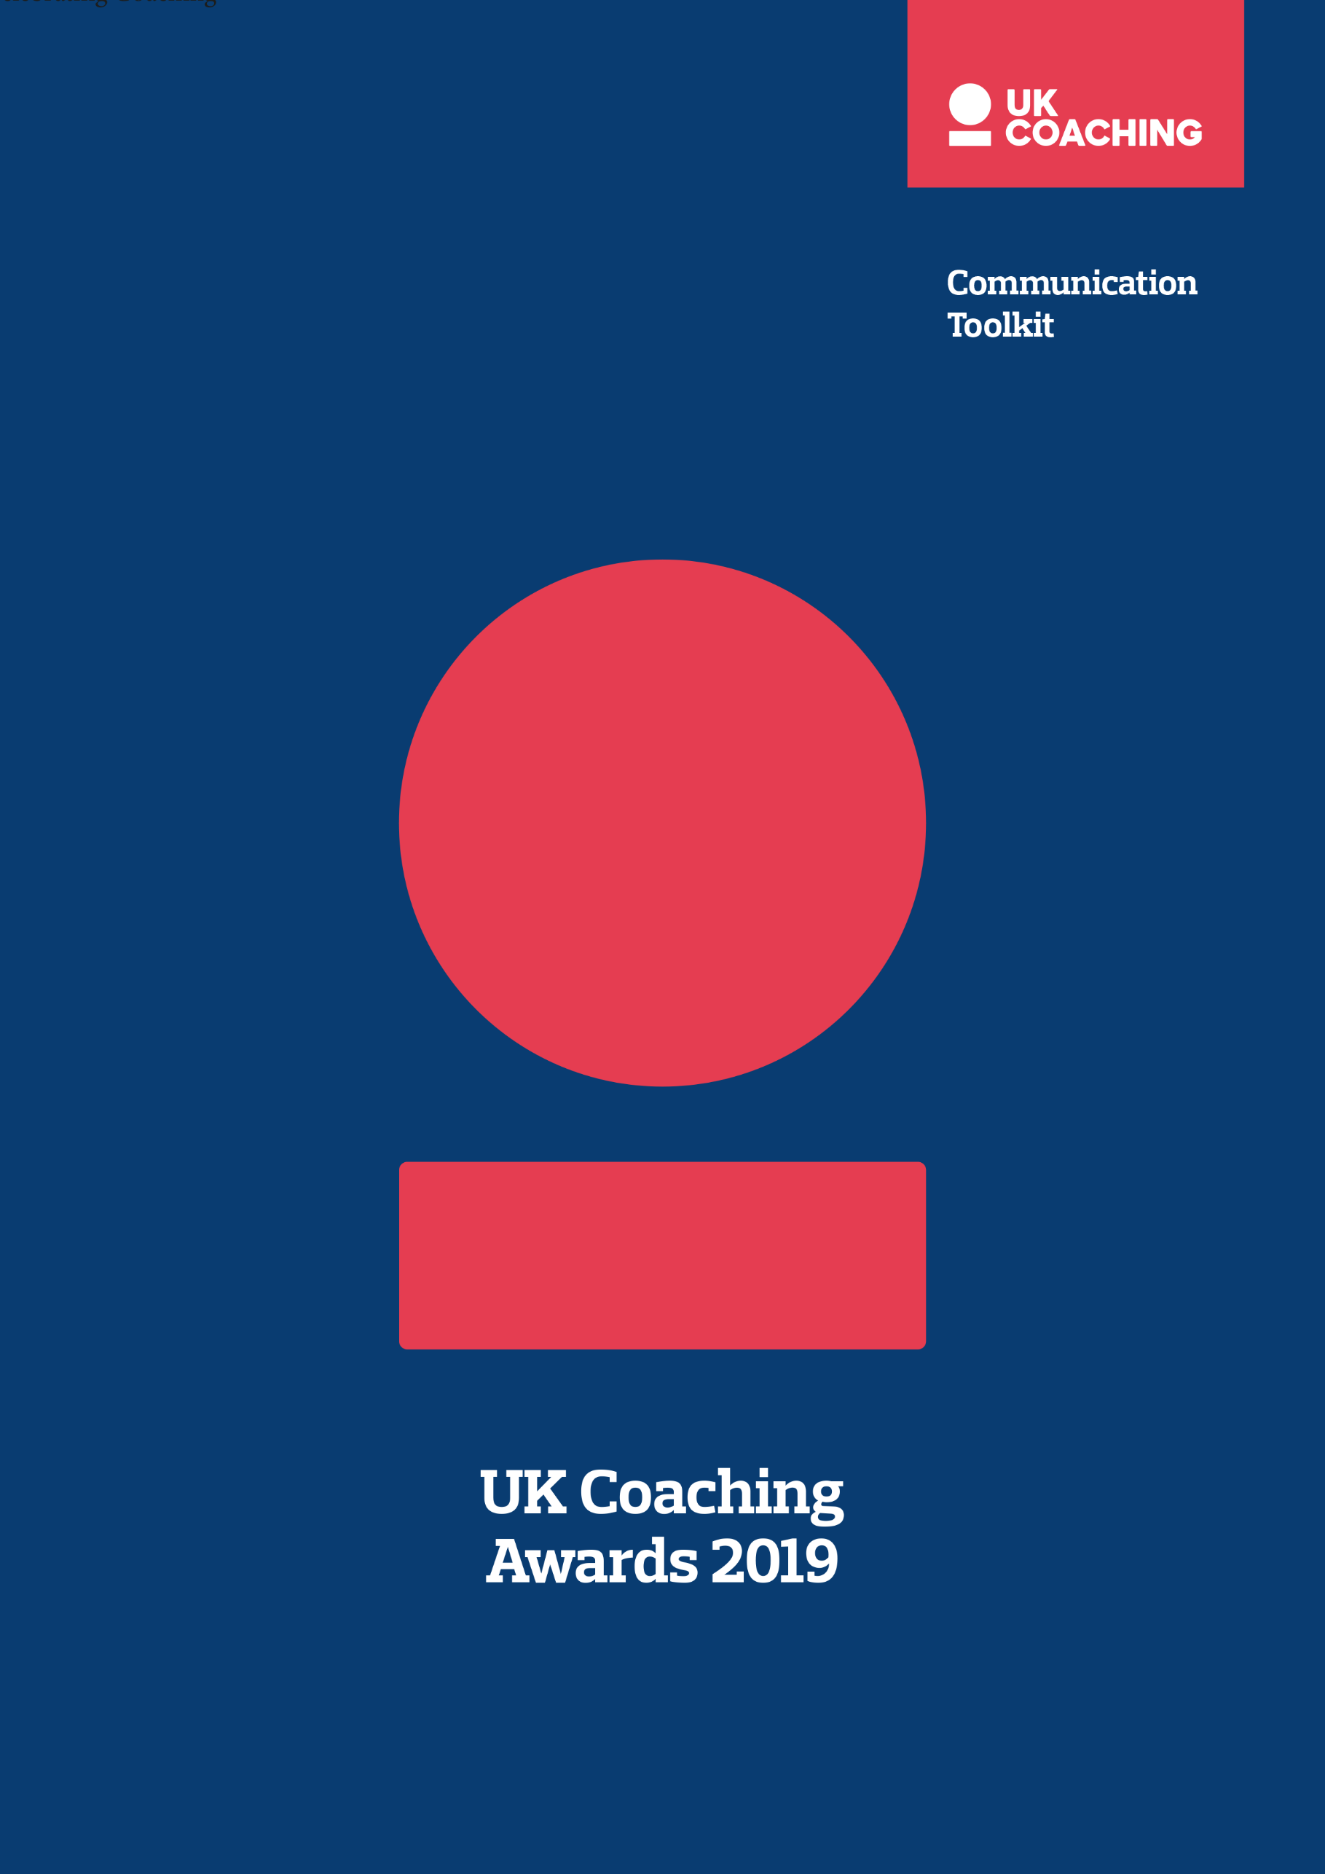

The nominations for the UK Coaching Awards 2019 are officially open.
We want the ‘nominations open’ announcement to be heard loud and clear so people turn out in their droves to nominate. Use this toolkit to help you, help us make the awards nominations the most diverse yet. Ensure people in your community are nominated to enhance their chance of being selected as a finalist.
Key Partner Messages
As one of our partners, there are two key things we’d like you to do:
- Encourage people to nominate a diverse array of coaches from all walks of life
- Nominate members of your workforce
Why should people nominate?
- to highlight the diverse work of coaches
- to say thanks to someone who is making a difference
- to showcase #GreatCoaching to policymakers to help secure future investment in coaching
Why should organisations nominate?
- to recognise #GreatCoaching in their sport, physical activity or community
- to raise the profile of a coach or programme that leads the way to empower, inspire and connect people from diverse communities
- to highlight the wider benefits that coaching has on their sport, physical activity or community
Key Dates 2019
7 August | Nominations open on the UK Coaching website
18 September | Nominations close at noon
25 November | Finalists announced on the UK Coaching website
5 December | Awards ceremony takes place the Tower Hotel London

News Item
Do you have a news area on your website? Here’s a press release which you can use to share the news.
Embargoed 7 August 2019, 12:00pm
Nominate for UK Coaching Awards to showcase the diversity of coaching
Nominations for the 22nd UK Coaching Awards are now open.
Hosted by UK Coaching, the annual event will be held at The Tower Hotel London on the 5 December 2019 and will showcase the diverse work of coaches from all walks of life helping people improve their well-being and activity levels.
UK Coaching’s research shows that the UK coaching community is diverse at grassroots levels, and through working alongside UK Sport and Sport England more is being done to attract a wider range of people into coaching at all levels.
With over 3 million people coaching across the UK regularly, this year’s Awards has been designed to ensure all coaches who give so much, from grassroots to the global stage, are recognised.
For the Awards, UK Coaching uses the broad definition of coaching and welcomes nominations on behalf of coaches, instructors, leaders, teachers, trainers and others who support people to achieve their sport and activity goals.

UK Coaching’s Director of Coaching Emma Atkins, said:
“We are very excited to be opening this year’s awards nominations. Through our summer of great coaching, we have demonstrated to more people than ever the transformative and long-lasting effects of coaching, contributing to the nation’s health, social integration and happiness.
“Broadly speaking, the coaching family across the UK is made up of a range of people from different backgrounds, experiences and motivations with a common belief to help people be the best they can be, whether that’s to win a gold medal or move more than they did yesterday. We would like the public to celebrate the work of coaches by nominating a diverse array of coaches that have made a difference in people’s lives and their communities.”
Overall, there are 12 award categories, eight for coaches, three in support of coaches and the Great Coaching Moment of the Year. All honour #GreatCoaching and truly celebrate coaches and organisations that make a difference.
New for 2019 is the Changing Lives Award, which will be awarded to a coach who is leading the way to empower, inspire and connect people from diverse communities to overcome life challenges using the power of #GreatCoaching.
Make your coach feel special, nominate them for the UK Coaching Awards.
The Awards for Coaches are given to individual coaches who have excelled and shown outstanding commitment in a certain area, or to an individual and/or group over the last 12 months. Collectively, they are:

- Children and Young People’s Coach of the Year
- Community Coach of the Year
- Changing Lives Award
- Talent Development Coach of the Year
- High Performance Coach of the Year
- Young Coach of the Year
- Lifetime Achievement Award
- And the Coaching Chain, which recognises contributions made by individual coaches throughout an elite athlete’s life in helping achieve their potential.

The Awards in Support of Coaches recognise those who recruit, develop, educate, qualify, and/or deploy coaches effectively in the UK. Collectively, they are:
- Coach Developer of the Year
- Transforming Coaching
- Coaching for an Active Life Award

The Great Coaching Moment of the Year, which celebrates a moment in time when a coach’s support and guidance paid off, will be back again this year. The Sports Journalists’ Association will be providing this year’s shortlist which will then be made open to a public vote. Further details will be announced soon.
Public nominations for the awards will close at noon on the 18 September and what follows is a rigorous, independent and impartial judging process. To ensure welfare is at the heart of the UK Coaching Awards, UK Coaching has a strict set of guidelines and criteria, through which an independent judging panel select the finalists. All finalists are verified by their respective governing body sport or representative organisation and all finalists are asked to sign and adhere to the UK Coaching Code of Conduct. All nomination information is treated as confidential until shortlists and winners are announced.
Nominate a coach for an award at ukcoaching.org/coachingawards.

-Ends-
Social
Support the nominations announcement by scheduling the following social messages. Don’t forget to @_UKCoaching and use the hashtag #GreatCoaching.
Nominations for the UK Coaching Awards 2019 are officially open! 😆🙌🏆  Head to www.ukcoaching.org/coachingawards & nominate someone who's made a difference  #GreatCoaching✨ | 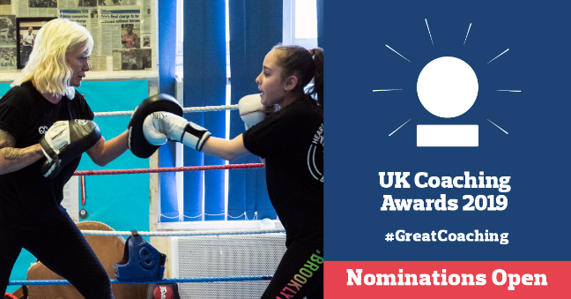
Showcase the diverse nature of coaching by nominating a coach who’s made a difference to your community for the UK Coaching Awards  Ensure all coaches from grassroots to the global stage are recognised 🙌  Head to www.ukcoaching.org/coachingawards & nominate  #GreatCoaching ✨ | 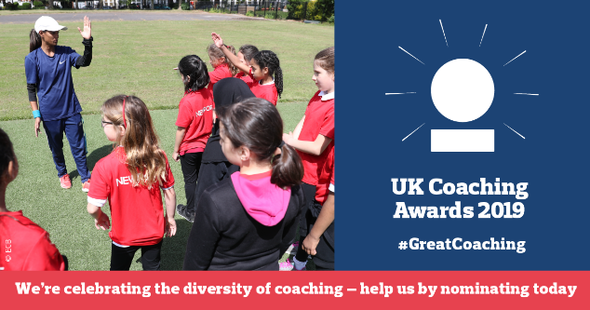
Coaches make differences in their communities 👍  Nominate your local hero for the UK Coaching Awards 2019 🔻🔻🔻  www.ukcoaching.org/coachingawards  #GreatCoaching ✨ | 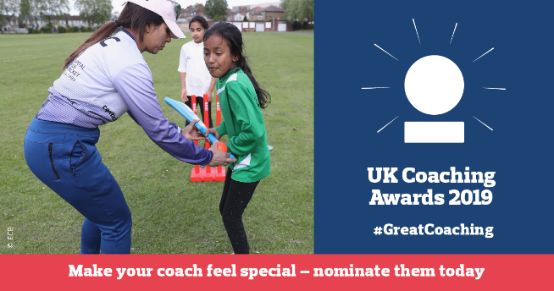
Know coaches from all walks of life helping people improve their connections, well-being and activity levels? 👌  Show your appreciation & nominate them for the UK Coaching Awards 🤔💡👇  https://www.ukcoaching.org/events/our-awards  #GreatCoaching ✨ | 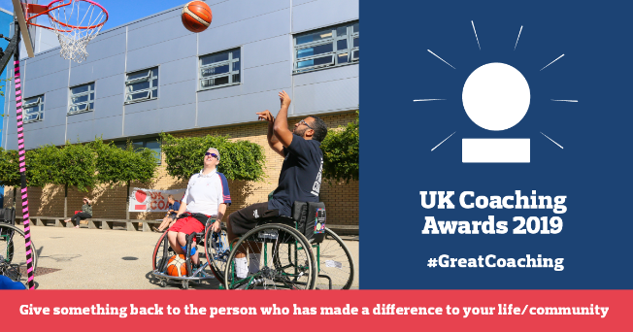
Coaching helps people, from all walks of life, to:  be active ✅  improve and succeed ✅  connect ✅  grow ✅  thrive ✅  A diverse array of coaches does the above & more for their communities  Nominate them for the UK Coaching Awards 2019  https://www.ukcoaching.org/events/our-awards  #GreatCoaching ✨ | 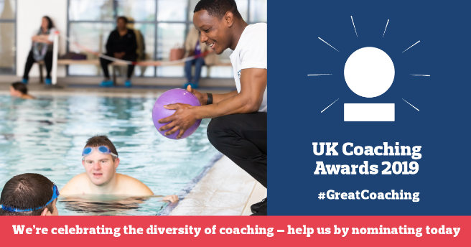
“We would like the public to celebrate the work of coaches by nominating a diverse array of coaches that have made a difference in people’s lives & their communities”  - UK Coaching's Emma Atkins  Get nominating folks!  https://www.ukcoaching.org/events/our-awards  #GreatCoaching ✨ | 