

**Protecting the planet for our people and places**

 **Rochdale’s Climate Change Strategy**

**2021 - 2025**

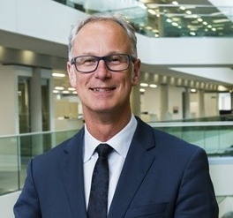

**Steve Rumbelow**

**Chief Executive**

**Councillor Sara Rowbotham**

**Lead Member for Climate Change and Sustainability**

Pollution is having a major impact on the natural environment and our health. It is causing the planet to get hotter which is leading to rising sea levels, warmer and acidic oceans, more rain and heatwaves. These environmental changes bring a threat of flooding, drought, land erosion, loss of habitation for wildlife and an increase in heat and cold related illness. Our borough has already suffered terrible flooding which has caused disruption to essential services, transport and loss of income for local businesses, so we know the devastation it can bring. In the UK, 40,000 people die annually from air pollution. Around 10% of Rochdale’s population have a respiratory disease and it is estimated that around 4.2% of deaths in Rochdale are related to respiratory diseases caused by air pollution. The climate emergency is threatening our existence and we must act quickly. Pollution mostly comes from human activity so we must all increase our efforts to reduce our own impact on the planet.

Our borough is facing major environmental challenges. The Council must help to limit the rise in global temperatures, reduce greenhouse gas emissions, reduce the amount of waste that is produced and ensure places and spaces are resilient to the shocks and stresses of climate change. This plan identifies the urgent action we need to take to achieve environmental sustainability and enhance the prosperity of people and the planet. This includes using renewable sources of energy for powering transport and heating buildings, being more efficient and responsible when we are making, buying and using goods and services, protecting and maintaining the natural environment and ensuring that our infrastructure can withstand expected and unexpected situations. Taking climate action will improve lives, not diminish them. It can deliver additional benefits such as improved health, job opportunities and bringing people together. Most of all it will secure a future for the next generation.

**What is climate change?**

The planet is heating up which is having a negative effect on the natural environment

Greenhouse gases are in the atmosphere

They come from human activity and natural processes

Burning fossil fuels contributes to greenhouse gases. The main sources of greenhouse gases are Transport (27.4%), Energy (24.5%), Business (17.4%) and Residential (14.5%)





Farming contributes to greenhouse gases

Weather is more extreme

Decomposing waste creates greenhouse gases



Oceans are warmer, acidic and sea levels are rising

Deforestation means there are less trees to absorb gases





Antarctic ice and glaciers are melting

**Greenhouse gases**

**Greenhouse gases are the biggest threat to our planet.**

The main greenhouse gases are Carbon Dioxide (CO2), Nitrogen Dioxide (NO2) Methane (CH₄) and Fluorinated-gases. Greenhouse gases are man-made and produced in different ways through human activity.

|  |  |
| --- | --- |
| **Greenhouse gas** | **Produced by** |
| Carbon Dioxide | Deforestation  Animal respiration  Burning fossils fuels  Burning biomass (plant or animal material) |
| Methane | Wetlands  Agriculture  Livestock  Decaying waste |
| Nitrogen Dioxide | Vehicle emissions  Fertiliser use  Chemical industry |
| Fluorinated gases | Manufacturing processes and during the lifecycle of certain goods e.g. refrigerators, aerosols. foams) |

**Emissions are grouped into three categories:**

Direct - emissions that come from sources owned or controlled by an individual or business e.g. cars, boilers, machinery

Indirect - emissions that are generated through activities undertaken by individuals and businesses but they don’t own or control the source e.g. purchased electricity or heat from the national grid / energy provider

Consumption based - emissions from the things we buy make, distribute, buy and dispose of i.e. emissions over the lifecycle of a product or service

**Impact of climate change**

**Source:** [BEIS final UK greenhouse gas emissions national statistics 1990-2019](https://data.gov.uk/dataset/9568363e-57e5-4c33-9e00-31dc528fcc5a/final-uk-greenhouse-gas-emissions-national-statistics)

**Impact of greenhouse gases for people and places**

**Putting greenhouse gases into the atmosphere and behaving in ways that are harmful to the planet will result in changes to the natural environment, leading to negative outcomes for people and places.**

**Impact of polluted air on health**

**Dirty air makes a major contribution to ill health and early death in our communities. Air pollution harms our health at every stage of life and the most vulnerable people in society are hit hardest. Those most at risk include:**

**Adults, especially in cities, and drivers**

**The elderly and those with health conditions**

**Children and young people**



Air pollution has been linked to premature births, low birthweight and miscarriage. Children are more vulnerable as their organs and immune systems are still developing. It can lead to childhood asthma, aggravate asthma attacks, lung damage and a lifetime of health problems

Air pollution can really worsen some health conditions, leading to flare ups and triggering heart attacks and strokes. There is now research showing that air pollution potentially increases the risk of getting dementia.

Adults are also vulnerable to air pollution. People who spend more time in areas with a high concentration of air pollution are most affected. That includes some drivers and people who spend a lot of time in cities.

**European and UK climate change policy and targets**

**The European Union and UK Government have set targets for reducing the impact of climate change**

|  |
| --- |
| **Global warming**  **The Paris Agreement 2015**  Keep global temperatures well below 2°C and aim for 1.5 °C |
| **Greenhouse gases**  **The Paris Agreement 2015**  Reduceglobalgreenhouse gas emissions to below 1990 levels by second half of the 21st century  **Climate Change Act 2008 (sixth carbon budget)**  Slash all UK greenhouse gas emissions by 78% by 2035 compared to 1990 levels |
| **Net zero Greenhouse gases**  **Government target set in 2019**  Bring UK GHG emissions to net zero by 2050 (recommended by the Committee on Climate Change) |
| **Nitrogen dioxide emissions**  **The Air Quality Standards Regulations 2010**  NO2 emissions to comply with EU Limit Values in the shortest possible time   * The hourly mean value may not exceed 200 micrograms per cubic metre (µg/m3) more than 18 times in a year * The NO2 annual mean value may not exceed 40 micrograms per cubic metre |
| **Renewable energy**  **Renewable energy directive 2018**  32% of energy is fulfilled by renewables by 2030  10% of transport fuels come from renewable sources by 2030 |
| **Waste management**  **The Waste Strategy 2018**  Cut the amount of waste going to landfill by 10% by 2035  65% of municipal waste to be recycled by 2035  70% of packaging waste to be recycled by 2030 (85% of paper and cardboard, 80% of Ferrous metals, 80% aluminium, 75% glass  Halve per capita, food waste at the retail and consumer level |

**The road map to net zero**

**UK Government published a 10 point plan in November 2020 for a Green Industrial Revolution**

|  |
| --- |
| **Zero Emission vehicles**  End sale of all new petrol and diesel cars and vans by 2030  All new cars and vans to be zero emission from the tailpipe by 2035 |
| **Greener buildings**  Public Sector to reduce direct emissions by 50% by 2032 (compared to a 2017 baseline) |
| **Greener Transport**  Double cycle activity to 1.6 billion stages per year by 2025 (from 2013 levels of 0.8)  Double walking activity to 300 stages per person per year by 2025  Increase the proportion of children aged 5 to 10 that usually walk to school to 55% by 2025 (2014 levels of 49%)  **NB: a stage essentially means a trip e.g. walking from home to the shop would be one stage** |

**Regional policy and targets**

**The Greater Manchester Combined Authority has set targets for Greater Manchester aligned with European and national policy**

|  |
| --- |
| **Carbon dioxide emissions**  Greater Manchester Environment Plan 2019  Bring CO2 emissions to net zero by 2038  10% reduction in heating and cooling demand by 2025 with a 22% total reduction by 2038  38% reduction in industrial emissions by 2025 with a 50-77% reduction by 2038  Retrofit 61,000 homes per year by 2024  Public buildings to obtain an average Display Energy Certificate (DEC) rating of D or better by 2024 and C by 2030 |
| **Nitrogen dioxide emissions**  **Greater Manchester Clean Air Plan 2019**  Reduce NO2 emissions on road links where modelling has identified exceedances beyond 2020 (152 stretches of road identified across GM)  Greater Manchester Environment Plan 2019  100% of all cars are zero emissions by 2035  100% of all buses are zero emissions by 2035 |
| **Renewable energy**  Greater Manchester Environment Plan 2019  Add 45MW of local renewable electricity generation by 2024  Add 10TWh of low carbon heating by 2024  Add another 45MW of energy supply through other sources  20% renewable energy generation at new developments |
| **Waste management**  Greater Manchester Environment Plan 2019  Limit any increase in the quantity of waste produced to 20%  Achieve a recycling rate of 65% by 2035 |
| **Natural environment**  Greater Manchester Environment Plan 2019 - 2024  Plant 3 million trees by 2035 and a further 1-2 million by 2050  Restore 50-75% of peatlands by 2038 |

**Local policy and targets**

**On 17th July 2019 Rochdale Council passed a motion on climate change**

**The Council resolves to:**

* Declare a climate emergency
* Work towards ensuring that the Council and the borough of Rochdale is carbon neutral by 2038. Achieving this will require the Council to take a leadership role and significant investment and policy initiatives from the government
* Develop a working group to support the Council move from declaration to delivery drawing in cross sector expertise, capacity and capability. The working group should draw on existing expertise within the borough as well as including residents who are representative of the borough as a whole
* Set in place a process of engagement and collaborative action that enables an action plan to be considered by Cabinet and Council in early 2020, based on achieving the aforementioned targets.

**The climate emergency in Rochdale**

**The borough has an average reading of 8.3 micrograms per cubic metre of air pollution** (**Source:** [**Public Health England**](https://fingertips.phe.org.uk/search/air%20quality#page/3/gid/1938133043/pat/126/par/E47000001/ati/102/are/E08000005/iid/92924/age/-1/sex/-1/cid/4/tbm/1/page-options/car-do-0)**)**

**The borough is producing 1,980,000 tonnes of CO2 emissions (as at 2021) (Source:** **SCATTER****)**

**The main sources of CO2 emissions are transport, domestic and industry**

**Only around 2.5% of CO2 emissions in the borough come directly from the Council**

**10 stretches of roads in the borough are modelled to exceed legal limit values of NO2 beyond 2020**

**4.7% of mortality in the borough is attributable to air pollution (2019)** **(Source:** [**Public Health England**](https://fingertips.phe.org.uk/search/air%20quality#page/3/gid/1000002/pat/6/par/E12000002/ati/102/are/E08000005/iid/30101/age/230/sex/4/cid/4/tbm/1/page-options/car-do-0)**)**

Source - [SCATTER (Setting City Area Targets and Trajectories for Emissions Reduction)](https://scattercities.com/pages/background/)

**The risks to properties and landscapes**

The National Trust’s Climate Hazard Map shows the risk to properties and landscapes across Britain as the planet heats up. This is the worst case scenario if there are no interventions on emissions. The immediate concern for the borough is the risk of slope failure, which means there could be mass movement of rock debris and soil if the land can’t stand up to natural stresses and weathering. The townships of Rochdale North and Pennines are already at a higher risk with the whole borough being at risk by 2060.

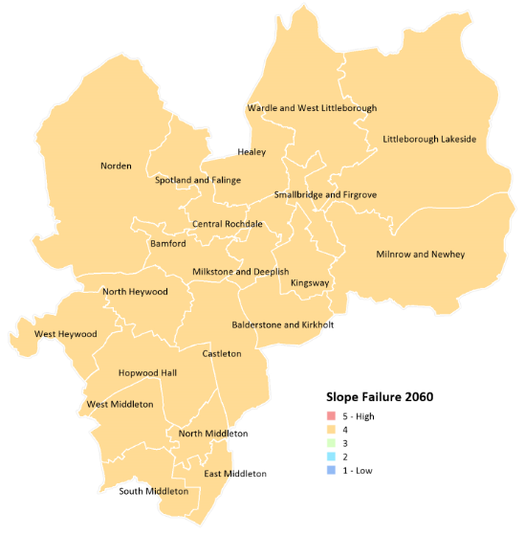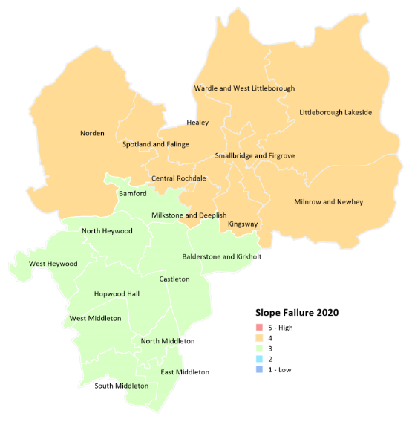

Source: [National Trust Climate Hazard Map](https://nationaltrust.maps.arcgis.com/apps/webappviewer/index.html?id=0bc569747210413a8c8598535a6b36e1)

Another immediate concern is the current risk of storm damage for Littleborough Lakeside. The whole borough will be at a significant risk of storm damage by 2060 with no interventions.

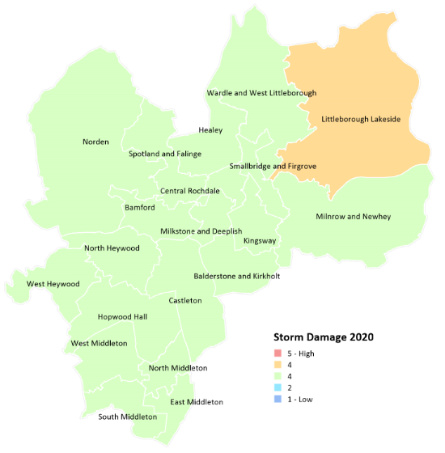

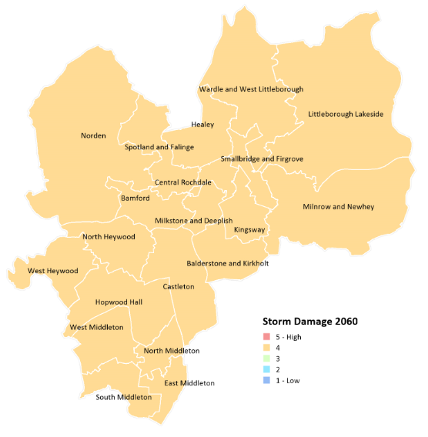

By 2060 the borough will also have a high risk of soil heave, particularly in the Middleton and Rochdale South Townships. Soil heave is when soil expands and pushes the ground upwards, if the soil is beneath a property it can cause building foundations to become unstable. By 2060 there will also be a significant risk of overheating and humidity, particularly in West Middleton.

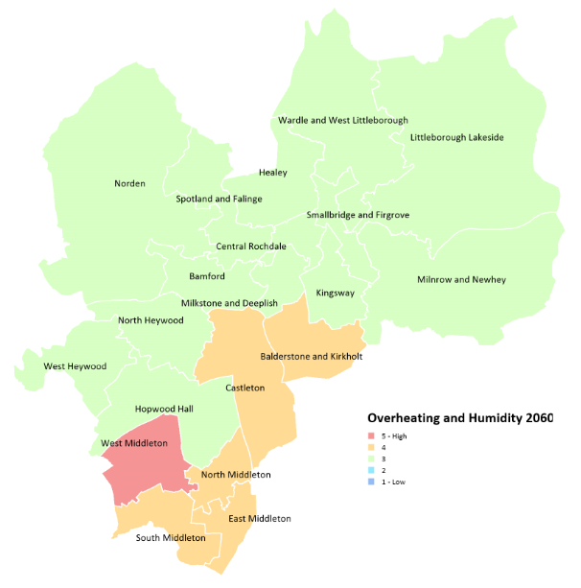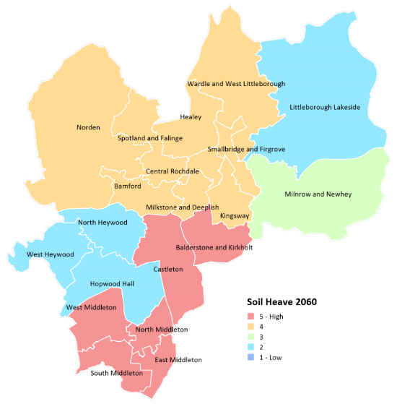

**Reducing Rochdale’s carbon emissions by 2038**

Using emissions pathways projections from the SCATTER (Setting City Area Targets and Trajectories for Emissions Reductions) data tool and from the Tyndall Centre we can plot Rochdale’s pathway to net zero by 2038.

If the borough followed the base ambition under the SCATTER pathway between now and 2038 then the projection is that there would be a cumulative saving of just over 172,074 tonnes of CO2. That would be largely down to external factors such as decarbonisation of the electricity grid and modest changes to buildings energy efficiency and land use.

If the borough followed the maximum ambition under the SCATTER pathway then we would still not achieve carbon neutrality but would reduce carbon emissions in the borough by around 52.5%. This would mean for instance tree-planting to increase current coverage by 30% by 2030 and a further increase of 20% from 2030-2050; from 2021, 100% new-build properties are built to passivhaus standard; a reduction in energy demand for our homes of 27%; a 22% reduction in road freight; and the average modal share of cars, vans and motorbikes decreasing from current national average 74% total miles to 38%.

If however, we use the Tyndall Centre climate commitments for Rochdale which suggest an immediate programme of CO2 mitigation to deliver cuts in emissions averaging a minimum of -13.1% per year, this shows that the period to 2025 is absolutely critical to any ambitions the borough may have of getting to, or close to net zero.

Source: [SCATTER Cities pathways and Tyndall Centre setting climate commitments for Rochdale (July 2021)](https://carbonbudget.manchester.ac.uk/reports/E08000005/)

The longer we delay making progress, the greater the difficulty of achieving ambitions on Climate Change. Carbon reductions alone will not mean that the borough can get to net zero by 2038. We will need measures including Carbon Capture and Storage (CCS) and Carbon Offsetting.

Carbon Capture and Storage is the process of capturing CO2, transporting it to a storage site within the natural environment such as oceans, soil or rock formations and depositing it there so it won’t enter the atmosphere.

Carbon Offsetting involves investing in environmental projects in order to balance out carbon emissions. For example to offset emissions produced from undertaking activities you might plant trees which help to remove carbon from the atmosphere.

**Bringing nitrogen dioxide emissions within legal limits**

**10 stretches of roads in the borough are exceeding EU legal limit values. Clean Air measures must be implemented to comply by 2023. These include a Clean Air Zone around the local road network which will apply a daily travel charge to the highest polluting vehicles including vans, buses, taxis, private hire vehicles and heavy goods vehicles.**

|  |  |  |  |
| --- | --- | --- | --- |
| Summary of exceedances before and after clean air measures | | | |
|  | Local Model point exceedances on Pollution Climate Modelling (PCM) links | Additional Local Model point exceedances on local roads (non PCM links) | Total Local Model point exceedances |
| 2021 | | | |
| Without Clean Air Measures | 10 | 0 | 10 |
| Clean Air Phase 1 (applies to buses, taxis and commercial vehicles) | 2 | 0 | 2 |
| Change in exceedances | -8 | 0 | -8 |
| 2023 | | | |
| Without Clean Air Measures | 2 | 0 | 2 |
| Clean Air Phase 2 (applies to Light Goods Vehicles) | 0 | 0 | 0 |
| Change in exceedances | -2 | 0 | -2 |

Roads in the borough that are included in the Clean Air Zone (highlighted red and orange)

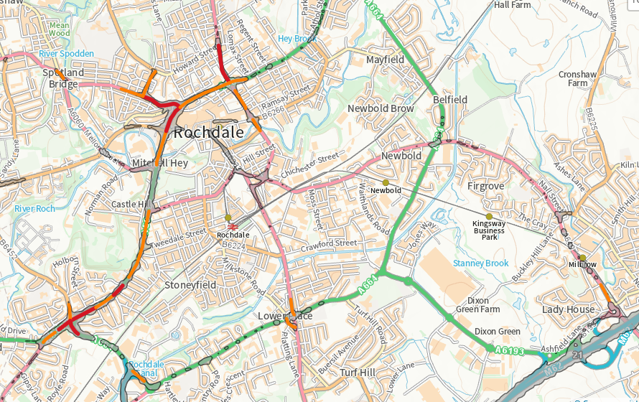

**Climate action**

**Five key areas where we can take action to reduce emissions are:**

1. **ENERGY**

Use greener types of electricity and heating in the places where we live and work

1. **TRAVEL**

Reduce journeys and use less polluting types of transport

1. **BUILDINGS**

Ensure buildings and infrastructure demand less energy and can withstand extreme climate impacts

1. **CONSUMPTION AND PRODUCTION**

Use less natural resources and reduce waste when producing and using goods and services

1. **NATURAL ENVIRONMENT**

Manage our air, land, water, plants and animals to protect the Earth’s natural resources

**How climate friendly is our borough?**

**Friends of the Earth have said that Rochdale is currently only 72% climate friendly**







The borough currently has only **13MW** of renewable power

Only **37%** of homes in the borough are well insulated and **13%** of households can’t afford to heat their homes properly.

**Only 5%** of the borough is woodland

5.4% of the borough is blanket bog but not all is in good condition. Blanket bog is important for habitat and provides a carbon store, helping to reduce flood risk.





Only 12% of people in the borough commute by public transport, 1% cycle and 10% walk. Only 12% share their car.

The borough reuses, recycles and composts **48%** of its household waste.

There are only **10** public electric vehicle (EV) charging points across the borough

Source: https://takeclimateaction.uk/climate-action/how-climate-friendly-your-area-enter-your-postcode-see-results-your-community

**Covid-19 and achieving sustainability**

Sustainability is about meeting our needs now without compromising the ability of future generations to meet their own needs. Climate change is the biggest threat to sustainability and is more likely to affect poorer people and places. True sustainability can only be achieved if social, economic and environmental factors are balanced. This means supporting people to meet their basic needs of health, housing, water and food and growing the economy by having the right businesses, jobs and investment whilst not depleting the earth’s natural resources so that we have enough to continue to live and thrive on this planet. The Covid-19 crisis has brought significant challenges. We have seen a worsening of issues - poor health, poverty, inequality, poor quality environments and unbalanced ecosystems, making it more difficult to achieve sustainability. From a social sustainability perspective people with health conditions, vulnerable groups such as older people or those from an ethnic minority background and those living in poor quality housing have been impacted the most. The economic consequences are evident in terms of business closures, changes to business operations and job losses. From an environmental perspective some negative outcomes include an increased amount of domestic and medical waste, reduced recycling efforts and increased use of chemicals for cleaning, although on a positive note the halt on travelling has helped to reduce greenhouse gas emissions. In its annual report to Parliament in June 2020 the Committee on Climate Change stated that it is important that we seize the opportunity to turn the Covid crisis into a defining moment in the fight against climate change and sustainable development. The report identified five investment priorities for 2021:

1. Replacing or improving energy systems with more efficient equipment
2. Planting trees, restoring peatlands and enhancing greenspaces
3. Using low carbon electricity to power transport and heating
4. Implementing initiatives and infrastructure to make it easy for people to walk, cycle and work remotely
5. Implementing systems and processes to stop waste and promote reuse, sharing, repair and recycling of resources

The Chancellor of the Exchequer’s ‘Plan for Jobs’ published on 20 July 2020 set out a £3 billion green investment package that could help support around 140,000 green jobs and upgrade buildings and reduce emissions. This includes a £2 billion Green Homes Grant scheme to help homeowners and landlords pay for green improvements such as loft, wall and floor insulation; and a £1 billion programme to make public buildings, including schools and hospitals, greener.

<https://www.theccc.org.uk/2020/06/25/covid-19-can-be-an-historic-turning-point-in-tackling-the-global-climate-crisis/>

<https://www.gov.uk/government/publications/a-plan-for-jobs-documents>

**Sustainable Development Goals (SDG’S)**

**The SDG’s are a set of global goals aimed at creating a better and more sustainable future for all. Our approach to tackling climate change will be about achieving social, economic and environmental sustainability across the borough. We have identified specific outcomes for each of the 17 goals which take into consideration government priorities following Covid-19.**

|  |  |  |
| --- | --- | --- |
|  | | **Deliver the following co-benefits in tackling climate change**  Social sustainability - Meet people’s basic needs and provide opportunities to ensure quality of life  Economic sustainability - Grow the economy whist using resources efficiently and responsibly  Environmental sustainability - Conserve natural resources and protect ecosystems for future generations |
|  | | **Build the resilience of those most vulnerable to climate-related events**  Energy efficient homes  Homes can withstand environmental shocks  Access to affordable energy (to provide thermal comfort) |
|  | | **Support sustainable food production and practices that can withstand climate change**  Local food production  Healthier eating habits  Resilient agricultural practices |
|  | **Relieve the burden of climate related illness and disease**  Air, water and land free from pollution and contamination  Less respiratory and communicable or infectious diseases  Healthier lifestyle habits, working environments and green spaces |
|  | **Build knowledge and skills in sustainability**  Education about sustainable development and sustainable lifestyles  Education and vocational training programmes to support careers in a green economy  Workforces equipped with skills for working in greener industries and sectors |
|  | **Empower women and girls to support economic growth and development**  Girls and young women particpating in Science, Technology, Engineering and Maths (STEM) subjects  Women working in the clean tech sector  Women as stewards of natural and household resources involved in climate action |
|  | **Manage demand for water and threats to water security resulting from climate change**  Better water-use efficiency  Better management, protection and restoration of water-related ecosystems, rivers, lakes etc.  Strong surface water management to reduce risk of sewer flooding  Improved water quality with less need for treating |
|  | **Reduce use of fossil fuels that are harmful to the environment**  Renewable electricity generation  Diversity and flexibility of energy supply including low carbon heating and hydro power  Fossil fuelled private vehicles, bus and other fleets replaced with zero emission capable alternatives  Road freight transport shifted to rail and water transport |
|  | **Support clean and green economic growth**  New industries at the forefront of clean and green innovation e.g. advanced materials, digital technologies  Companies trading in low carbon environmental goods and services  New types of jobs supporting clean and green growth |
|  | **Reduce the intensity of carbon emissions from the industry sector**  Circular and resource efficient production models that reduce waste and encourage recycling  Environmentally friendly equipment, technologies and processes being used  Infrastructure and industries upgraded or retrofitted |
|  | **Advance equal opportunity and reduce inequalities of outcomes in addressing climate change**  Representation and voice of young people  Diverse and vulnerable groups supported to move to cleaner and greener ways of living  Those most vulnerable to climate change benefitting first from climate action |
|  | **Make urban areas cleaner, greener and with climate responsive infrastructure**  Inclusive, sustainable, resilient and accessible buildings, roads, green and public spaces  Sustainable drainage plus measures for relieving heat stress/providing cooling  Well connected and sustainable public transport systems and active travel (cycling and walking)  The most polluting vehicles removed from town centres  The natural environment included in the design of urban areas (blue/green infrastructure)  Implementation of risk and disaster mitigation, adaptation and management measures |

|  |  |
| --- | --- |
|  | **Protect the loss of scarce resources through prevention, reduction, recycling and reuse**  Reduced waste, including food and plastic waste  Recycling of different types of materials e.g. paper, cardboard, aluminium, glass  Reduced heat demand from existing homes, new buildings and commercial and public buildings  Harvested rainwater used as a resource in combatting climate events (drought, flooding) |
|  | **Raise awareness to make it easy to identify and respond to the impact of climate change**  Carbon literacy for all  Behaviour change campaigns  Volunteering opportunities for climate action and nature restoration projects |
|  | **Protect areas for aquatic biodiversity**  Aquatic habitats created or enhanced  Aquatic habitats protected from damage caused by land and water activity  Aquatic wildlife sustained by tackling destructive fishing practices and managing aquaculture and tourism |
|  | **Protect and restore vital ecosystems and species**  Net gains in biodiversity through new development  Tree and wildflower planting as part of sustainable drainage systems  Wildlife habitats created, enhanced or protected from harm, including managing and restoring peatlands  Green spaces, green belt and designated nature sites created and maintained |
|  | **Mobilise change through effective participation and governance**  People leading the climate change agenda across all sectors - political, public sector, communities  Responsive, inclusive, participatory and representative decision-making at all levels  Environmental sustainability criteria embedded in policies, plans, processes e.g. procurement, planning etc.  Progress reported against achievement of climate change actions and targets |
|  | **Deliver sustainability goals through cooperation, finance and data**  Multi-stakeholder partnerships that share resources including knowledge, expertise, technology, money  Funding to support climate change projects and initiatives  High-quality, timely and reliable data to understand the current and future climate position |

**Engagement and collaborative action**

**Preventing climate change requires engagement from various partners and activity across multiple areas of work. We have established a Climate Emergency Working Group to direct and oversee climate related activity in the borough.**

**(2) Public Sector**

**Local authority, NHS, Fire, Police, education, Your Trust**

Public sector land and buildings

Vehicles – fleet/staff

Schools & Colleges

Leisure Centres, Arts & Culture

Human Resources – work and travel

Community centres

**(3) Domestic/ Housing**

**Strategic Housing, Registered Providers, Private rented/ landlords, homeowners**

Building standards

Large scale retrofit

New developments



**(4) Transport & travel**

**TfGM, GMCA, RBC, Dept. of Transport, OZEV**

Clean Air Plan (CAP)/Clean Air Zones (CAZ)

Zero emission / electric vehicles

EV infrastructure

Public and community transport

Active travel - Walking/cycling

Taxis/private hire



**(5) Industry & Commercial**

**RDA/Green Business Group/Growth Company**

Green investment

Retail

Industrial processes

Commercial/office

Supply chains and procurement

Skills & training

**(6) Energy & Consumption**

**Utilities/DNOs/GMCA/RBC/Community Energy**

Waste minimisation and recycling

Circular economy

Green growth

Renewable generation

Community Energy projects

Grid/network

Energy supply inc. affordability and thermal comfort

**(7) Natural Environment**

**RBC/Environment Agency/Utilities/Land owners/Groundwork/community organisations**

Sustainable development and resilience

Environmental protection

Biodiversity

Environmental management

Food & agriculture

**(8) Voluntary**

**Action Together/Interfaith Groups**

Third sector

Co-operatives/non-profit

Community and Faith Groups

**(9) Engagement, Co-design and Co-production**

**Tenants and residents/Young people/ MP’s, local councillors, Townships**

Awareness and behaviour change

Carbon Literacy

Campaigns and events



**(1) Policy, Finance and Standards**

Advocacy - Government, Greater Manchester Combined Authority, Utilities, NGOs, other public sector (e.g. NHS)

Regulation and standards – Including planning, building regulations, highways

Finance and Resources - £5 million Council capital funding, external funding, grants, investment

Data and intelligence - baseline and scenario planning

Communications and training - carbon literacy and behaviour change campaigns

Research and best practice – Academic and professional (e.g. Universities, think tanks, Environment Agency)



**Delivery plan**

|  |  |  |  |  |  |
| --- | --- | --- | --- | --- | --- |
| **Ref** | **Goal** | **Outcomes** | **Actions** | **Lead** | **SDG** |
| CC1 | Build the resilience of those most vulnerable to climate-related events | Energy efficient homes | Determine energy efficient building standards for homes across the borough including new and existing stock  Develop a programme for large scale retrofit of the existing housing stock including social housing, private rented and homeowners and secure funding to support delivery.  Encourage Rochdale homeowners to engage in the GM Retrofit Accelerator Programme to implement energy efficient measures to their properties | Planning / Building Control  Strategic Housing/Registered Providers  Strategic Housing | No poverty |
| Homes can withstand environmental shocks | Work with the Environment Agency and United Utilities to invest in flood defence measures in areas where homes are at a higher risk of flooding from rivers, surface water and groundwater.  Identify opportunities to work with Moors for the Future and landowners to deliver ‘Slow the Flow’ measures for natural flood risk management in the borough’s uplands and river valleys.  Improve flood literacy so that residents and businesses understand their flood risks and how they can be more flood resilient. | Strategic Planning |
| Access to affordable energy (providing thermal comfort) | All eligible, vulnerable households are able to access financial support or advice to reduce their home energy bills  Households switching to a clean tariff through the Greater Manchester Big Clean Switch | Strategic Housing / Energy Works |
| CC2 | Support sustainable food production and practices that can withstand climate change | Local food production | Local suppliers, buyers and retailers including the hospitality industry, schools, shops and businesses sourcing food produce from within the borough  Network of growing spaces for edible community gardens across the borough, including identifying new allotment locations and community orchards | Climate Change and Sustainability Manager and partners  Environmental Management | Zero hunger |
| Healthier eating habits | Schools promoting healthier eating, in particular encouraging a shift away from meat based to plant based diets  Colleges building healthier eating into the catering and sports science curriculum  **The Food Solutions Warehouse providing food and healthy eating advice and tips to residents that encourages plant based diets** | Schools / Facilities Management  VCFSE / Colleges |
| Resilient agricultural practices | Agricultural sites across the borough diversifying their farming systems to consider practices such as agroforestry, intercropping, mixed crop-livestock and crop rotation  Engage in the Environmental Land Management Partnership in the Irwell Catchment to support local farmers in accessing available funding and support as part of the governments agricultural transition plan - a pathway to sustainable farming | Climate Change and Sustainability Manager and Groundwork |
| CC3 | Relieve the burden of climate related illness and disease | Air, water and land free from pollution and contamination | All businesses and homes across the borough not using agricultural chemicals including pesticides – council to take a lead by banning its own use of these products  Engage with landowners and developers to support the repurposing of contaminated land sites  Take action on littering of the most frequent and problem waste materials such as fast food packaging, cigarette butts, used drink bottles, broken glass etc.  Implement the Greater Manchester Clean Air Plan | Environmental Management  Public Protection | Good health and wellbeing |
| Less respiratory and communicable or infectious diseases | Address future threats including antibiotic resistance, declining vaccination rates, pandemic flu, emerging diseases and health inequalities  Introduce no smoking spaces | Public Health |
| Healthier lifestyle habits, working environments and green spaces | Consider the introduction of Green Wheels Travel Schemes to encourage employees to use active modes of transport for business travel or commuting  Implement green social prescribing across the borough to enable all GPs, health care practitioners and local agencies to refer patients for nature based interventions and activities | Climate Change and Sustainability Manager and partners  Public Health / VCFSE |
| CC4 | Build knowledge and skills in sustainability | Education about sustainable development and sustainable lifestyles | Cultural and education programme every 5 years in line with United Nations Climate Change Conference (COP)  All educational establishments - early years, primary, secondary and colleges in the borough to be signed up to the Eco Schools Programme and achieving Eco-Schools Green Flag accreditation  Teaching workforce equipped with awareness and understanding of the climate change agenda with schools incorporating “green life skills” into the education programme to advocate pro-environmental behaviours | Your Trust / Action Together  Council’s Children’s Services Directorate - Schools  Council’s Children’s Services Directorate – Schools | Quality Education |
| Education and vocational training programmes to support careers in a green economy | Develop a local climate apprenticeship programme to prepare young people for jobs in a green economy  Create a network of green skills centres across local colleges and training centres to offer higher level certificates in green business and sustainability courses  Colleges and businesses working together to develop an aligned education and employment offer that ensures young people have the skills to support the key work needed to reduce carbon emissions – housing retrofit, renewable energy and that there are local job opportunities and local people are securing them | Work and Skills / Colleges |
| Workforces equipped with skills for working in greener industries and sectors | Conduct a green survey to map current and future sustainability levels, skill requirements and needs and demands of businesses across the borough which will inform a green business directory | Work and Skills / Rochdale Development Agency |
| CC5 | Empower women and girls to support economic growth and **development** | Girls and young women participating in Science, Technology, Engineering and Maths (STEM) subjects | Schools and colleges engaging in activity for [International Day of Women and Girls in Science](https://en.unesco.org/commemorations/womenandgirlinscienceday) on 11th February every year | Schools | Gender Equality |
| Women working in the clean tech sector | Explore with local colleges and Greater Manchester Combined Authority the potential for a Women in CleanTech and Sustainability Scholarship as part of the Green Work and Skills Programme | Work and Skills |
| Women as stewards of natural and household resources involved in climate action | Create a Women in Sustainability network in the borough which involves training women to understand their role in conserving natural resources in the household (e.g. cooking, shopping, and energy use) who act as champions and train and support other women. | Work and Skills / VCFSE |
| CC6 | Manage demand for water and threats to water security resulting from climate change | Better water-use efficiency | Reduce unnecessary water use and in home wastage and encourage water conservation measures across the Council’s estate and in homes, schools and businesses.  Roll out a ‘Backyard SUDS’ programme to focus on urban water conservation at home.  Work with utility companies to prevent leaks, improve drainage and sewer systems | Strategic Planning and partners (Environment Agency and United Utilities) | Clean water and sanitation |
| Better management, protection and restoration of water-related ecosystems, rivers, lakes etc. | Build ‘Buffers’ along the borough’s lakes, rivers, canals etc., where native vegetation is allowed to grow, to create areas of separation between human activities and waterways. This physical space protects waterways by filtering pollutants and preventing erosion  Carry out regular clean ups of local rivers and waterways |  |
| Strong surface water management to reduce risk of sewer flooding | Engage with United Utilities who have responsibility for maintaining surface water drains to reduce flood risks | Strategic Planning |
| Improved water quality with less need for treating | Work with the Environment Agency and United Utilities to maintain and improve the quality of fresh, marine, surface and underground waters | Strategic Planning |
| CC7 | Reduce use of fossil fuels that are harmful to the environment | Renewable electricity generation | Identify and develop projects under the Greater Manchester Go Neutral 2 programme on Council and partner assets including land, building and carparks to deliver a pipeline of smart energy opportunities e.g. solar farms, solar carparks with EV charging, wind turbines and grid connected battery storage (via a range of investment and delivery models)  Develop a business case to establish a Local renewable energy company to support deployment of renewable technologies on businesses, public buildings and homes  Ensure that lighting across the borough is mainly LED bulbs - council buildings, street lights, local businesses, community buildings | Climate Change and Sustainability Manager / Council and GM partners | Affordable and clean energy |
| Diversity and flexibility of energy supply including low carbon heating and hydro power | Develop a Local Area Energy Plan (LAEP) to identify future demand for heat and power to underpin proposals to upgrade the local energy network and enable decarbonisation in line with local objectives  Support the development of Community and Cooperative Energy organisations to support diverse energy supply, community wealth building and energy democracy through local community ownership of energy systems e.g. Middleton Cooperating  Explore the potential for micro hydropower generation across Rochdale’s waterways  Support the implementation and delivery of the Greater Manchester Hydrogen and Fuel Cell Strategy. | Climate Change and Sustainability Manager and council partners  Climate Change and Sustainability Manager and Strategic Planning |
| Fossil fuelled private vehicles, bus and other fleets replaced with zero emission capable alternatives | Replace Euro non-compliant council fleet with new compliant vehicles including electric and biofuel supported by appropriate charging and refuelling infrastructure at council sites  Ensure all council vehicles have Green Number Plates and encourage take up of green plates across the borough  Become an all-electric or hydrogen bus fleet borough  Implement Clean Air Plan mitigation measures to encourage uptake of zero tailpipe emission vehicles including: clean bus fund, clean freight fund, clean taxi fund and credit finance  Implement a last mile delivery scheme utilising e cargo bikes and small electric vans | Environmental Management  Environmental Management / Comms  TfGM  Public Protection  Economy |
| Road freight transport shifted to rail and water transport | Support the development of the Greater Manchester Freight and Logistics Strategy led by Transport for Greater Manchester | Economy / Highways |
| CC8 | Support clean and green economic growth | New industries at the forefront of clean and green innovation e.g. advanced materials, digital technologies | Establish an Advanced Machinery and Productivity Institute in the borough to drive the design, development and manufacture of advanced machinery and robotic systems to meet changing manufacturing needs. | Rochdale Development Agency | Decent work and economic growth |
| Companies trading in low carbon environmental goods and services | Prioritise investment in start-up businesses that offer environmentally friendly products and services | Economy / Rochdale Development Agency |
| New types of jobs supporting clean and green growth | Prioritise relocation, start up or expansion of clean tech businesses in the borough, in particular support for cooperatives and social enterprises | Economy / Rochdale Development Agency |
| CC9 | Reduce the intensity of carbon emissions from the industry sector | Circular and resource efficient production models that reduce waste and encourage recycling | Establish a ‘Renew’ shop at Rochdale Recycling Centres selling donated, pre-loved household items at an affordable price  Voluntary, Community, Faith and Social Enterprise (VCFSE) sector accessing support and funding through schemes such as Recycle for Greater Manchester Community Fund for waste prevention, increasing recycling, reuse of household waste and reducing contamination.    Maintain and manage our own waste as part of a circular economy to reduce waste to landfill and support reduction, recycling and reuse of waste - consider opportunities for energy and heat recovery from waste | Environmental Management  VCFSE  Environmental Management / Economy | Industry, innovation and infrastructure |
| Environmentally friendly equipment, technologies and processes being used | Business across the borough signed up to the Eco Business Pledge to commit to being sustainable and reducing their environmental impact  Solar bins in place across the borough for compacting of rubbish and increased waste storage space to support fewer collection trips and reduce emissions | Public Protection  Environmental Management |
| Infrastructure and industries upgraded or retrofitted | Businesses accessing green advice and funding through local advocacy services such as the Growth Company and Groundwork, through effective signposting and promotion  Small and micro businesses accessing tools, resources and advice via the UK Business Climate Hub to help them take practical steps to cut emissions  Business across the borough accessing the Industrial Technology Fund for roll out of clean technologies | Economy / Rochdale Development Agency / Your Trust / other partners |
| CC10 | Advance equal opportunity and reduce inequalities of outcomes in addressing climate change | Representation and voice of young people | Deliver a Green Youth Summit in 2021  Deliver weekly events and activities linked to the climate emergency agenda through the Council’s Youth Service  Deliver a programme of creative activities in schools linked to the climate emergency agenda e.g. through the arts and heritage centre, local theatre company etc. | Your Trust  Youth Service  Your Trust | Reduce Inequalities |
| Diverse and vulnerable groups supported to move to cleaner and greener ways of living | Appoint a Green Neighbourhood Coordinator to mobilise action in local communities, including allocating community grants to support green projects, with a focus on delivery in more diverse and vulnerable settings in the borough | VCFSE |
| Those most vulnerable to climate change benefitting first from climate action | Secure funding to implement ‘School Streets’ in the borough, to restrict motor traffic at drop off and pick up times, thus protecting the health of children and young people | Highways |
| CC11 | Make urban areas cleaner, greener and with climate responsive infrastructure | Inclusive, sustainable, resilient and accessible buildings, roads, green and public spaces | Reallocation of road space along major strategic corridors to encourage different modes of travel – Streets for All project | Highways | Sustainable cities and communities |
| Sustainable drainage plus measures for relieving heat stress/providing cooling | Support the Greater Manchester IGNITION Project to develop innovative finance solutions for the natural environment which will see investment in local initiatives such as green walls, green roofs, street trees, urban green spaces, Sustainable drainage systems (SuDS) | Strategic Planning and GM partners |
| Well connected and sustainable public transport systems and active travel (cycling and walking) | Develop a local Cycling and Walking Plan to identify opportunities for active travel routes and create cycle and walking corridors across the borough, including offering cycle training to every school child and adult  Establish an Active Travel Group to create a platform for local cycling and walking clubs and organisations with an interest in active travel to come together to identify opportunities and to support promotion of active travel to other residents | Highways/TfGM |
| The most polluting vehicles removed from town centres | Implement a Clean Air Zone that will impose a daily charge on vans, buses, coaches, taxis, private hire vehicles, minibuses and heavy goods vehicles that do not meet emissions standards  Deployment of electric vehicle charging points across the borough within publically accessible spaces, including fast and rapid points  Create additional park and ride spaces at stations across the borough to encourage travel on public transport  Extend the pilot E-Scooter scheme across borough town centres and industrial parks to offer a sustainable transport solution linked to public transport infrastructure  Businesses implementing car share schemes and car clubs to offer employees alternatives to using their own vehicles for business travel and commuting | Public Protection  Highways  Economy  Economy  Green Business Group |
| The natural environment included in the design of urban areas (blue/green infrastructure) | Develop an urban farm and eco-park in the borough similar to the Northern Roots project in Oldham  Repurpose contaminated land sites for sustainable energy projects or eco habitats  Establish a ‘Bee-Stops’ programme to develop mini ecosystems on viable bus shelters in the borough  Identify opportunities for tree and woodland planting across the borough as part of our local Pennine Edge Forest and the trans Pennine Northern Forest to help deliver improved carbon management, manage pollution, reduce flood risk, enhance biodiversity and recreational opportunities and make our town centres and neighbourhoods more resilient to heat stress.  Support the development of a South Pennine Regional Park to create a cross regional framework for investment and collaboration in sustainable land management and the environmental economy.  Identify and deliver significant new tree and woodland planting within the Council’s land ownership  Work with City of Trees, the Woodland Trust and Forestry England to engage and encourage private landowners and maximise funding opportunities for tree planting and management.  Work strategically in managing the impact of tree diseases such as Ash Dieback. | Environmental Management  Strategic Planning  Strategic Planning/Environment Management |
| Implementation of risk and disaster mitigation, adaptation and management measures | Plan and prioritise action in areas of the borough that are most at risk of climate hazards (as per the climate hazard map) to limit soil heave, storm damage, slope failure, overheating and humidity  Develop climate change standards for new infrastructure and apply to planning policies, as well as introducing a climate and sustainability impact assessment to ensure that all projects have consideration for their environmental / carbon impact so that adaptations can be applied | Strategic Planning |
| CC12 | Protect the loss of scarce resources through prevention, reduction, recycling and reuse | Reduced waste, including food and plastic waste | Establish a Real Junk Food Project Hub in the borough to support redistribution of surplus food and reduce food waste  Introduce ‘No single use plastic’ initiative in the borough utilising national awareness raising days to encourage behaviour change – Plastic free July, National Refill Day | VCFSE  Climate Change and Sustainability Manager | Responsible consumption and production |
| Recycling of different types of materials e.g. paper, cardboard, aluminium, glass | Utilise national awareness raising days to encourage behaviour change - Zero Waste Week, Recycle Week  Continue to maintain a kerbside recycling collection from households including plastic bottles, cans and glass. Once the outcome of the government consultation on consistency in household and business recycling in England is known, (expected early 2022) the council will work with GMCA to implement any necessary changes and achieve any recycling targets set. | Environmental Management |
| Reduced heat demand from existing homes, new buildings and commercial and public buildings | Consider the potential to implement heat networks for town centres and other viable domestic and commercial areas  Determine energy efficient building standards for commercial, public, industrial buildings  Deployment of energy efficiency and heating measures across Council buildings to support public sector decarbonisation  Deployment of energy efficient and heating measures across schools, primary care sites, local business and social housing to support decarbonisation | Economy  Economy  Technical and Building Surveying |
| Harvested rainwater used as a resource in combatting climate events (drought, flooding) | Implement a programme to harvest rainwater from public building roofs and use to supplement mains water supply |  |
| CC13 | Raise awareness to make it easy to identify and respond to the impact of climate change | Carbon literacy for all | Develop an e learning module to embed carbon literacy into corporate induction  Support Carbon Literacy Action Day on 1st November 2021 by using the Carbon Literacy Programme to train Council leaders  Appoint a Training Coordinator to roll out Carbon Literacy across the Council and to other key stakeholders | Climate Change and Sustainability Manager | Climate action |
| Behaviour change campaigns | Campaigns around key environmental days such as Earth Day, Plastic Free  Annual Rochdale Green Summit aligned with Greater Manchester Mayor’s Green Summit | Communications  Your Trust / Action Together |
| Volunteering opportunities for climate action and nature restoration projects | Significant numbers of green volunteers trained and working on community improvement projects in parks and countryside across the borough  Introduce ‘Making a Difference’ Days at the Council which involves employees taking green action | Environmental Management |
| CC14 | Protect areas for aquatic biodiversity | Aquatic habitats created or enhanced | Engage with the Environment Agency and United Utilities to protect aquatic habitats in the borough including rivers, lakes, streams ponds, wetlands and bogs | Strategic Planning/Climate Change & Sustainability Project Manager | Life below water |
| Aquatic habitats protected from damage caused by land and water activity | Encourage residents to pledge to protect the ocean and marine animals through their own actions including conserving water, shopping local to reduce shipping and using less plastic |  |
| Aquatic wildlife sustained by tackling destructive fishing practices and managing aquaculture and tourism | Develop Hollingworth lake as an aqua tourism destination.  Work with the Environment Agency and United Utilities to protect local waterways and preserve fish species | Your Trust  Strategic Planning/Environmental Management |
| CC15 | Protect and restore vital ecosystems and species | Net gains in biodiversity through new development | Identify opportunities to deliver the Greater Manchester Nature Recovery Strategy within the Council’s land ownership and through working with landowners and land managers across the borough.  Working with a range of key stakeholders, partnerships and programmes to increase opportunities for funding and the capacity to deliver net-biodiversity gains.  Identify specific Biodiversity Net Gain delivery opportunities within the Council’s land assets and establish opportunities to create a borough wide habitat bank.  Ensure a robust approach to assessing and delivering Biodiversity Net Gain requirements from new development through local planning policy and development management decisions that explore opportunities to deliver biodiversity gain through carbon offsetting.  Move from a grass monoculture to planting with a wider variety of plant species to naturalise grass verges and open spaces and encourage greater biodiversity. The Council to lead and provide advice and encourage all schools and businesses to do the same. | Strategic Planning/Environmental Management | Life on land |
| Tree and wildflower planting as part of sustainable drainage systems | Every child will be given the opportunity to plant a tree or wildflowers in their school, garden or neighbourhood over the next 2 years. |  |
| Wildlife habitats created, enhanced or protected from harm, including managing and restoring peatlands | Delivering ‘Places for Everyone’ and the Council’s Core Strategy and future local plan documents to ensure that biodiversity is given appropriate protection including designated areas, existing habitats are restored and improved and new habitats created. | Planning |
| Green spaces, green belt and designated nature sites created and maintained | Produce supplementary planning guidance to encourage good design and the effective safeguarding and enhancement of biodiversity in development proposals | Planning |
| CC16 | Mobilise change through effective participation and governance | People leading the climate change agenda across all sectors - political, public sector, communities | Dedicated political lead for climate change in the borough  Identify the requirements for additional staff resource and fund ongoing temporary posts to support delivery of projects and dedicated Council officer to act as a Programme Manager for the climate agenda | Policy & Performance | Peace, justice and strong institutions |
| Responsive, inclusive, participatory and representative decision-making at all levels | Implement a digital platform for ongoing conversation and engagement (Common Place)  Explore citizen’s assemblies and good help as an opportunity for twenty first century democracy around the climate change agenda. | Policy & Performance  Place Team |
| Environmental sustainability criteria embedded in policies, plans, processes e.g. procurement, planning etc. | Climate impact assessment embedded into council procurement processes for decisions on large scale contracts  Climate impact assessment included in Cabinet reports | Climate Change & Sustainability Project Manager |
| Progress reported against achievement of climate change actions and targets | Use the SCATTER tool to model an emissions reduction pathway for the borough, reporting progress annually to the Climate Emergency Working Group | Climate Change & Sustainability Project Manager |
| CC17 | Deliver sustainability goals through cooperation, finance and data | Multi-stakeholder partnerships that share resources including knowledge, expertise, technology, money | Establish a Green Bond investment scheme to encourage investment in the borough and to help fund climate change projects  Utilise the ‘Pathways to Healthy Net Zero Housing for Greater Manchester’ data tool and model the domestic needs for retrofit. | Finance  Strategic Housing | Partnerships for goals |
| Funding to support climate change projects and initiatives | Establish a community funding pot to support VCSFE sector in undertaking climate change action / projects in the borough  Secure funding from the Government Public Sector Decarbonisation Programme and other Government programme such as the Green Homes Grant Local Authority Delivery Scheme and the Sustainable Warmth Fund  Secure funding for further decarbonisation of assets through the Greenworks Community Renewal Project  Secure funding from the National Lottery Climate Action Fund to support Rochdale communities to take action on climate change  Secure funding from the Office for Low Emission Vehicles (OLEV) to support the extension of electric vehicle charging infrastructure  Secure funding via Recycle for Greater Manchester Community Fund  Secure funding from the Industrial Technology Fund  to support roll out of clean technologies at industrial sites  Secure funding from the Greater Manchester Environment Fund to support local net biodiversity projects and carbon offsetting | Policy & Performance/  Finance |
| High-quality, timely and reliable data to understand the current and future climate position | Procure a new council system to support asset management and reporting  Develop a carbon reporting tool so that the Council can monitor its emissions and energy usage  Install a real time air quality monitoring station in the borough to expand and support the GM air quality monitoring network and have realtime data available and published via the internet | Strategic Asset Management  Climate Change & Sustainability Project Manager/Energy Officer  Public Protection |