PRESS RELEASE

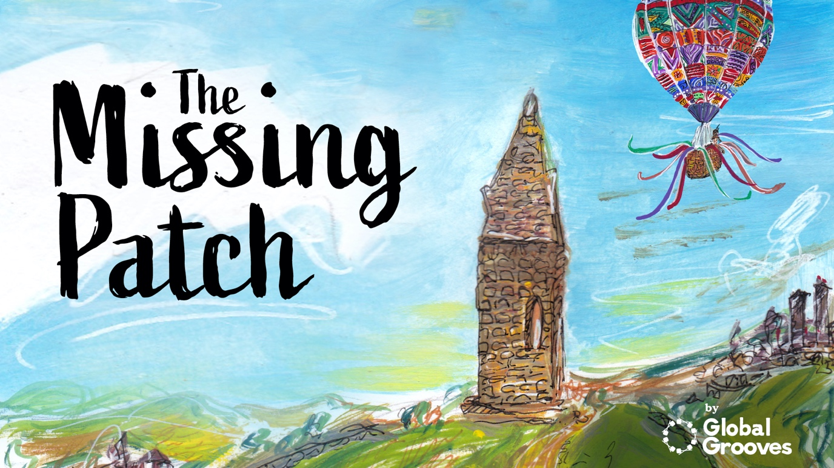

Can you help find The Missing Patch?
April 2020

Hot on the heels of Global Grooves’ Vale Live initiative comes The Missing Patch, an arts project designed for participation while under COVID-19 pandemic lockdown.
The artist-led Carnival arts organisation is asking residents of Tameside – and, of course, the wider world – to help find The Missing Patch.
A hot air balloon has come down in Tameside. A man is desperate to get to Rio in time for Carnival.
‘Questions, questions! We don’t have time for questions! Can’t you just get me a new patch? Then I’ll be in Rio in no time!’
‘Okay,’ I said. ‘I’ve got some friends that can help.’
Can you help?
Visit themissingpatch.org to read the story in full.
Funded in part by Action Together, Jigsaw Housing and GMCA, participants have three ways to get involved in The Missing Patch:
1. Request a batik patch kit
Global Grooves will send participants a kit containing fabric, wax, dye and instructions to make their very own batik patch. Completed patches will be sent back to Global Grooves using the enclosed self-addressed envelope and will be collated to create a hot air balloon skin – or envelope, as they’re technically called – ready for Carnival.
2. Scan a picture of your own creation
For those participants that don’t fancy batiking but do want to get involved, Global Grooves is looking for beautiful designs that can be scanned in and emailed for printing onto fabric. Using a dinner plate as a template – any size welcome! – participants can design and decorate their patch with any materials they choose.
3. Don’t fancy making something?
Global Grooves also wants writers to get involved, sending poems and short stories for inclusion in a digital book. The prompt is simply: what happens next? How does the strange man get hold of his missing patch? What happens to the characters in the story? Does the balloon make its way from Tameside to Rio in time for Carnival? What happens along the way?
And when the missing patch is found?
Once social distancing measures are removed and life can go back to normal, Global Grooves’ in-house artists will be stitching together all returned fabric patches to create a life-size hot air balloon – basket and all – which will appear at a future community event, while submitted creative writing will be edited into a digital book for everyone to enjoy online.
For more details about how people can get involved, and to upload creations, please visit themissingpatch.org

ENDS

Notes to editors

The Vale, situated at the top of Micklehurst Road in Mossley and a former industrial unit, is currently being transformed into the Northern Carnival Centre of Excellence which will open to the public in 2021. A purpose-built venue for live music, theatre and dance, it will also comprise of studio space for a variety of visual arts. the-vale.co.uk
Global Grooves is an artist-led Carnival arts organisation based at The Vale in Mossley, Tameside. We bring together the very best culturally diverse artists from around the world to create stunning carnival presentations, develop next generation artists, incubate companies, stimulate innovation in the sector and inspire diverse communities to participate in Carnival, both across UK and internationally. globalgrooves.org

