Food Solutions Network
Improving ‘food access’ for the people of Rochdale borough
The Food Solutions Network exists to facilitate community, voluntary, faith and social enterprise (VCFSE) sector organisations, alongside statutory partners, to improve access to food for the people of Rochdale Borough. We want everyone in the Rochdale borough to be able to enjoy nutritious, appropriate food with dignity and without deprivation.
Food Provision
This means that a range of food solutions need to be available and accessible including crisis food and low cost food plans, hot meals and soup kitchens, specialist food that meets dietary or cultural needs, home delivery services, shopping help, school holiday dinners, support with cooking skills and support to make healthy food choices and reduce food waste.
Social food offers need to be included; shared celebration food, luncheon clubs, group/online cooking and eating groups can all increase community wellbeing, boost skills and friendships and unite people. Food provision can also help identify opportunities to support people in a better way; economic, social, family and health support needs can often be uncovered with a conversation about food options.
Dignity
‘With dignity’ means that we must support food solutions that flex to the persons needs and do not develop a culture of dependency. Support should be available without judgement and individual choice and autonomy encouraged.
In Rochdale borough we want to ensure that if you are in crisis and can't afford food you can access a foodbank offer along with other crisis support (Support with debt or emotional support for example). The foodbank will provide you with basic food to sustain you, including food that meets your cultural needs. You can progress to a Pantry or Food Club as the crisis eases, and start to self-manage but at a reduced cost, a step up towards self-management, or as a barrier to prevent crisis. Other support is available to you too, like cooking skills groups or specialist dietary support or social eating groups. We can connect you to local businesses that deliver meals, arrange for a volunteer to help with your shopping or connect you with community based hot food offers.
Together
There are many food provisions and offer in the Rochdale Borough, from grassroots organisations to national initiatives. By working together, we are able to:
- Increase reach and accessibility of food support
- Harness the bulk buying power and logistics capabilities of anchor institutions
- Progress grassroots ideas into action quickly and effectively by making the most of assets held within the group
- Develop shared understanding and support mechanisms and build mutually beneficial relationships between partners
- Take advantage of surplus food and reduce waste
- Connect food provision to other types of support to enable holistic, person centred support

Membership
Facilitated by Action Together. Open membership to all VCFSE organisations involved with ‘food’ from crisis food to celebration food.
The initial members of the group, who participated in the Food Providers report research (published August 2020) are listed below – however new participants are welcome to join the network at anytime:
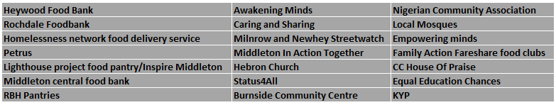
2020 Priorities
- Develop a Food Cooperative Warehouse to operate as a food/supplies donation redistribution centre open to all VCFSE food providers to benefit from
- Stock warehouse via a surplus stock scheme with local businesses and a ‘Care Package’ scheme with local VCFSE organisations
- Connect with the Economic Support Network to operate the warehouse as a skills/training/volunteer ‘hands on learning’ opportunity

