Food Solutions Network
Food Solutions Network Report
August 2020

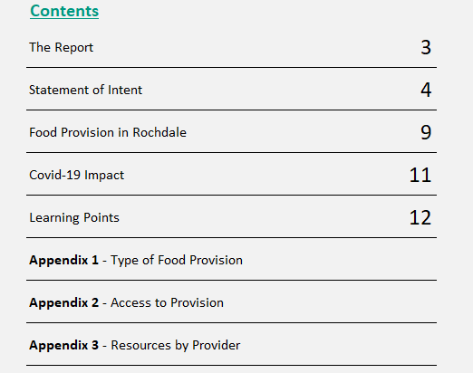

The Report
The purpose of this report is to capture the geography and type of food provision from the Voluntary, Community, Faith and Social Enterprise (VCFSE) and Mutual aid sectors across Rochdale Borough during the Covid-19 pandemic of 2020. This does not include the provision of the Community Response Hubs.
The mapping of food provision captured in this this report will be used as an evidence base of food provision across Rochdale and to identify any gaps in support. Though we recognise that this the data contained in the report does not capture all the provision offered by the VCFSE in the borough, the providers that have taken part are all active members of the Food Solutions Network. The Food Solutions Network was set up during the pandemic by Action Together and aims to being providers together to improve access to nutritious, appropriate food, with dignity and without deprivation.
This report will also act as a blueprint to scale up emergency provision across Rochdale borough should there be a second wave of COVID 19 or equivalent emergency.
Insights and reflections
- The majority of provision captured focuses on crisis and emergency food offers (55%); there is an opportunity to focus on ‘step up’ provision such as food clubs and pantries
- Potential need for more weekend provision
- Heavily reliant on donations, opportunity strengthen business donation/social value schemes to support this and to work with VCFSE to increase ‘generated income’
- Decrease in numbers of volunteers despite new initiatives being set up, possibly due to age of volunteers and shielding limitations
- Huge increase in number of people supported compared to ‘pre-Covid’. Its estimated around 3,000 people were supported prior to Covid and 12,000 during Covid; this is a 400% increase.
We thank the following organisations have contributed to this report by completing a survey in July 2020:
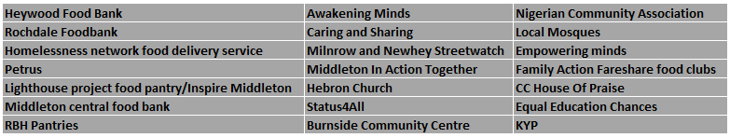

Food Solutions Network – Statement of Intent
The Food Solutions Network exists to facilitate community, voluntary, faith and social enterprise sector organisations, alongside statutory partners, to improve access to food for the people of Rochdale Borough. We want everyone in the Rochdale borough to be able to enjoy nutritious, appropriate food with dignity and without deprivation.

Food Provision
Food solutions need to be available and accessible including crisis food and low cost food plans, hot meals and soup kitchens, specialist food that meets dietary or cultural needs, home delivery services, shopping help, school holiday dinners, support with cooking skills and support to make healthy food choices and reduce food waste.
Social food offers need to be included; shared celebration food, luncheon clubs, group/online cooking and eating groups can all increase community wellbeing, boost skills and friendships and unite people. Food provision can also help identify opportunities to support people in a better way; economic, social, family and health support needs can often be uncovered with a conversation about food options.

Dignity
‘With dignity’ means that we must support food solutions that flex to the persons needs and do not develop a culture of dependency. Support should be available without judgement and individual choice and autonomy encouraged.
In Rochdale borough we want to ensure that if you are in crisis and can't afford food you can access a foodbank offer along with other crisis support (Support with debt or emotional support for example). The foodbank will provide you with basic food to sustain you, including food that meets your cultural needs. You can progress to a Pantry or Food Club as the crisis eases, and start to self-manage but at a reduced cost, a step up towards self-management, or as a barrier to prevent crisis. Other support is available to you too, like cooking skills groups or specialist dietary support or social eating groups. We can connect you to local businesses that deliver meals, arrange for a volunteer to help with your shopping or connect you with community based hot food offers.

Together
There are many food provisions and offer in the Rochdale Borough, from grassroots organisations to national initiatives. By working together, we are able to:
- Increase reach and accessibility of food support
- Harness the bulk buying power and logistics capabilities of anchor institutions
- Progress grassroots ideas into action quickly and effectively by making the most of assets held within the group
- Develop shared understanding and support mechanisms and build mutually beneficial relationships between partners
- Take advantage of surplus food and reduce waste
- Connect food provision to other types of support to enable holistic, person centred support

In Rochdale borough there are 32 different food providers who are part of the Food Solutions Network, available to support residents who are in need of a type of food support. Providers offer a variety of different types of provision ranging from crisis food parcels, meal deliveries to shopping and home delivery services.
Each provider has a different capacity and function with the majority being supported by volunteers as well as relying on donations in order to continue to help residents most in need.
The ward boundary map in figure 1 highlights the location of 20 of the food providers in Rochdale borough who provided data for the report. The majority of food providers are located within Central Rochdale and Milkstone & Deeplish wards; this location correlates with the high levels of deprivation that is prominent in these two areas of the borough. Noticeably there is a cluster of provision within the Middleton Township although in relation to the map there isn’t much local food provision in the Pennines and Heywood Township areas (e.g. Littleborough Lakeside, West Heywood and North Heywood).

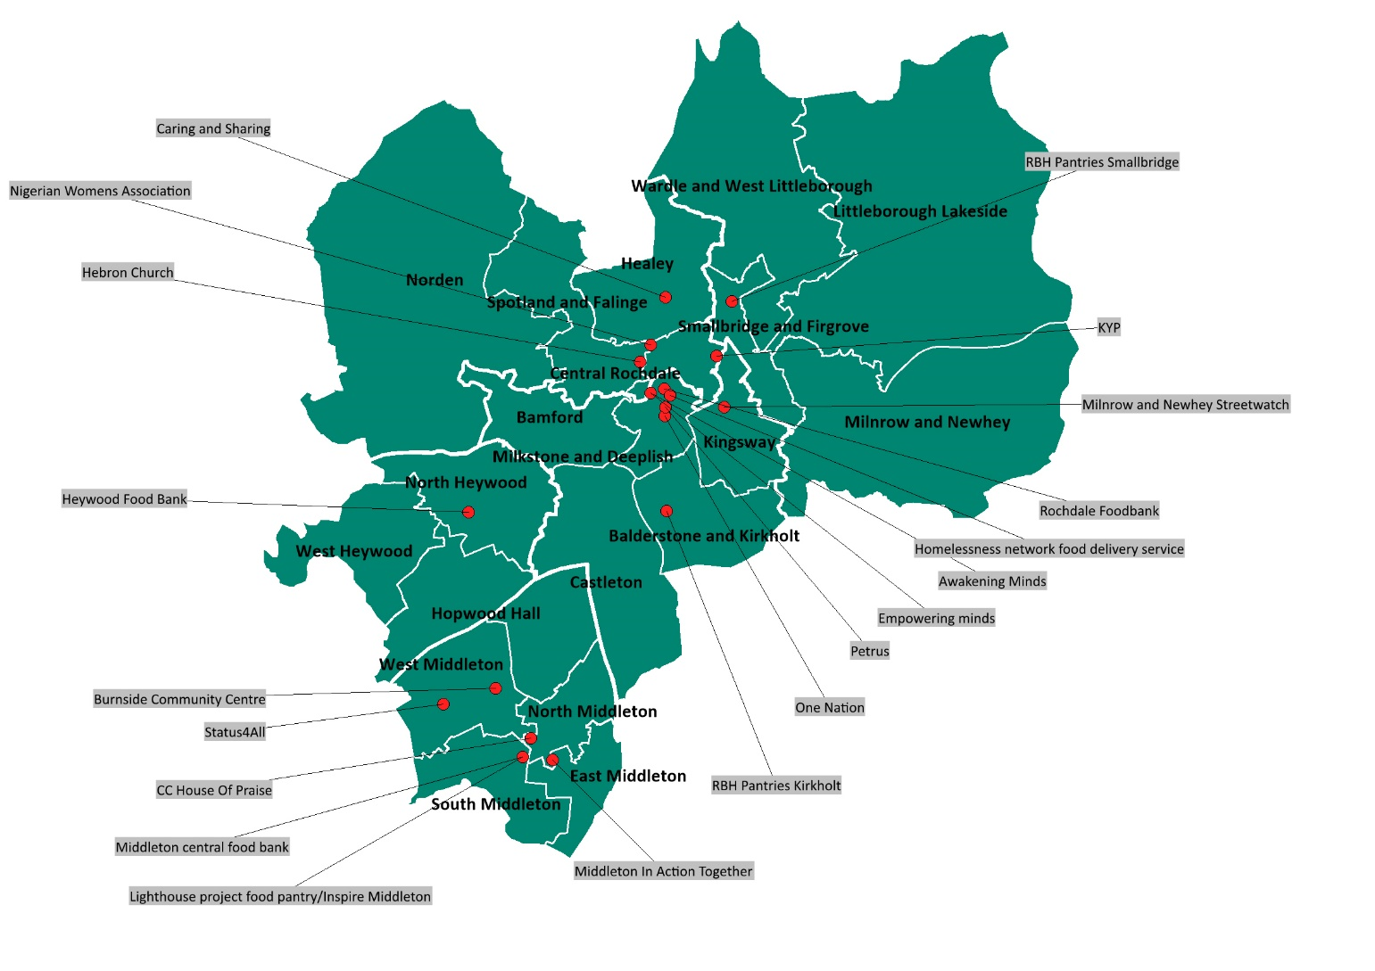
Figure 1: Location of Food Providers in Rochdale
4
4
4

Rochdale is one of the most deprived borough’s in the country and is ranked 25th (out of 326 local authorities) in terms of overall deprivation. 32.5% of the borough’s population reside in the 10% most deprived nationally local super output areas (LSOAs are small geographical areas grouped by postcodes within the overall Rochdale boundary).
The table (Figure 2) shows the number of food providers that are located in each ward within Rochdale borough against the deprivation percentage (IMD 2019) for each ward.
The majority of food providers are located in areas that would be classed as more deprived within the borough.
South Middleton although less deprived, has two food providers in its ward. When measured against catchment it is likely that these providers support other areas within the Middleton Township.

Figure 2: Food Providers in Rochdale by Ward and Deprivation Score
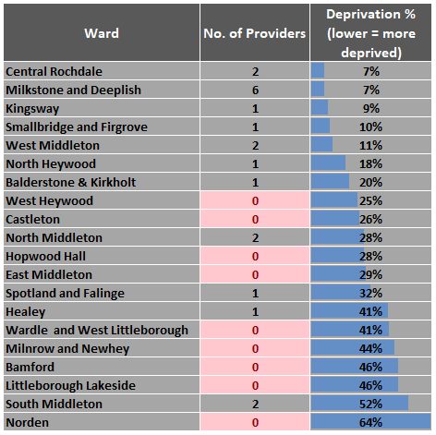

In order to better understand how providers support residents of Rochdale the map (Figure 3) has been created that highlights the 20 food providers, who provided data, each with a 1 mile location radius surrounding the provider location.
Some areas of the map aren’t covered by the 1 mile radius from any of the food providers. This suggests that is may be more difficult for some residents to access food provision especially from walking distance.
Please note some providers can support further than 1 mile but it was thought presenting the data in this way may be useful to understand location from a local perspective. This map can be refined once the correct radius of support for each provider is understood.

Figure 3: Food Providers in Rochdale by Catchment Area (1 Mile)
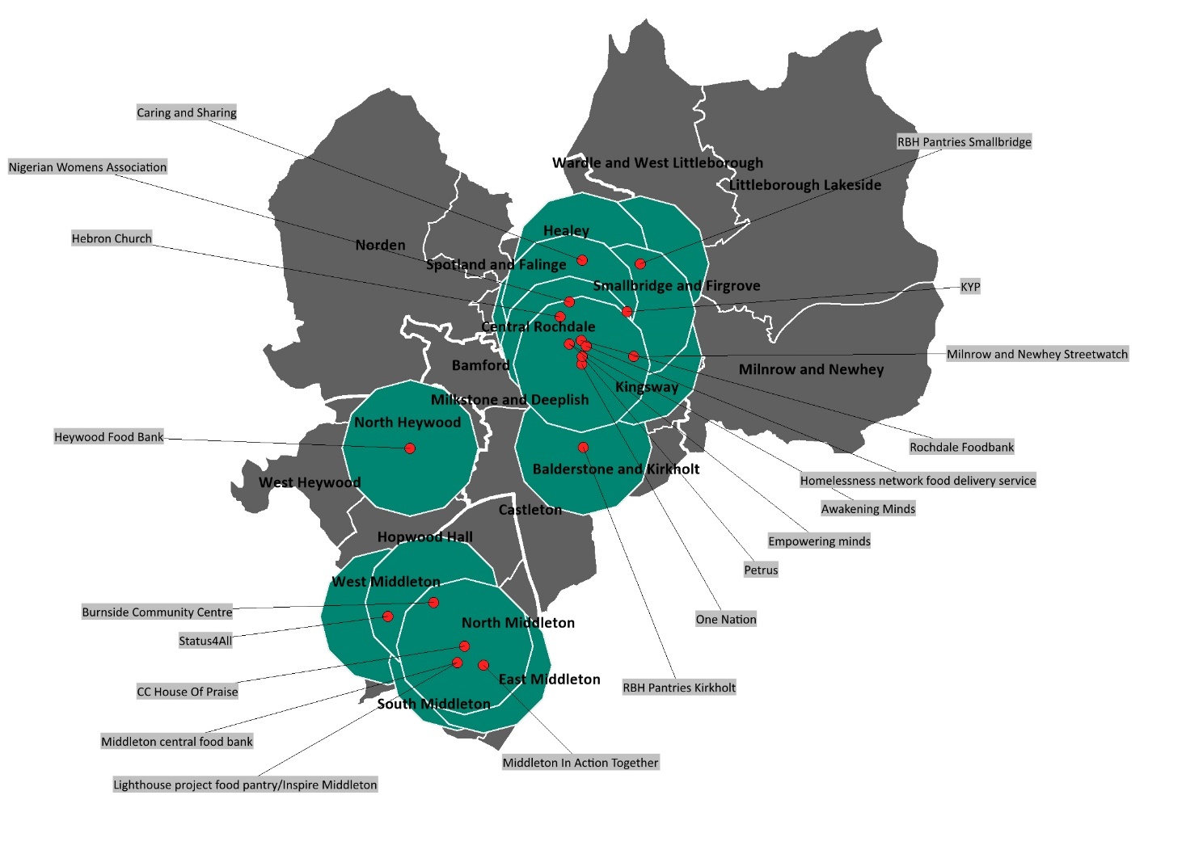

Food Provision in Rochdale
Type of Provision
There is a wide range of different types of food provision available in Rochdale.
Based on the data provided from 20 food providers the table below (Figure 4) highlights a count of the number of food providers in Rochdale against the type of provision offered.
50% (10) of providers offer crisis food provision in the form of one off parcels and 35% (7) offer meal delivery to residents. There are 9 foodbanks (both Trussell Trust and other) as well as 5 food clubs offering support across the borough. Notably none of the providers offer social food provision and only one offers a community café.
Appendix 1 shows the breakdown of type of food provision by food provider.

Figure 4: Type of Food Provision
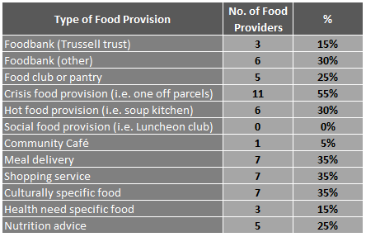

Access to Provision
95% (19) of food providers offer their support to residents during the week. 8 (40%) provide support anytime (weekdays and weekends) these providers are listed below:
- Heywood Foodbank
- Homelessness network food delivery
- Caring & Sharing
- Milnrow & Newhey Streetwatch
- Middleton In Action Together
- Status4All
- Nigerian Community Association
- Family Action Fareshare food clubs
Appendix 2 highlights the providers in relation to when the provision offered can be accessed.

Figure 5: Access to Provision
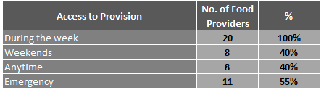

Resources
Food providers in Rochdale resource their work in a variety of ways, although the majority comes from donations with 75% (15) receiving food donations and 65% (13) receiving money donations respectively.
Other ways resourcing is generated is via the Local Authority, grants and some through generated income.
Appendix 3 shows how each of the 20 food providers resource their work.

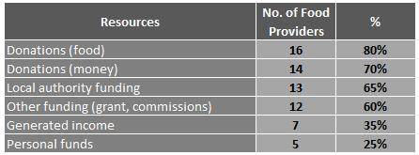
Figure 6: Resources

Covid-19 impact on Food Provision in Rochdale
As part of the data collection for this report providers were asked to provide information regarding what a typical week was like for them prior to the Covid-19 pandemic and what a typical week was like during the pandemic.
This information came in a variety of formats and has been amalgamated into the estimated average format in Figure 7 below.

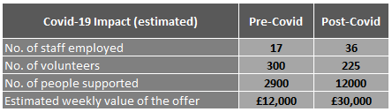
Figure 7: Covid-19 Impact on Food Provision (Weekly)

As expected the number of people and families supported increased during the pandemic as there were additional pressures on residents in regards to isolating, accessing benefits and lockdown measures. The estimated increase was around 300%; increasing from around 3,000 residents/families supported a week to 12,000. Support provided included meals, shopping and food vouchers.
Staff employed doubled during the pandemic although the number volunteers reduced for providers overall. The reduction in volunteers is likely due to the demographic of some regular volunteers having to shield and isolate due to their age.
The estimated weekly value of the offer provided doubled; this would be expected due to the higher demand placed on providers to support residents during this time period.
Around 50% of the food providers when asked said that there overall capacity met demand during the Covid-19 pandemic.

Learning Points
Need for a collaborative approach
The Community Response Fund, enabled as part of the COVID-19 Community Response highlighted the volume of groups that were supporting people with a diverse range of food offers in the borough.
The data and intelligence gathered through calls made to the Emergency Helpline highlighted shopping needs for shielded cohorts but also underlying food needs connected to economic support needs. Food/shopping was also a gateway into a deeper conversation about other help needed. Food donations were coming in thick and fast but often randomly so they could not always be taken advantage of e.g. 1000 airline meals that needed a home within a few days and surplus stock from bakeries that needed heating but no venues with ovens open.
It was clear that a coordinated approach was needed to help link support offers together, and share information and practice between groups to develop coordinated food solutions.
What worked
- Spending time talking to each other, learning and creating an environment of shared endevour not competition
- Sharing resources, RBC shared data and intelligence support to create this report, VCFSE offered their services as part of ‘hub’ referral pathways
- A cooperative approach
  - Food Solutions Network has an open and diverse membership which ranges from Soup Kitchens to the Soil Association to neighbour shopping groups to Foodbanks to Housing Association Pantries to Mosque groups and Children’s Centre Food Clubs
  - Connection to the Economic Support Network, which is co-chaired with Citizens Advice and brings together VCFSE groups that support people around money, work and skills issues
  - Both these Networks link in with a ‘sister’ Food Provision and Economic Support meeting, led by RBC and attended by representatives from the VCFSE. These separate but connected networks/meetings allow for recommendations and information to flow between groups whilst retaining each groups autonomy and focus. This contributes to appropriate shared solutions being developed and ensures connection with other programmes of work.

Appendix 1 – Type of Food Provision by Provider
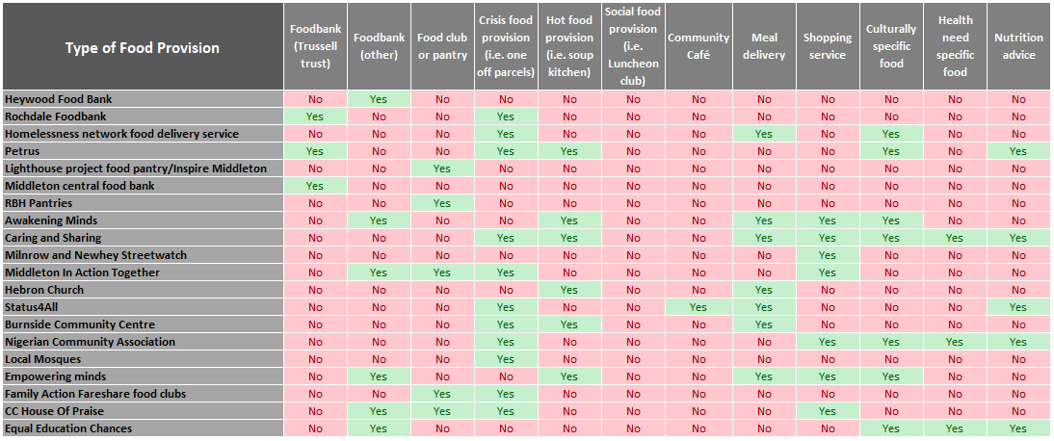

Appendix 2 – Access to Provision by Provider
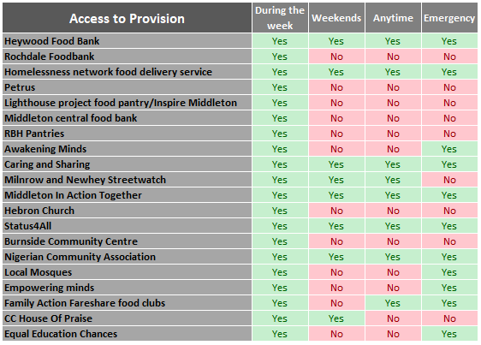

Appendix 3 – Resources by Provider
