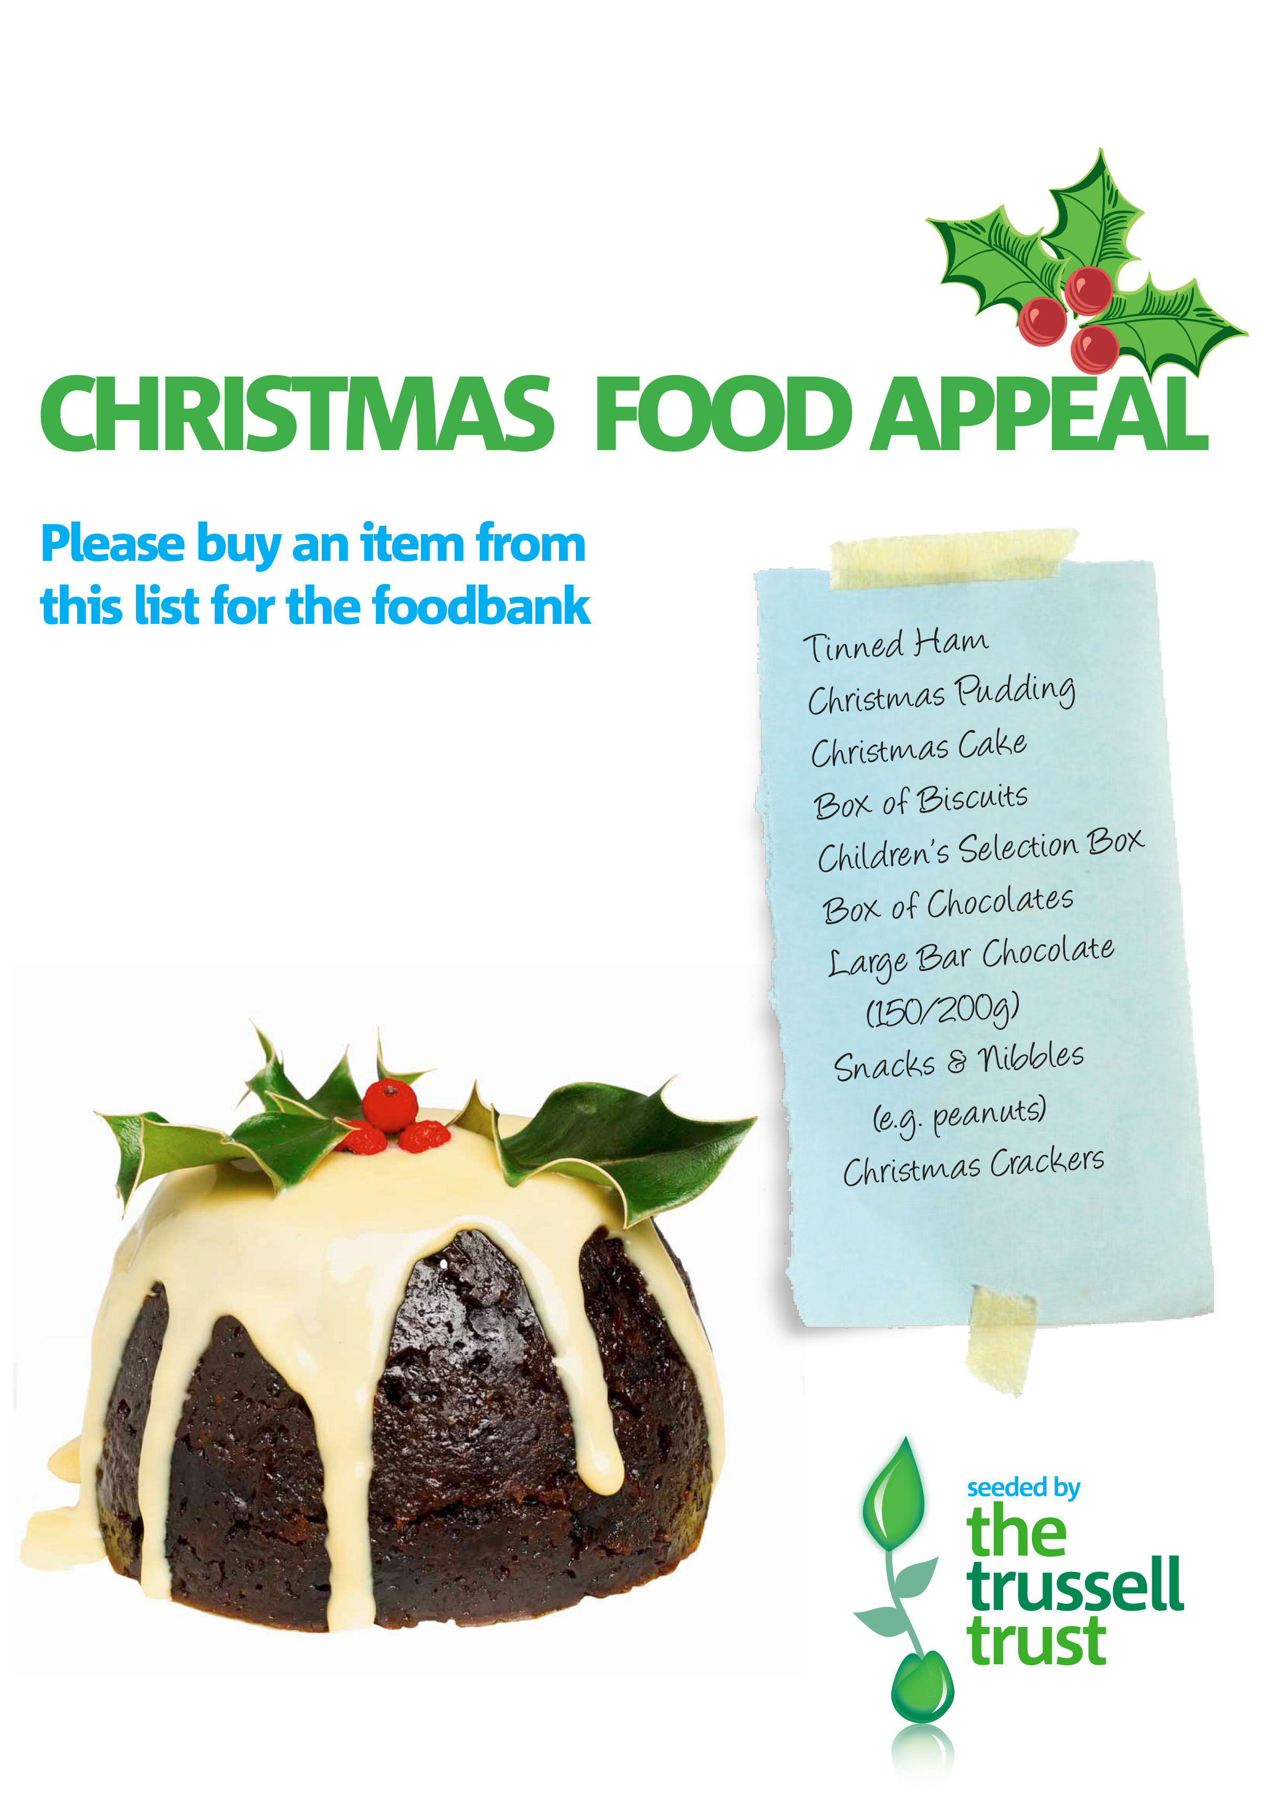

In the 3 weeks leading up to Christmas 2018 the foodbank will provide approximately 400 Christmas food parcels to local individuals and families in crisis. Last year we gave a 3 day food parcel to 382 people as well as a bag of Christmas treats.

Thank you for your support!

Registered Charity Number: 1161048| Registered in England and Wales

**tamesideeast.foodbank.org.uk**