Oldham Food Solution Network (OFSN)

**Terms of Reference**

**1. Context & Introduction**

The Oldham Food Solution Network is a multi-agency partnership drawn from various partners and representatives from across the food system. It provides oversight of food activity, supports shared ambitions and finding innovative ways of working which considers the impact of the food system as a whole. To contribute towards the following:

* a resilient food system that delivers food security for all
* tackling inequalities,
* diet-related ill-health
* and the environmental impact of the food we produce and consume

**2. Purpose & Aims**

The purpose of OFSN is to identify opportunities for action. By putting local people at the heart of this approach, OFSN aims to bring together communities, partners and organisations to work co-operatively to improve fair access to fresh, local, affordable healthy food. As well as providing a forum for interaction, OFSN will develop a consistency of vision and approach with stakeholders to enable cooperative action and build a strong network across Oldham, and Greater Manchester.

**3. Vision**

Food in Oldham has the power to change lives, through enabling communities to thrive; raising our aspirations; establishing infrastructure; and innovative ways of working which consider the impact of the food system as a whole. Good food in Oldham works to establish a resilient food system that delivers food security for all; tackling inequalities, diet-related ill-health and the environmental impact of the food we produce and consume, whilst at the same time building prosperity through local wealth-building making Oldham a great place to live, work and play.

**4. Mission**

To establish a range of community food provision options that help people on low food budgets access a good diet. We have accessible low-cost food redistribution models strategically operating across the borough and these models are sustainable indefinitely. Build a good food culture within our communities. Put sustainable food production and consumption at the heart of food system planning and design, ensuring that we use cooperative approaches to find solutions and adaptations and focus on where we can facilitate, control and deliver most value in line with our vision.

**5. Food Strategy and Action Plan**

Oldham Council has commissioned a Food Strategy and Action Plan. See attached documents. The strategy identifies three key themes with an ambition for what we are looking achieve across these themes. These have been developed in consultation with key Council partners and stakeholders in light of Covid-19 and the potential to ‘build back better’ using food we begin the post Covid-19 journey.



**6. Oldham Food Partnership: Wider network, Board Membership & Chair**

OFP is comprised of network of individuals and organisations, as well as a steering group; the Partnership Board who shape the vision and drive activity. The overarching Oldham Food Partnership is drawn from across all sectors of areas of the food sector in Oldham with an interest in creating a more equitable and sustainable food system. The wider network supports the vision of the Partnership Board and agrees to work towards achieving their goals. The Partnership is comprised of:

a. Partnership Board Members who work proactively to achieve the vision outlined above by:

* Driving forward strategic policies relating to food
* Providing regular guidance to the partnership
* Monitoring OFP’s progress against its Action Plan
* Overseeing the management of relevant budgets, and other resources
* Sharing knowledge, raising awareness and developing support for OFP and its work
* Being an advocate for OFP in other boards, meetings or forums

Each Partnership Board member carries equal weight in terms of decision-making, and in the event of being unable to attend, a member can appoint a deputy for **one** meeting only. Deputies cannot vote on behalf of the board member. Partnership Board members wishing to leave the Board are requested to give notice and advise the Chair of their intention.

b. OFP Network Members (previously referred to as members) who support the vision of OFP and agree to work to towards achieving its goal over and above any individual aims or objectives. The network will:

* Commit to the vision, strategy and action plan of OFP and actively support it
* Receive information and updates about the Partnership and its activity
* Have an opportunity to input into the Action Plan and be appraised of progress
* Nominate and elect the Partnership Board Members on a one person, one vote basis
* Participate in the wider food network and be an advocate for OFP

Project Partners support the vision of OFP and agree to work to towards achieving that goal over and above any individual aims or objectives. Project partners will:

* Support the partnership in the delivery and/or achievement of one or more of its actions
* Participate in informal meetings with other partners
* Attend Partnership Board meetings as and when required

The Chair will be elected together with a Deputy from the Partnership Board members, and these posts will be subject to annual re-election and appointment.

Members of the Partnership Board will be made up of representative from the three main programme themes with sector representation agreed by all partner members on an annual basis. The Partnership Board are able to collectively agree the appointment of additional Partnership Board members where are gaps or the group requires specific expertise. The Partnership Board will be comprised of a Chair, plus a minimum of 8 board members, but will not exceed 15.

Any individual, group, organisation or business can join OFP at any time, as a part of the network or invited as a project partner. They can put themselves up for election to the Partnership Board at the next annual election only if they have been a member for a minimum of six months, unless directly appointed by Board.

**7. Meetings**

Meetings of the OFSN will be arranged as follows:

* Members will meet monthly for 1-1 ½ hours.
* Members who have not attended four consecutive meetings will be assumed to have resigned and replacements will be sought unless advised to the contrary.
* If there is any potential conflict of interest, members must declare their circumstances before discussion on that item. If it is deemed necessary, they will be requested to leave the room and/or abstain from voting.
* Agenda and associated papers will be issued at least one week prior to the meeting.
* Confidential or business/commercially sensitive information may **not** be shared beyond the meetings/memebers, however, general minutes or meeting notes, and any actions arising will be shared with the full membership.
* Meetings will be at Oldham Council or online due to Covid restrictions.

**8. Reporting**

OFSN will report to the Oldham Food Security board and will connect with the wider network through the delivery of the strategy and action plan. Reports on the annual progress will be produced for circulation to all members, stakeholders, partners and other appropriate groups. The Oldham Food Partnership Coordinator will carry out this duty.

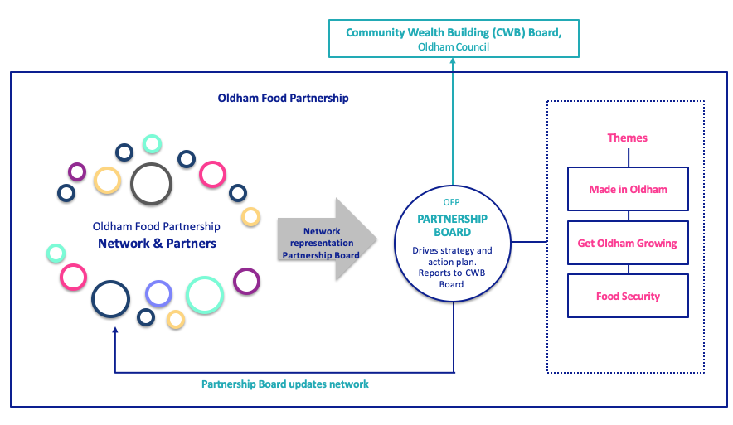

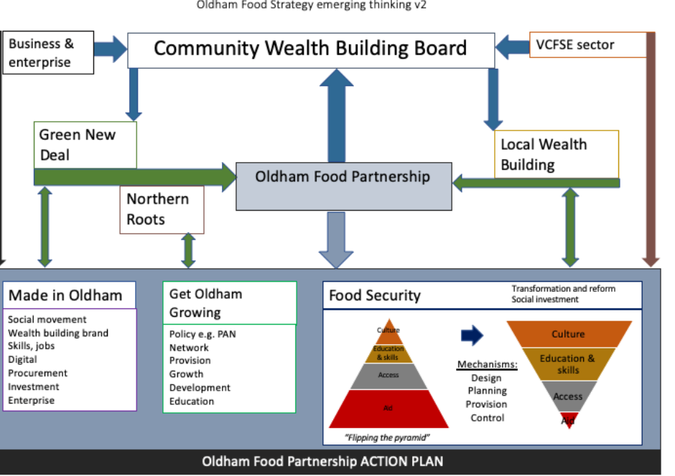

**9. Review**

These terms of reference will be reviewed annually.

**Appendix**

Suggested Oldham Food Partnership Board membership and sub groups:

|  |  |  |  |
| --- | --- | --- | --- |
| **Role / area** | **Name** | **Job Title** | **Organisation** |
| Chair | Katrina Stephens | DPH | Oldham Council |
| Deputy Chair | TBC |  |  |
| Food Programme Manager | Mike Bridges | Public Health Specialist | Oldham Council |
| Food Partnership Coordinator | Shajna Begum | Oldham Food Partnership Coordinator | Oldham Council |
| Community Wealth Building | Andy Hunt | Programme Manager Community Wealth Building | Oldham Council |
| Northern Roots | Anna Da Silva | Programme Director | Northern Roots |
| Funding | Dave Catherall | Principal Officer | Oldham Council |
| Economic Development | Suzanne Barrett | Regeneration Officer | Oldham Council |
| Housing and neighbourhoods | Kelly Webb | Operations Director | FCHO |
| Institutional Food Catering | Anne Burns | Education Catering Manager | Oldham Council |
| Community food knowledge and skills | Anna Kennedy | Director | WIFI NW |
| **Food Security** | Laura Windsor Welsh  Nayan Joshi | Strategic Locality Lead  Senior Partnerships Officer | Action Together |
| **Get Oldham Growing** | Anne Flemming | GOG Programme Manager | Oldham Council |
| **Made in Oldham** | TBC |  |  |
|  |  |  |  |
|  |  |  |  |

Sub groups:

Get Oldham Growing,

* Will Wills Environmental Manager, Oldham Council
* Caroline Lawson, Veg in the Park
* Alan Price, Lees Eco Hub
* Subnum Hariff-Khan, Library and Information Manager, Oldham Council

Made In Oldham, Chaired by:

* Education and skills e.g. Jon Bloor, Head of Lifelong Learning Employment and Skills
* Business owner e.g. Mumtaz Khan, Kesan Foods, Dan Arundel, Arundel bakery
* Economic development officer e.g Suzanne Barrett or Sara Hewitt
* Digital e.g. Paul Sweeting, Live and Now.
* Procurement lead e.g. Steve Boyd
* Northern Roots e.g. Clare Taylor BD lead, Northern Roots

Food Security Steering Group, Chaired by Mike Bridges, facilitated by Shajna Begum

* Rachel Dyson, Oldham Council
* Andy Hunt, Oldham Council
* Cllr Cath Ball, Oldham Council
* Simon Shuttleworth, Oldham Council
* Lorraine Black, FCHO
* Laura Winsdor Welsh, Action Together
* Mark Game, The Bread and Butter Thing