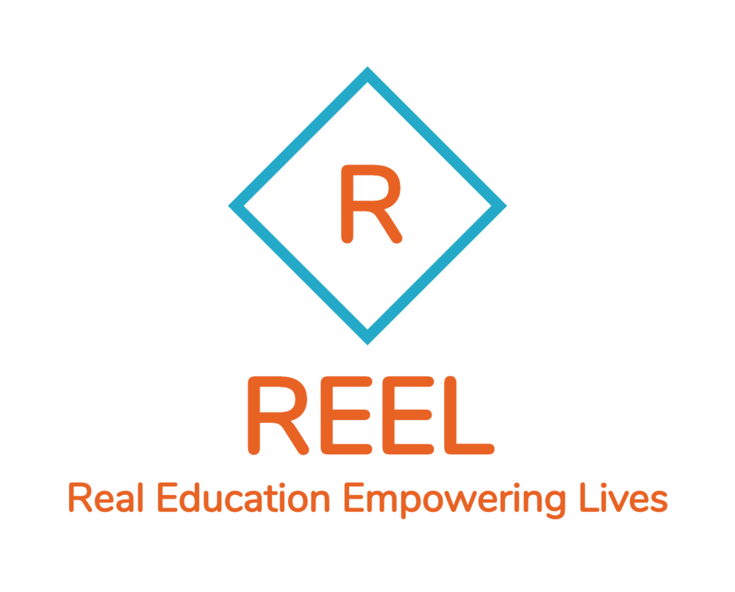
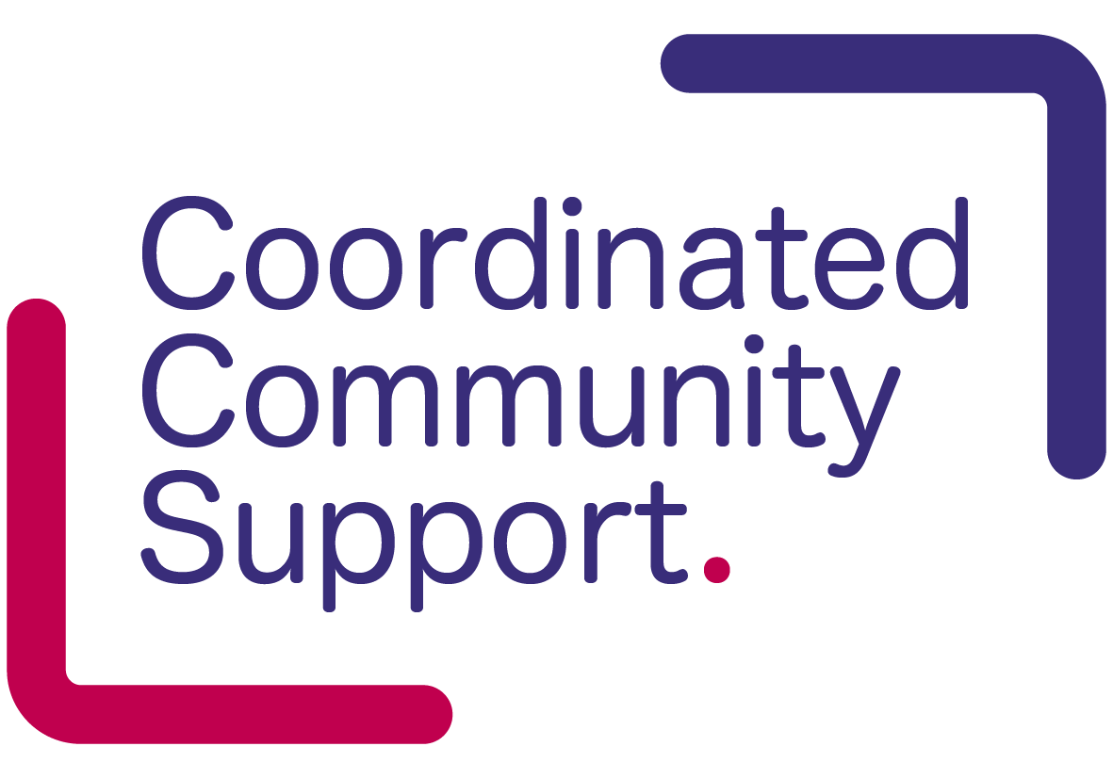

Referral Form for Emergency Clothing Support Oldham

Complete all of the information requested below and email the form to rack@reelcic.co.uk

REEL CIC works with local partner agencies to get essential clothing to those who need it the most. We donate to people in urgent crisis need. We want to help build self-esteem by providing essential clothing to both adults and children to feel safe and like their peers, and to help them reach their full potential. We rely on donations and money from supporters of this cause. Clothing is distributed by referral agents only.

Referral Criteria: To be considered for Emergency clothing crisis support the applicants must be:
- In financial hardship.
- Receiving on-going, regular support from a professional organisation.
- Resident in the UK with the intention to remain in the country long term.
- Must have ensured that every effort has been made to check that a statutory, education or governmental body cannot fund the activity or item being requested.
We are unable to support:
- Adults or Children who are Looked After by the Local Authority
- Where there is any other clear statutory responsibility for meeting their needs

Referral Checks:
Has an application for this person / family been made to the Oldham Local Welfare Provision (OLWP)? Yes / No (delete as appropriate)
If No, Why not?

If Yes, what is the status of the application to OLWP? Write “Yes” next to the appropriate statement
Submitted and waiting for a reply
Application has been approved
Application has been turned down
Application cannot be made because of no resource to public funds
Application accepted and support given
IMPORTANT - Adults may be referred every 4-6 months and Children may be referred every 3 months.
Registration to become a Referral Agent
Referral Organisation:
Referrer’s name:
Telephone Number:
Reason for making an application to REEL CIC ‘The Clothing Rack’ for emergency clothing crisis support: Please tell us why this person / family requires emergency clothing support:

Client Details: (Must be 18 years - Adult, Parent or Guardian)
Family Name:
Family Address:
Postcode:
Family contact number:
(This number will be used to discuss clothing preferences to give dignity and choice)

Clothing Request: Please see attached information sheet for examples of what is usually included in an emergency clothing bundles for adults and children. If you require specific items please details below. We do our best to meet the needs however depends on stock.

Household Composition and Important clothing information
 | Name | Gender | Age | Ethnic Origin | Clothing sizes, likes and any important detail e.g. allergy or risks

Person one

Person two

Person three

Person four

Person five

Person six

Clothing Collection:
Referral agency collection is required.
We will respond via email within 24 hours of receiving your referral to arrange collection within 5-7 working days.

Are the family/individual given consent to discuss clothing choices with us direct? YES / NO

Employment status of adults (please highlight)
Sick/disabled Training part time Working part time
Student full time Unemployed Working full time – self employed
Student part time Working full time Working part time – self employed
Training full time
Benefits (tick all that apply)
Income support. Pension credits Employment & support allowance
Attendance allowance Carer’s allowance Widowed parent’s allowance
Maternity allowance Disability living allowance Incapacity benefit
Tax credits. Job seekers’ allowance Other (please specify)

Please email this completed form to rack@reelcic.co.uk

