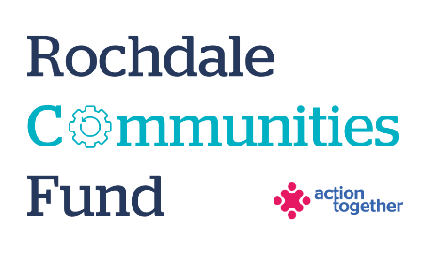
Rochdale Communities Fund –
Micro Grants
Application Form (up to £1,000)
Section One: Your Organisation
Name of Organisation:
Address of Organisation:

Contact Details: | Main Contact | Second Contact
Name:
Position in group:
Telephone Number:
Mobile Number:
Email address:
Address (including postcode):

 | Yes | No
Are you based or working in the Rochdale Borough with beneficiaries from the area? | ☐ | ☐
Please tick the area (s) that will benefit from this project: | ☐ | ☐
Rochdale North (Central Rochdale, Healey, Norden) | ☐ | ☐
Rochdale South (Balderstone & Kirkholt, Bamford, Castleton, Kingsway and Milkstone & Deeplish) | ☐ | ☐
Heywood | ☐ | ☐
Middleton | ☐ | ☐
Pennines (Smallbridge and Firgrove, Milnrow and Newhey, Littleborough Lakeside and Wardle and West Littleborough) | ☐ | ☐
Are you a member of Action Together? (if not, you will need to become a member to access this grant. We can help you with this.) | ☐ | ☐
Do you have a governing document? | ☐ | ☐
Do you have a bank account in the organisation’s name with at least two unrelated signatories? | ☐ | ☐
Are you a non-profit organisation where all surplus is re-invested back into the community? | ☐ | ☐
Does your organisation have an annual turnover of less than £25,000? | ☐ | ☐
Have you received funding above £1,000 from the Rochdale Communities Fund previously? (If so, unfortunately you won’t be eligible to apply for this Micro Grant) | ☐ | ☐

Section Two: Your project
Please tick which one of the following priorities your project addresses
Challenging poverty and driving equality:
- Support people and communities to get back on their feet and take more control over their lives – i.e. practical support, advice or peer support | ☐
- Reduce inequalities and help more people reach their potential | ☐
- Strengthen community voice and action on the things that matter most to them | ☐
Promoting health and wellbeing:
- Enabling people and communities to support their social, mental and physical wellbeing | ☐
- Challenging health inequalities through working with marginalised groups whose needs are not being met by existing services | ☐
- Build strong relationships in and across communities | ☐

What is the name of your project?
What is your idea / what will you do with the grant? Please include how you will deliver the project e.g. is it part of an ongoing project, is it a new project, how many weeks will the project run for
Maximum of 500 words.
Please explain who will benefit from the project?
How many people will directly benefit from the project?

Please provide a breakdown of how you will spend the grant
Item | Breakdown (how have you worked out your costings?) | Amount Requested
Total amount requested? |  | £

Section Three: Supporting Documents
Please provide a copy of your governing document.
All successful applicants will be required to supply a copy of the following information as part of the grant agreement, prior to any funding being released.

Required supporting information
☐ Details of a bank account in organisation’s name with at least two unrelated signatories (we will require a copy of a bank statement)
☐ Insurance details (if applicable) (public liability and employers’ liability)
☐ Safeguarding policy (if applicable)

Section Four: Grant Declaration
- I certify that the information contained in this application is correct. I understand that if in any way the information is not correct, the application may be disqualified, or any grant awarded may be repayable on request.
- If the information changes in any way I will inform Action Together as soon as possible.

Main contact for this project:
Role within organisation:
Enter name to confirm agreement (instead of a signature)
Date:

Other Senior contact for the organisation
Role within organisation:
Enter name to confirm agreement (instead of a signature)
Date:

