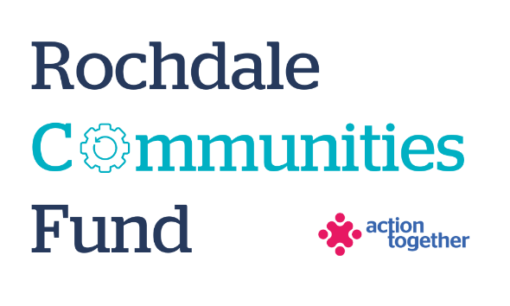
Rochdale Communities Fund – Micro Grants
Application Form (up to £500)
Section One: Your Organisation
Name of Organisation:
Address of Organisation:

Contact Details: | Main Contact | Second Contact
Name:
Position in group:
Telephone Number:
Mobile Number:
Email address:
Address (including postcode):

 | Yes | No
Are you based or working in the Rochdale Borough with beneficiaries from the area?
Please tick the area (s) that will benefit
Rochdale
Heywood
Middleton
Littleborough
Boroughwide
Are you a member of Action Together? (if not, you will need to become a member to access this grant. We can help you with this.)
Do you have a set of rules about how you will work together? (It’s ok if you’re a newly formed group and don’t have this.)
Do you have a bank account in the organisation’s name with at least two unrelated signatories?
Are you a non-profit organisation where all surplus is re-invested back into the community?
Does your organisation have a annual turnover of less than £100,000?

Section Two: Your project
Please tick which one of the following priorities your project addresses
Challenging poverty and driving equality:
- Support people and communities to get back on their feet and take more control over their lives – i.e. practical support, advice or peer support | ☐
- Reduce inequalities and help more people reach their potential | ☐
- Strengthen community voice and action on the things that matter most to them | ☐
Promoting health and wellbeing:
- Enabling people and communities to support their social, mental and physical wellbeing | ☐
- Challenging health inequalities through working with marginalised groups whose needs are not being met by existing services | ☐
- Build strong relationships in and across communities | ☐

What is the name of your project?
What is your idea / what will you do with the grant?
Please also tell us who you will be helping and what will you spend the money on? Maximum of 500 words.
How many people will directly benefit from the project?

Please provide a breakdown of how you will spend the grant
Item | Breakdown (how have you worked out your costings?) | Amount Requested
Total amount requested? |  | £

Section Three: Supporting Documents
Please provide a copy of any of the following documents that you have.
Dependant on the nature of your set up or activities we may need to help you to get these in place if you don’t already have them.

Required supporting information
☐ Details of a bank account in organisation’s name with at least two unrelated signatories (we will require a copy of a bank statement)
☐ Insurance details (if applicable) (public liability and employers’ liability)
☐ Safeguarding policy (if applicable)

Section Four: Grant Declaration
- I certify that the information contained in this application is correct. I understand that if in any way the information is not correct, the application may be disqualified, or any grant awarded may be repayable on request.
- If the information changes in any way I will inform Action Together as soon as possible.

Main contact for this project:
Role within organisation:
Enter name to confirm agreement (instead of a signature)
Date:

Other Senior contact for the organisation
Role within organisation:
Enter name to confirm agreement (instead of a signature)
Date:

