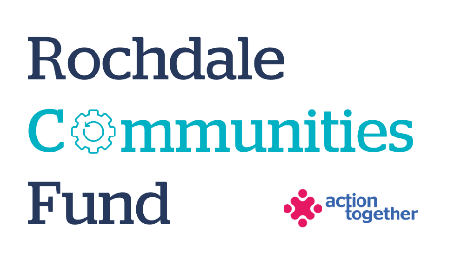
Rochdale Communities Fund –
The Big Pan Community Cooking Programme
Application Form (up to £1,000)
Section One: Your Organisation
Name of Organisation:
Address of Organisation:

Contact Details: | Main Contact | Second Contact
Name:
Position in group:
Telephone Number:
Mobile Number:
Email address:
Address (including postcode):

 | Yes | No
Are you based or working in the Rochdale Borough with beneficiaries from the area?
Please tick the area (s) that will benefit:
Rochdale
Heywood
Middleton
Littleborough
Boroughwide
Are you a member of Action Together? (if not, you will need to become a member to access this grant. We can help you with this.)
Do you have a governing document?
Do you have a bank account in the organisation’s name with at least two unrelated signatories?
Are you a non-profit organisation where all surplus is re-invested back into the community?
Are you currently members of the Food Solutions Network?

Section Two: Your project
Please tick below to confirm that your project meets the criteria of this funding:
- We have access to a venue which meets the needs of the programme and is accessible to the local residents | ☐
- We will deliver at least two 6 week BigPan programmes in our community venue | ☐
- We will provide a hot, nutritious, low cost meal to families | ☐
- We will complete a BigPan cooking champion training session | ☐
- We will use food pantries/clubs to enhance the use of food provided | ☐
- We will give families a safe, warm space for the duration of the sessions | ☐
- We will provide a social environment for people to eat a meal together | ☐
- We will reduce health inequalities through teaching independence through cooking skills | ☐

What is the name of your project?
What community venue will your Big Pan programme take place in?
What is your idea / what will you do with the grant? Please include how you will deliver the project e.g. is it part of an ongoing project, is it a new project, how many weeks will the project run for
Maximum of 500 words.
Please explain who will benefit from the project?
Please can you share what experience you have in delivering food projects in the Rochdale Borough?
How many people will directly benefit from the project?

Please provide a breakdown of how you will spend the grant
Item | Breakdown (how have you worked out your costings?) | Amount Requested
Total amount requested? |  | £

Section Three: Supporting Documents
Please provide a copy of your governing document.
All successful applicants will be required to supply a copy of the following information as part of the grant agreement, prior to any funding being released.

Required supporting information
☐ Details of a bank account in organisation’s name with at least two unrelated signatories (we will require a copy of a bank statement)
☐ Insurance details (if applicable) (public liability and employers’ liability)
☐ Safeguarding policy (if applicable)
☐ Level 2 (minimum) - Food Hygiene Certificate

Section Four: Grant Declaration
- I certify that the information contained in this application is correct. I understand that if in any way the information is not correct, the application may be disqualified, or any grant awarded may be repayable on request.
- If the information changes in any way I will inform Action Together as soon as possible.

Main contact for this project:
Role within organisation:
Enter name to confirm agreement (instead of a signature)
Date:

Other Senior contact for the organisation
Role within organisation:
Enter name to confirm agreement (instead of a signature)
Date:

