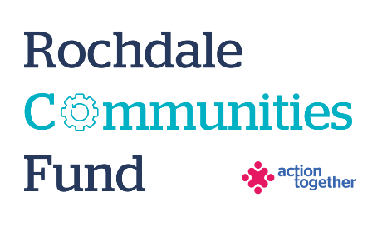
Rochdale Communities Fund – Refugee and Asylum Seeker Resettlement Support Fund
Application Form (up to £5,000)
Section One: Your Organisation
Name of Organisation:
Address of Organisation:

Contact Details: | Main Contact | Second Contact
Name:
Position in group:
Telephone Number:
Mobile Number:
Email address:
Address (including postcode):

 | Yes | No
Are you based or working in the Rochdale Borough with beneficiaries from the area? | ☐ | ☐
Please tick the area (s) that will benefit: | ☐ | ☐
Rochdale North (Central Rochdale, Healey, Norden) | ☐ | ☐
Rochdale South (Balderstone & Kirkholt, Bamford, Castleton, Kingsway and Milkstone & Deeplish) | ☐ | ☐
Heywood | ☐ | ☐
Middleton | ☐ | ☐
Littleborough | ☐ | ☐
Boroughwide | ☐ | ☐
Are you a member of Action Together? (if not, you will need to become a member to access this grant. We can help you with this.) | ☐ | ☐
Do you have a governing document? | ☐ | ☐
Do you have a bank account in the organisation’s name with at least two unrelated signatories? | ☐ | ☐
Are you a non-profit organisation where all surplus is re-invested back into the community? | ☐ | ☐
Does your organisation have an annual turnover of less than £1,000,000? | ☐ | ☐
Are you currently a member of the Rochdale Refugee and Asylum Seeker Multi Agency Forum | ☐ | ☐

Section Two: Your project
Please tick which one of the following priorities your project addresses
Promote Inclusivity and Belonging:  Projects that create a sense of belonging. These should encourage inclusivity, promote cross cultural friendships and relationships, and help people feel valued and connected within their local community. | ☐
Integration within communities:  To actively support the integration of new arrivals into the local community. This may include everyday life ESOL classes, cultural celebration events, support for children in school and their families. | ☐
Mental Health and Wellbeing:  Projects that focus on mental health and wellbeing support are encouraged. This may include creating and sustaining safe spaces, supporting people to thrive, signposting to appropriate support. | ☐
Cultural Exchange and Awareness:  Projects that promote cultural exchange including events to enhance cultural pride and embrace diversity, projects that support integration and improve tolerance | ☐

What is the name of your project?
What is your idea - We would like to know how your project will help local refugee’s and people seeking asylum and how it fits in with the priorities that you have ticked
Please tell us how you know this offer is needed?

What will you do with the grant? Please tell us how you will deliver the project (for example, where, when, what methods would you use, who will be involved).
If this is a collaborative project, please tell us why you want to work in partnership (please give detail of the roles played by each organisation)
Please explain who will benefit from the project?
How many people will directly benefit from the project?
When will your project take place? Please include an approximate start and end date

Please provide a breakdown of how you will spend the grant
Item | Breakdown (how have you worked out your costings?) | Amount Requested
Total amount requested? |  | £

Section Three: Supporting Documents
Please provide a copy of your governing document.
All successful applicants will be required to supply a copy of the following information as part of the grant agreement, prior to any funding being released.

Required supporting information
☐ Details of a bank account in organisation’s name with at least two unrelated signatories (we will require a copy of a bank statement)
☐ Insurance details (if applicable) (public liability and employers’ liability)
☐ Safeguarding policy (if applicable)

Section Four: Grant Declaration
- I certify that the information contained in this application is correct. I understand that if in any way the information is not correct, the application may be disqualified, or any grant awarded may be repayable on request.
- If the information changes in any way I will inform Action Together as soon as possible.

Main contact for this project:
Role within organisation:
Enter name to confirm agreement (instead of a signature)
Date:

Other Senior contact for the organisation
Role within organisation:
Enter name to confirm agreement (instead of a signature)
Date:

