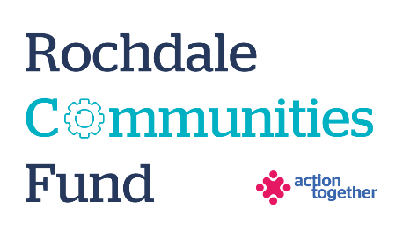
Rochdale Communities Fund –
Food Solution Grants
Application Form (up to £5,000)
Section One: Your Organisation
Name of Organisation:
Address of Organisation:

Contact Details: | Main Contact | Second Contact
Name:
Position in group:
Telephone Number:
Mobile Number:
Email address:
Address (including postcode):

 | Yes | No
Are you based or working in the Rochdale Borough with beneficiaries from the area?
Please tick the area (s) that will benefit:
Rochdale
Heywood
Middleton
Littleborough
Boroughwide
Are you a member of Action Together? (if not, you will need to become a member to access this grant. We can help you with this.)
Do you have a governing document?
Do you have a bank account in the organisation’s name with at least two unrelated signatories?
Are you a non-profit organisation where all surplus is re-invested back into the community?
Does your organisation have an annual turnover of less than £1,000,000?

Section Two: Your project
Please tick which one of the following priorities your project addresses
- Emergency FREE Food: Groups providing short-term, emergency support (for example food banks, community fridges, waste food projects or soup kitchens) which aim to relieve immediate pressure, but also offer additional support so that people don’t need to use the food bank again in the future. | ☐
- Food Pantries or other membership food clubs (i.e. social supermarkets, community shops, local food hubs): Established food pantries who are softening the blow of high living costs and creating conditions for communities to grow and thrive, by bringing people together around food. | ☐
- Social Eating Projects: food projects that bring communities together and combine food with addressing root causes of food poverty (e.g. providing benefits help or debt advice) | ☐
- Food Growing Projects: initiatives to help residents and community groups to learn how to grow food | ☐
- Educational Food Projects: funding to enable community groups to find the time and space for learning and broader development around food I.e. Learn to Cook Programmes or Cooking on a Budget. | ☐
- Cultural Food Offers – projects that represent the traditions, beliefs, and practices of a geographic region, ethnic group, religious body, or cross-cultural community. | ☐

What is the name of your project?
What is your idea - We would like to know how your project will help local people and how it fits in with the aims of the fund and the priorities that you have ticked Maximum of 500 words.
How have you developed your project idea? Please tell us how you know this offer is needed in your community and how it will fit with other local food offers
What will you do with the grant? Please tell us how you will deliver the project (for example, where, when, what methods would you use, who will be involved).
Please can you explain what food support you already provide in Rochdale Borough?
How do you collaborate with other organisations in the Rochdale Borough who deliver food support? Are you part of the Food Solutions Network?
Please refer to the guidance notes before completing this question:
Where does your project sit on the Reducing Disparities ladder? How will it support people to move out of food poverty?
How will you share the progress and difference your project is making during and at the end of the project?
Please explain who will benefit from the project?
How many people will directly benefit from the project?
When will your project take place? Please include an approximate start and end date

Please provide a breakdown of how you will spend the grant
Item | Breakdown (how have you worked out your costings?) | Amount Requested
Total amount requested? |  | £

Section Three: Supporting Documents
Please provide a copy of your governing document.
All successful applicants will be required to supply a copy of the following information as part of the grant agreement, prior to any funding being released.

Required supporting information
☐ Details of a bank account in organisation’s name with at least two unrelated signatories (we will require a copy of a bank statement)
☐ Insurance details (if applicable) (public liability and employers’ liability)
☐ Safeguarding policy (if applicable)
☐Level 2 (minimum) - Food Hygiene Certificate

Section Four: Grant Declaration
- I certify that the information contained in this application is correct. I understand that if in any way the information is not correct, the application may be disqualified, or any grant awarded may be repayable on request.
- If the information changes in any way I will inform Action Together as soon as possible.

Main contact for this project:
Role within organisation:
Enter name to confirm agreement (instead of a signature)
Date:

Other Senior contact for the organisation
Role within organisation:
Enter name to confirm agreement (instead of a signature)
Date:

