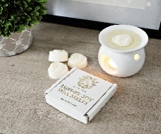

CALLING ALL OVER 50’s!
Come and join us at the Primrose Centre
Thursday 9th December, 1 - 3pm
CHRISTMAS CRAFTS & AFTERNOON TEA

Wednesday 22nd December, 2.30 – 3.30pm
MAKING WAX MELTS

Wednesday 12th January, 12.30pm
LUNCH CLUB WITH GUEST SPEAKER

Thursday 13th, 20th, 27th January,
3rd & 10 February, 1.30 – 3.30pm
PAPER CRAFTS WITH LIFELONG LEARNING
(Participants must attend all 5 sessions)

Please ring or text Jan on 07736 693120 or email jan.wade@greatplaces.org.uk to book a place
on any of the above sessions

FACE MASKS MUST BE WORN WHEN MOVING AROUND THE CENTRE

