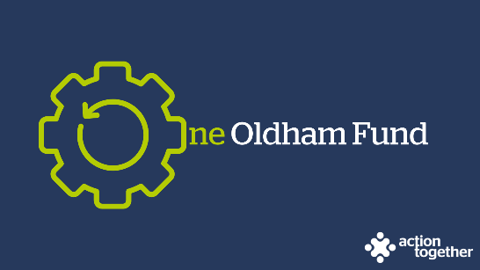

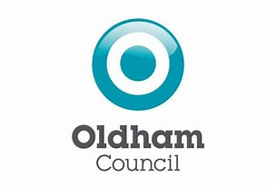
One Oldham Fund Medium Grants Programme for Community Centres (up to £25,000) - Application

Section One: Your Organisation
Name of Organisation:
Companies House/Charity Reg. number: | Company House/Charity Registration number if applicable
Correspondence Address:

Website / social media details:
Contact Details: | Main Contact | Second Contact
Name:
Position in group:
Telephone Number:
Mobile Number:
Email address:

Are you a Community Centre based in Oldham? | Yes / no
Are you a not for profit organisation? | Yes / no
Do you have a business plan? (If yes, please provide a copy) | Yes / no
Are you community led and run? (Please describe below how members of the community are involved in leading and running your Community Centre or refer us to the relevant section in your business plan) | Yes / no
Are you based at and occupying a community building that is rooted in a sense of place? (Please provide more details below or refer us to the relevant section in your business plan e.g. where are you based and which community or communities do you work with) | Yes / no
Does your organisation have multiple functions including regular sessions that are open to members of the community without charge and without the need to book in advance? Please provide more details below or refer us to the relevant section in your business plan) | Yes / no
Does your organisation have unparalleled local knowledge and well established networks and connections into the community you are physically based in? Please provide some examples below or refer us to the relevant section in your business plan | Yes / no
Is your mission to improve the whole community and not just a part? Please let us know what your mission statement is below or refer us to the relevant section in your business plan | Yes / no
Are you a member of Action Together? (if not, you will need to become a member to access this grant. We can help you with this.) | Yes / no
Do you have a bank account in the organisation’s name with at least two unrelated signatories? | Yes / no
Does your organisation with adults or children at risk? | Yes / no
Have you completed a Quality in Action Award? | Yes / no
If you have completed a Quality in Action Award please can you confirm when this was completed?
Have you completed an Action Together Health Check with your development worker? | Yes / no

Section Two: Your project
Have you had any conversations with Oldham Council about your Community Centre’s potential role as a key place based site to support effective partnership working and delivery of front facing services for residents closer to home as part of Oldham Council’s Place Base Integration programme? Please can you confirm who you have been speaking to and the stage that you have reached with the discussions?
Which of the following priorities does your project mainly fit in with? (you can tick up to two)
Diverse opportunities to get together, with regular activities to boost physical and mental health and community spirit.
Supporting our residents to gain the knowledge and skills to confidently make choices and participate in decisions about their own health.
Giving children the best start in life.
A clean green and healthy environment.
A local area that meets people’s needs and makes them proud.

What is the name of your project?
What is your idea ?
- We would like to know how your project will support your community by reducing health inequalities and promoting preventative activity
- how does your idea fit with the priorities that you have ticked?
You may also send us a short video or some pictures to support your application. If you wish to send a video please contact funding@actiontogether.org.uk as it is not possible to send this by e mail.
What will you do with the grant?
- Please tell us how you will deliver the project (for example, where, when, what methods would you use, who will be involved).
- Please also tell us how you have involved your community in designing the project?
How many people will directly benefit from the project?
Which of the following communities will mainly benefit from your project? (you can tick as many as apply)
People with disabilities
Older people
Children and young people
LGBT+
Communities experiencing racial inequalities
Families
Single gender (e.g. men’s or women’s groups) – please specify
Faith
When will your project take place? Please include an approximate start and end date
What changes or difference will your project make to your community centre and to the people taking part in any funded activities?
- What will you do to find this out?

Please provide a breakdown of how you will spend the grant
Item description | Breakdown (how have you worked out your costings, for example no. of hours x hourly rate?) Where available , please provide copies of quotes or links to the item online for larger items of expenditure | Amount Requested
Total amount of grant requested? |  | £
Total cost of project |  | £
If relevant where is the rest of the money coming from?

Section Three: Supporting Documents
If you have not recently received funding from Action Together, please provide a copy of the following documents that you have. If they are not easily available, they can be sent after your application. Dependant on the nature of your set up or activities we may need to help you to get these in place if you don’t already have them. We will need to see copies of documents marked * before funding can be released.

If you have recently received funding from us, we will look at the supporting documents that you have previously provided and will only ask for further information where necessary. Please provide copies of any documents with your application that you have not provided previously.

Required supporting information
☐ A copy of your governing document*
☐ Details of a bank account in organisation’s name with at least two unrelated signatories (we will require a copy of a bank statement)*
☐ Insurance details (public liability and employers’ liability)*
☐ Safeguarding policy *
☐ If your project involves building work please provide copy quotes, evidence of your right to occupy the building and, if necessary, a copy of the building owners’ permission to carry out the work and planning permission.
☐ Your business plan or other planning documents such a funding strategy that you may have available

Section Four: Grant Declaration
- I certify that the information contained in this application is correct and I am authorised to sign this application. I understand that if in any way the information is not correct, the application may be disqualified, or any grant awarded may be repayable on request.
- If the information changes in any way I will inform Action Together as soon as possible.

Main contact for this project:
Role within organisation:
Enter name to confirm agreement (instead of a signature)
Date:

Other senior contact for the organisation
Role within organisation:
Enter name to confirm agreement (instead of a signature)
Date:

Please send this application and any supporting documents to funding@actiontogether.org.uk

