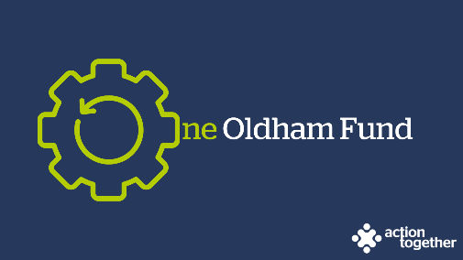
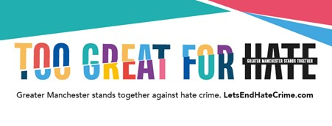

One Oldham Fund Programme - Let’s End Hate Crime Grants 23 - 24

Guidance Notes

Building Confident and Cohesive Communities

“NO ONE SHOULD FACE VIOLENCE, ABUSE OR HATRED JUST BECAUSE OF WHO THEY ARE, WHO THEY LOVE, WHERE THEY’RE FROM, WHAT THEY LOOK LIKE OR WHAT THEY BELIEVE.”

Hate crime is defined as ‘any criminal offences perceived, by the victim or any other person, to be motivated by hostility, prejudice, towards someone based on a personal characteristic’. In Greater Manchester hate crime is monitored across six strands: race, religion, sexual orientation, trans identity, disability and alternative subcultures.

Hate crime is significantly under-reported. Even in difficult times, continued efforts by local groups and organisations are needed to raise awareness of and challenge hate crime in our communities and to help instil confidence in victims by highlighting how and where hate crime incidents can be reported.

Through Action Together on behalf of Oldham Council, Greater Manchester Combined Authority (GMCA) makes funding available annually to support projects across the Oldham Borough that promote awareness of hate crime and how to report it.

What can the funding be used for?
- Hate crime awareness raising activities or events in Oldham during the Greater Manchester Hate Crime Awareness Week taking place Monday 5th to Sunday 11th February 2024 that can help become the catalyst for further conversations.

- Applications will be considered for events and activities held later than this where reasonable justification is provided as long as they are launched during Greater Manchester Hate Crime Awareness week 2024 and will be delivered by no later than 31 March 2024.

- Organisations should also be:

  - Helping to change/challenge the behaviours, narratives and perceptions of hate crime; and

  - Highlighting the support of third-party reporting centres and encouraging more victims to report hate crimes to either the Police or third-party reporting centres across the Borough.

- Examples of some projects that could be supported include:
  - indoor hate crime awareness events in specific geographical, cultural and ethnic communities including guest speakers, workshops and refreshments.
  - in-person and digital Pride celebration events incorporating hate crime awareness raising activities
  - outdoor family fun day, youth and play sessions and hate crime awareness information-sharing event in a local community’s park.
  - sporting events involving people affected by or at risk of hate crime including awareness raising activities.
  - craft workshops in aid of developing a hate crime awareness raising campaign.
  - workshops co-created with and for people with learning disabilities based around the hate crime awareness and public transport.
  - community “icebreaker” and cultural learning event in the wake of a series of hate crimes in a specific area of Oldham
This list is not exhaustive, however. If you have an innovative idea for a project and would like to discuss it further before submitting an application, please contact Virbai Kara at virbai.kara@oldham.gov.uk

- The funds can be used to cover the costs of speakers, arts/crafts, running workshops, developing a play or a film, or any other reasonable costs for holding an eligible activity or event as part of Greater Manchester’s Hate Crime Awareness Week 2024. Applications can include expenses for volunteer time and food and refreshments provided that they do not exceed 15% of the total amount applied for.

- Groups can apply for a grant of up to £1,000 to assist with the type of event or activity referred to above.

- The deadline for applications is 5pm on Monday 8 January 2024

Who is the funding for?

You can apply for a grant if:
- you are a voluntary, community, faith and social enterprise (VCFSE) group locally rooted or actively working in the borough of Oldham; and
- a member of Action Together (you can register for free to become a member here) and
- you are formally constituted
You may not apply for this grant if you applied and were successful in the last round in 2022/2023
Please Note:
- We welcome applications from groups that are new to the programme. Where appropriate, we encourage partnership or joint applications for this funding particularly where the partners are working in different areas of Oldham.
- Priority will be given to innovative projects which make use of activities to engage participants which show an awareness of more than one strand of hate crime and projects which can show a tangible product at the end that can then be re-used e.g. hate crime awareness resources such as posters, film clips, music, artwork, presentation materials and research documents and findings etc.
- Only one application for funding will be accepted per organisation.
- To receive this funding, any outstanding monitoring information required by us, relating to other grant funding must have been completed.
- You may also go on to apply for other grants within the One Oldham Fund Programme if you are eligible.
If you are successful
Successful applicants must be able to attend an in person Hate and How to Effectively Challenge Session on Tuesday 23rd January 2024 9.30am to 11.30am if they have not already attended a prior session.
A selection of “Let’s End Hate Crime” branded materials will be provided for you to use during your event or activity.
We understand that planning a project in such challenging times is difficult and that your plans may need to change to respond to factors outside your control. If you feel at any point that you are unable to deliver your project as originally planned, then please contact us so that we can discuss any changes that you may wish to make.
To help us understand the impact of this funding, successful applicants will:
- be asked to provide a short report to us about your project when it has ended and tell the story of your project by providing copies of social media posts, photos etc. We will provide a copy of sample questions at the start of your project so that you know what information the funder will be looking for.
- be offered further support from one of our community development workers throughout and beyond this project.

Completing the application form
- Please ensure that ALL parts of the application form are completed.
- We have not included word count limits in the application form as we want you to be able to tell us about your ideas without having to worry about the number of words you are using – as a general guide however we are only looking for brief summary and 1 or 2 paragraphs for each answer should be enough for you to be able to tell us about your plans.
- If you have any queries about the application process or would like some support to complete the application form or become a member of Action Together, please contact a member of our team at development@actiontogether.org.uk or call 0161 339 2345 and ask to speak to a member of the Oldham Development Team.
- Eligible applications will be considered by a panel on 17 January 2024. We aim to notify you of the outcome of their decision by email within 3 working days.

Please e mail your application to funding@actiontogether.org.uk by no later than 5pm on Monday 8 January 2024

