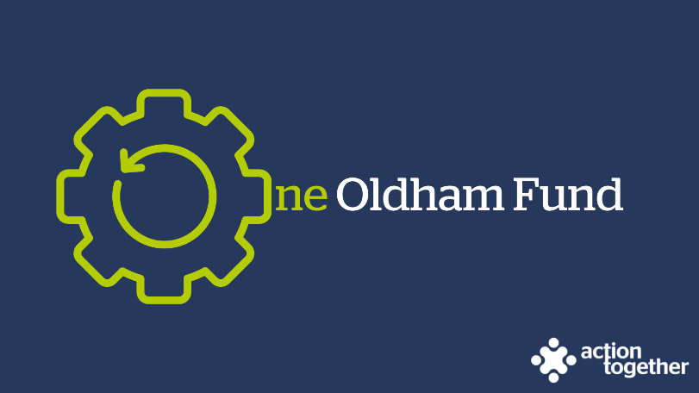

One Oldham Fund Active Travel Grants Programme
(Up to £1000) – Guidance Notes

The One Oldham Fund is a strategic single investment fund that uses pooled resources for the voluntary, community, faith and social enterprise (VCFSE) sector in Oldham.

This investment, which forms part of a larger investment made by the Department for Transport to Transport for Greater Manchester (on behalf of GMCA) will support the sector’s resilience to enable VCFSE organisations that are locally rooted and active in Oldham to support the Active Travel Programme in Oldham.

What do we mean by Active Travel?

Applications should be for projects that aim to support people to choose to travel across their local area either by walking or cycling, creating a culture shift of moving more as part of everyday journeys by increasing confidence, improving infrastructure and working with the people of Oldham to improve the health and wellbeing of our residents.

What can the funding be used for?

Projects should support one or more of the following priorities:
- Enhancing and developing active travel programmes and activities
- Increasing knowledge, skills, awareness and confidence about active travel and walking and cycling infrastructure
- Influencing behaviour change within communities so residents participate in active travel,
and should benefit residents of the Central District of Oldham.
Key Dates
- Deadline for applications - Grants will be awarded on a rolling programme. We will stop accepting applications when all of the funding available has been allocated or at 12 noon on Monday 15 July 2024, whichever occurs sooner.
- Project length – Projects must be completed by no later than 30 September 2024.

Who is the funding for?
You can apply for a grant for:
- Up to £1,000 if you are:
  - a voluntary, community, faith and social enterprise (VCFSE) group locally rooted or actively working in the Central District of Oldham; and
  - a member of Action Together (you can register for free to become a member here) and
  - you are formally constituted
- Up to £200 if you do not have a constitution but you are involved in informal social action or mutual aid activity in the Central District of Oldham.
  - Mutual Aid is the term we use to describe people giving each other needed support in communities.
  - Social Action is the term we use to describe people coming together (physically or remotely) to help solve the problems that are important in their communities.
Please Note:
- To receive this funding, any outstanding monitoring information required by us, relating to other grant funding must have been completed.
- You may apply to this round of One Oldham Fund Active Travel Grant (up to £1000) once only.
- You may also go on to apply for other grants within the One Oldham Fund Programme if you are eligible.
If you are successful
We understand that planning a project in such challenging times is difficult and that your plans may need to change to respond to factors outside your control. If you feel at any point that you are unable to deliver your project as originally planned, then please contact us so that we can discuss any changes that you may wish to make.
To help us understand the impact of this funding, successful applicants will:
- be asked to provide a short report to us about your project when it has ended and tell the story of your project by providing copies of social media posts, photos etc. We will provide a copy of sample questions at the start of your project so that you know what information we will be looking for.
- be offered further support from one of our community development workers throughout and beyond this project; and
- be offered the opportunity to participate in networks of groups and organisations to be able to share expertise and experience
- connect with Oldham’s Social Prescribing Team, and where appropriate accept referrals from them, so that funded projects can be linked to local infrastructure Oldham, It's Your Move | TfGM Bee Active

Completing the application form
- Please ensure that ALL parts of the application form are completed.
- We have not included word count limits in the application form as we want you to be able to tell us about your ideas without having to worry about the number of words you are using – as a general guide however we are only looking for brief summary and 1 or 2 paragraphs for each answer should be enough for you to be able to tell us about your plans.
- If you have any queries about the application process or would like some support to complete the application form or become a member of Action Together, please contact Stacey Wallwork by e mailing stacey.wallwork@actiontogether.org.uk or call 0161 339 2345.
- Eligible applications will be considered by an online panel. We aim to notify you of the outcome of their decision by email within 10 working-days of receipt of your application.
- This fund operates on a rolling programme but will be paused when all available funding has been awarded.

Please e mail your application to funding@actiontogether.org.uk

