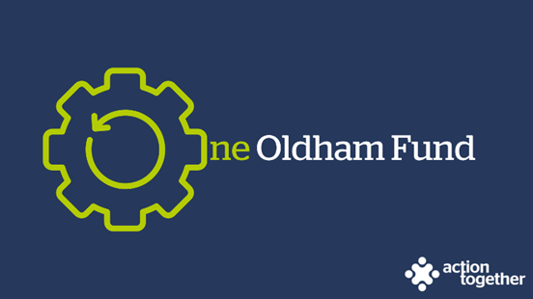

One Oldham Fund Programme – Developing Recovery Communities
(Micro grants - up to £1,000) – Guidance Notes

The One Oldham Fund is a strategic single investment fund that uses pooled resources for the voluntary, community, faith and social enterprise (VCFSE) sector in Oldham. This investment from Oldham Council is intended to improve outcomes for individuals in structured treatment plans recovering from substance and alcohol abuse and to support VCFSE organisations to make a contribution to those outcomes over time.
What projects can the funding be used for?

Applications should meet at least one of the following priorities:
- The development and expansion of recovery communities and peer support networks for substance and alcohol misuse in Oldham,
- To increase the visibility of recovery from substance and alcohol misuse and support social integration networks, or
- Improved networks of social connections so that people facing social exclusion through substance and alcohol misuse have the opportunity to live healthy and fulfilling lives through involvement in a community that supports their recovery, encourages social integration, builds their abstinence and wellbeing and is led and organised by their peers and families.
Deadline for applications – 12 noon Monday 27 November 2023.
Projects must be completed and any funding spent by 30 June 2024.
Who is the funding for?
You can apply for a grant of up to £1,000.00 if:
- you are a voluntary, community, faith and social enterprise (VCFSE) group locally rooted or actively working in the borough of Oldham; and
- you are a member of Action Together CIO (you can register for free to become a member here); and
- you are formally constituted.

Please Note:
- To receive this funding, any outstanding monitoring information required by us, relating to other grant funding must have been completed.
- You may apply for a One Oldham Fund Developing Recovery Communities Grant even if you have previously received one from us.
- You may also go on to apply for other grants within our One Oldham Fund Programme if you are eligible.
What can you spend the money on?
The funding can be used for the delivery of already established groups or activities or to support in setting up a new group, with the main aim to support individuals in recovery from substance or alcohol abuse. Giving people the opportunity to live healthy and fulfilling lives through involvement in a community of peers and family members that supports their recovery, encourages social integration, builds their abstinence and wellbeing.
Your organisation may, for example, already be running a group or activity such as a men’s group, where people in recovery participate but the fact that those people in recovery is not the core focus of the group.
The funder is looking to understand how people in recovery are already being supported and wish to be supported in a non-clinical setting and how this may be developed and joined up across the Borough in the future.
If you have an idea and are unsure whether to apply please contact us by e mailing funding@actiontogether.org.uk or ask to speak to a member of the Oldham funding team on 0161 339 2345 and we will arrange for you to have a chat with the funder.
If you are successful
We understand that planning a project in such challenging times is difficult and that your plans may need to change to respond to factors outside your control. If you feel at any point that you are unable to deliver your project as originally planned, then please contact us so that we can discuss any changes that you may wish to make.
To help us understand the impact of this funding, successful applicants will:
- be asked to provide a short report to us about your project when it has ended and tell the story of your project by providing copies of social media posts, photos etc. if appropriate. We will provide a copy of sample questions at the start of your project so that you know what information we will be looking for.

- be offered support from one of our community development workers throughout and beyond the project,
- be asked to participate in a community of practice during and at the end of the funded activities where experiences and insight can be shared.
Completing the application form
- Please ensure that ALL parts of the application form are completed.
- We have not included word count limits in the application form as we want you to be able to tell us about your ideas without having to worry about the amount of words you are using – as a general guide however we are only looking for brief summary and 1 or 2 paragraphs for each answer should be enough for you to be able to tell us about your plans.
- If you have any queries about the application process or would like support to complete the application form or become a member of Action Together, please contact a member of the team at development@actiontogether.org.uk or call 0161 339 2345 and ask to speak to a member of the Oldham Development Team.
- Eligible applications will be considered by a panel on or around 6 December 2023. We aim to notify you of the outcome by email within 5 working-days of the panel’s decision, however we may contact you to offer support and to clarify aspects of your application further before submitting to the panel.
Please e mail your application by no later than 12 noon on Monday 27 November 2023 to funding@actiontogether.org.uk

