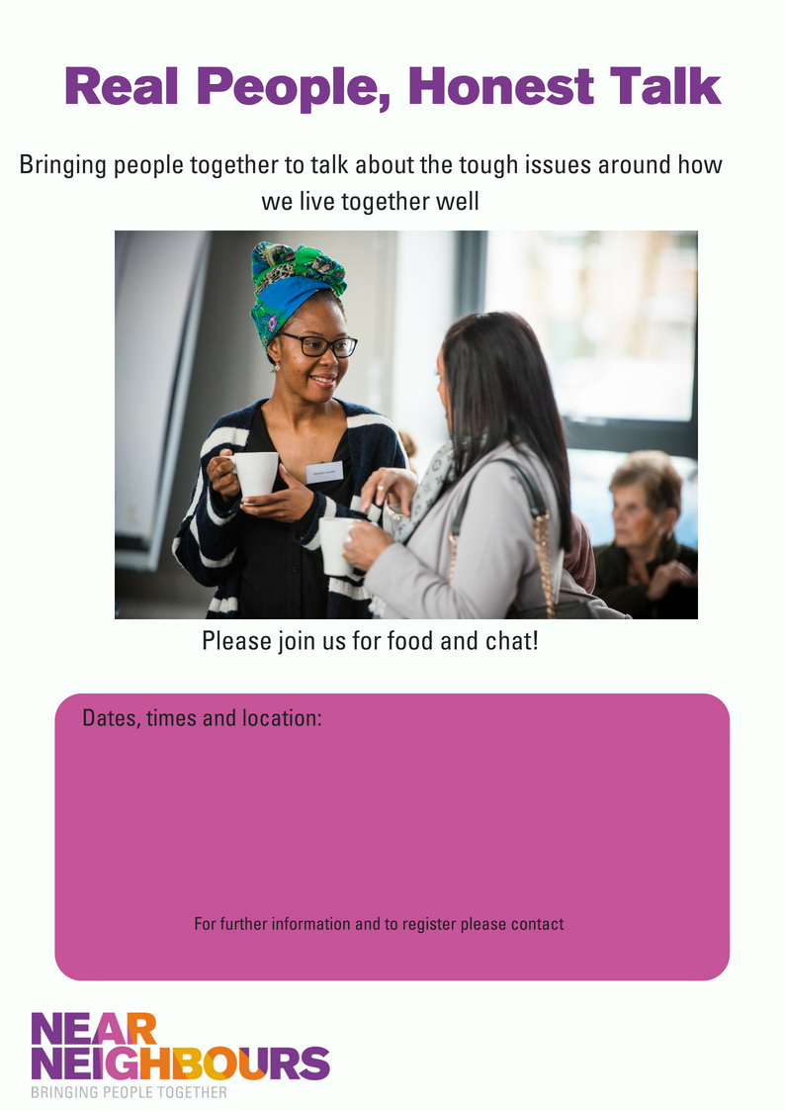

Community Hall, 1st Floor, The Strand, Kirkholt, Rochdale, OL11 2JG

Wednesday 10th July 10am- 1pm

Wednesday 17th July 10am- 1pm

Wednesday 24th July 10am- 1pm

Lunch and refreshments will be provided.

**Samra Kanwal, 07927 550744 samra@greatertogethermanchester.org**