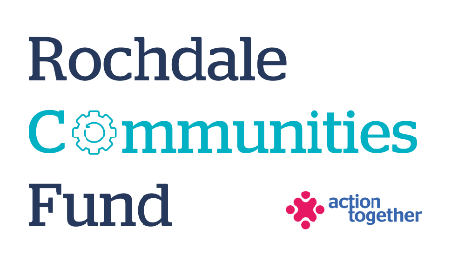
Rochdale Communities Fund –
Home from Hospital Fund – Culturally Appropriate Support
Application Form (up to £15,000)
Section One: Your Organisation
Name of Organisation:
Address of Organisation:

Contact Details: | Main Contact | Second Contact
Name:
Position in group:
Telephone Number:
Mobile Number:
Email address:
Address (including postcode):

 | Yes | No
Are you based or working in the Rochdale Borough with beneficiaries from the area?
Please tick the area (s) that will benefit:
Rochdale
Heywood
Middleton
Littleborough
Boroughwide
Are you a member of Action Together? (if not, you will need to become a member to access this grant. We can help you with this.)
Do you have a governing document?
Do you have a bank account in the organisation’s name with at least two unrelated signatories?
Are you a non-profit organisation where all surplus is re-invested back into the community?
Have you spoken to a Community Development Worker before completing this application form? (if not and you wish to arrange a conversation, please request to speak to a member of the Rochdale Development Team by emailing development@actiontogether.org.uk.
We encourage all organisations to speak with a Community Development Worker before submitting an application.)

Section Two: Your project
Please tick which one of the following priorities your project addresses
- Social connection, befriending and check ins for older people coming out of hospital | ☐
- Practical support for older people coming out of hospital (such as delivering prescriptions, food, or transport to appointments) | ☐
- Support for carers of older people | ☐
- Improving the health, wellbeing and resilience of people living in care homes | ☐

What is the name of your project?
What is your idea - We would like to know how your project will help local people and how it fits in with the aims of the fund and the priorities that you have ticked.
What will you do with the grant? Please tell us how you will deliver the project (for example, where, when, what methods would you use, who will be involved).
Which of the following communities will mainly benefit from your project? (you can tick as many as apply)
- Communities experiencing racial inequalities (please tell us which community)

- Faith (please tell us what faith community)

- LGBT+
- Other community that faces barriers to accessing mainstream services (please list)

What is your experience of supporting this community in Rochdale Borough? Is your organisation led by the community that you support (By and For)?

How do you know your project is needed – will it enhance an existing service or meet a known gap?
How will you reach the right people with your project? Please let us know any existing relationships you have with NHS teams, or other VCFSE or statutory services to publicise your service or work together
What experience do you have of working in a hospital setting and/or building relationships with NHS staff or partners?
Describe the outputs (activities to be delivered) and desired outcomes (benefits/changes) of your project
How many people will directly benefit from the project?
When will your project take place? Please include an approximate start and end date
How will you capture and demonstrate your impact and learning, during and at the end of your project?

Please provide a breakdown of how you will spend the grant
Item | Breakdown (how have you worked out your costings?) |  |  | Amount Requested
Total amount requested? |  |  |  | £
Can you provide any match funding to this project? If so what does that include (i.e. other funding sources, existing staff capacity, use of space)

Section Three: Supporting Documents
Please provide a copy of your governing document.
All successful applicants will be required to supply a copy of the following information as part of the grant agreement, prior to any funding being released.

Required supporting information
☐ Details of a bank account in organisation’s name with at least two unrelated signatories (we will require a copy of a bank statement)
☐ Insurance details (if applicable) (public liability and employers’ liability)
☐ Safeguarding policy (if applicable)

Section Four: Grant Declaration
- I certify that the information contained in this application is correct. I understand that if in any way the information is not correct, the application may be disqualified, or any grant awarded may be repayable on request.
- If the information changes in any way I will inform Action Together as soon as possible.

Main contact for this project:
Role within organisation:
Enter name to confirm agreement (instead of a signature)
Date:

Other Senior contact for the organisation
Role within organisation:
Enter name to confirm agreement (instead of a signature)
Date:

