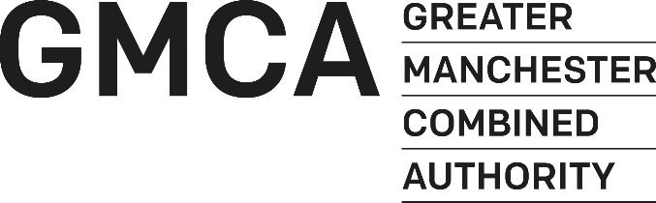

Stronger Together (Great Place)

Update December 2018
The Great Place scheme is designed to enable cultural and heritage organisations to make a step-change in how they work together, and with other organisations in other sectors, so that arts, culture and heritage contribute more to meeting local social and economic objectives. Our project; Stronger Together is designed to create a more sustainable cultural sector across Greater Manchester and achieve recognition for the role culture and heritage can play in delivering combined and district level priorities. We will achieve this through partnership, programme, use of research and data and advocacy.
I came into post as the Stronger Together project manager in September 2018 and since then have been working with colleagues at the Combined Authority and talking with arts and heritage colleagues across Greater Manchester, all as part of the project planning process.

Research and Data
We have a unique opportunity in GM to access not only research and data experts but also a breadth and depth of data not usually accessible to the cultural sector. For example, Mapping GM provides the public with a range of maps that can be used to explore GM’s housing, planning, infrastructure and demographic data. We are working with partners including the Audience Agency to look at how we can triangulate postcode-specific audience data with demographic and spatial data held by GMCA.

We have also commissioned Bellevue Productions to create a series of films on resident engagement and satisfaction with culture and heritage, as well as a bank of individual interviews which we will make available to the cultural sector for research and advocacy purposes. Alongside this, we will be offering film editing training to district arts officers and others across GM, so that they can use the film bank for research and advocacy in their districts.

Age Friendly Culture
Culture is a key component of the GM Ageing Well strategy and we will be rolling out the Cultural Champions programme across at least 3 new districts of GM. We are working with Manchester Museum; initiators of the fisrt Manchester Culture Champions, GMCVA and the GM Ageing Hub to make this happen. A call for proposals will be coming out by the end of 2018. We are delighted to announce the Emma Horridge has been appointed as Age Friendly Culture Manager to coordinate this programme. Emma is based at Manchester Museum and comes with brad experience in the cultural sector including the management of volunteer programmes.

We are also developing plans to further raise the profile of Age Friendly Culture through an ambitious, international collaboration (which we will be announcing soon) and profiling at the World Healthcare Congress 2019 and 2020.

Arts and Health
Live Well Make Art continues to deliver across GM. This grass roots social movement has been connecting health, arts and heritage professionals and activists through a series of events, micro grants and professional development opportunities. You can find up to date news on opportunities and events here: https://livewellmakeart.wordpress.com/blog/
Live Well Make Art is offering funding for micro commissions as a way of kick starting conversation and new ideas in art and health; more information is available on their blog.
We are continuing conversations with commissioners in Population Health, Children and Young People’s Mental health and Social Prescribing networks across GM to ensure a joined up approach to commissioning culture and health activity. We are placing an emphasis on ensuring quality of provision and exploring how to we can create mechanisms for reporting outcome measures. We hope to announce some developments in this area of work in the New Year.

Skills
Strong links between schools, colleges and the cultural sector and more important than ever and we are working with a number of partners to support these relationships. For example, Bridge GM supports schools and colleges to develop their careers’ programme, working closely with head teachers to take a more strategic approach. This strategic advice is supported by Enterprise Advisers; volunteers from the business community who are matched to a single school to offer industry expertise and strategic advice. We are working with Bridge GM to recruit leaders from the cultural sector to take on this volunteer role with a commitment of 6-8 hours per month for one year. This is a wonderful opportunity to work closely with an education setting, to promote creativity in careers programmes and to gain valuable insights into the careers offer. The role is fully supported by Louis Garbutt at Bridge GM and you can contact him here for more information louis.garbutt@gcemployment.uk
We are currently exploring how we can support pre-apprenticeship opportunities (for example year 10 work experience), which target areas with low take-up of creative skills training and cultural opportunities. We are working with Curious Minds to scope this. Please get in touch if you are interested in working with us on the sills agenda.
Another area of focus is heritage skills. After the Christmas break we will be talking to small, local heritage venues about how we can support their largely volunteer workforce. We will also be liaising with archivists from across GM on a professional development opportunity to further develop the relationship between archivists, artists and the public.

Arts at the Heart of Towns and Cities
GM Arts has been developing a new public programme of activity across GM encompassing co-commissioning across district boundaries and hyperlocal activity. The first opportunity; 10 simultaneous artist residencies across Greater Manchester, will be advertised by Christmas.
GM Arts are also planning a GM wide touring project to take place in autumn 2019. Details are tightly under wraps and represent a way for the cultural sector across GM to collaborate and do things differently for the benefit of GM residents.

