**MAHDLO GET A JOB … start date Monday 26th November 2018**

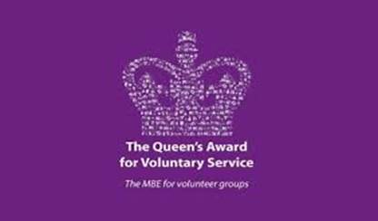    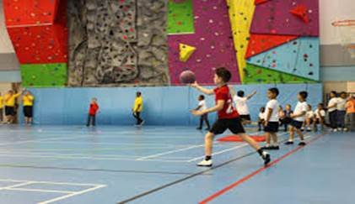

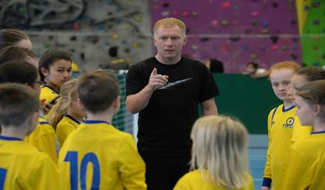     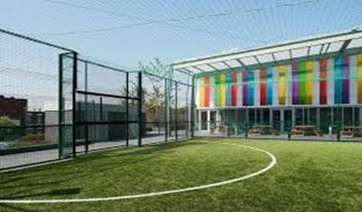

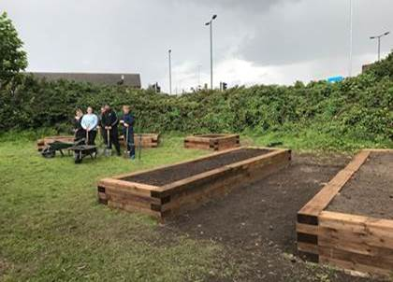     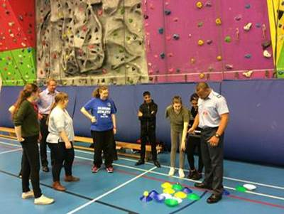

Social Enterprise Project at Impact Community Church       Royal Air force Visit -  problem solving, teamwork

I am pleased to confirm that I have started recruiting for the  next Mahdlo Get A Job programme  which will be starting  **on 26th November 2018 at 10 am,**  Mahdlo Youth Zone, Egerton Street, Oldham, OL1 3SE.  The 6 week Employability and personal development programme is for unemployed young people aged 16 to 21 year olds (up to 25 if additional needs or disability)  focusing on employability skills, life skills, social skills, Self awareness, managing feelings and motivation. Young people undertaking the programme will take part in a one week social enterprise project in the local community with the aim of improving the local area, young people learning new skills and developing confidence.  The Get a Job programme has achieved a success rate of over 85 % of young people who have completed the programme have progressed into  employment or further training.

The young people will be working towards the Personal Employability, Achievement and Reflection for Learning Award  (PEARL award) and will be given the opportunity to gain an emergency First Aid at work qualification. There will also be opportunities whilst on the course for further upskilling such as  Level 1 food hygiene and various AQAs which will help to build up the young peoples CV’s.  There is a particular emphasis on confidence building and raising aspirations.

Young people will be provided with a free weekly bus ticket for the duration of the programme and will get free admission to use the facilities  at Mahdlo which include a state of the art fitness suite, boxing studio, Astro turf football pitch and music studio.

If you would like to have a chat about the programme please contact 0161 624 0111 or by email [ali.sadaqat@mahdloyz.org](mailto:ali.sadaqat@mahdloyz.org) and I will arrange to meet to discuss further.  There are videos /photographs and  a  host of information available on the Mahdlo Get a Job Facebook page.

**Key Objectives of Get a Job Programme :**

Improve communication                                         Teamwork / Increase potential for progression

Positive attitude to work                                         Self management & organisation

Increase confidence                                                   Resilience / Problem solving

Increase social skills 3                                               Increase aspirations & motivation to succeed

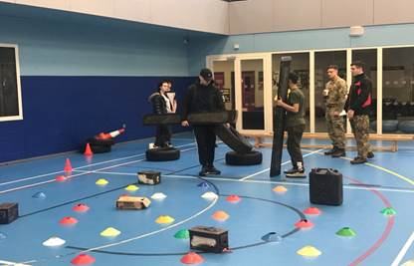      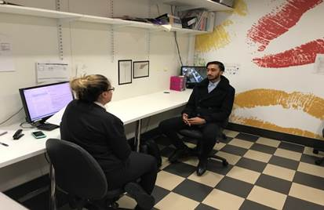

Royal fusiliers Visit – communication, Active listening                                           Mock interview  at McDonalds

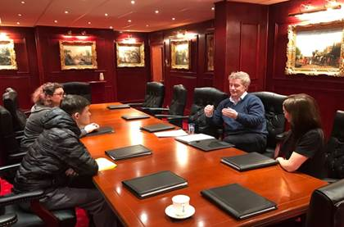      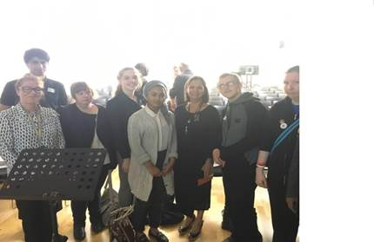

Work place visits to local businesses                                     Inspirational visit by Kamal Basran Authentic food Company