Action Together’s Trustees’ Week Comms Pack

Contents
- Introduction
- Intranet / web content
- Suggested social media posts

Introduction
Trustees are the group of people (also called the Board of Trustees) who act in a charity’s best interests, set the strategy or plan, make key decisions and oversee the running of a charity. Trustee roles are open to all ages, backgrounds and skills sets. It allows you to experience and gain new skills including developing skills in strategy, leadership and negotiation.

Trustees’ Week (6 – 10 November) is an annual event to showcase the great work trustees do and provide opportunities for everyone to get involved and make a difference. This year's theme is Many voices. Working together. With purpose. It celebrates the passion and commitment of trustees by sharing stories and different perspectives. Find out more by visiting https://trusteesweek.org.

For Trustees’ Week, Action Together is inviting you to recognise the fantastic contribution Oldham, Rochdale and Tameside trustees make to our communities. It is an opportunity to thank trustees for playing a vital role, volunteering their time and working together to make important decisions about their charity’s work.

Local charity, Action Together supports Oldham, Rochdale and Tameside people to volunteer in their area, and assists local organisations in developing volunteer programmes, policies, and roles.

Upload your organisation’s trustee roles by visiting Action Together’s website.
To discover trustees roles on your doorstep, visit Action Together’s volunteering opportunities directory. Alternatively call us on 0161 339 2345 or email volunteering@actiontogether.org.uk for help and advice from Action Together’s volunteering team.

Action Together is the infrastructure organisation for the voluntary, community, faith and social enterprise (VCFSE) sector in Oldham, Rochdale, and Tameside. It connects people with what’s happening in their community, develop community ideas into action, strengthen local organisations, and provide strategic influence for the charity and voluntary sector. Membership of Action Together is free and open to any VCFSE organisation in Oldham, Rochdale, or Tameside.

Here’s how you can join in Trustees’ Week:
- Check out the Get On Board page for information on how to get involved
- Register on our trustees roles and responsibilities training
- Sign up to our Oldham, Rochdale or Tameside Volunteer eBulletin
- Upload your trustee roles to our volunteering opportunities directory
- Register to become a trustee in Oldham, Rochdale or Tameside
- Follow @WeActTogether on Twitter and share your inspiring stories, videos and pictures using #TrusteesWeek #TrusteesWeek2023 #ThankATrustee.
- On social media tag someone you think would make a great trustee. Use #TagATrustee
- Like and follow www.facebook.com/WeActTogether on Facebook and share your inspiring stories, videos and pictures
- Organise online events to recruit trustees
- Check out the Meet the Trustees videos on YouTube
Action Together works with its members, local voluntary, community, faith and social enterprise organisations to promote volunteering opportunities in Oldham, Rochdale and Tameside.
Action Together’s volunteering team has a wealth of experience that gives groups and residents, in our local communities, the knowledge and skills to get the most out of volunteering and strengthen our local communities to improve the lives of local people. View the volunteering opportunities directory.
If your voluntary, community, faith or social enterprise organisation in Oldham, Rochdale and Tameside needs support to recruit trustees, please contact Action Together on Tel: 0161 339 2345 or Email: volunteering@actiontogether.org.uk.
If you could give Trustees’ Week a shout out on your intranets, newsletters, e-bulletins, websites and social media, that would be great.

Intranet / website content
(Feel free to tweak to suit your channel and audience)

Trustees’ Week 2023 in Oldham, Rochdale and Tameside

Action Together is inviting you to take part in Trustees’ Week (6 – 10 November) by recognising the fantastic contribution Oldham, Rochdale and Tameside trustees make to our communities. It is an opportunity to thank trustees for playing a vital role, volunteering their time and working together to make important decisions about their charity’s work.

Trustees are the group of people (also called the Board of Trustees) who act in a charity’s best interests, set the strategy or plan, make key decisions and oversee the running of a charity. Trustee roles are open to all ages, backgrounds and skills sets. It allows you to experience and gain new skills including developing skills in strategy, leadership and negotiation.

Local charity, Action Together supports Oldham, Rochdale and Tameside people to volunteer in their area, and assists local organisations in developing volunteer programmes, policies, and roles.

Here’s how you can join in Trustees’ Week:
- Check out the Get On Board page for information on how to get involved
- Register on our trustees roles and responsibilities training
- Sign up to our Oldham, Rochdale or Tameside Volunteer eBulletin
- Upload your trustee roles to our volunteering opportunities directory
- Register to become a trustee in Oldham, Rochdale or Tameside
- Follow @WeActTogether on Twitter and share your inspiring stories, videos and pictures using #TrusteesWeek #TrusteesWeek2023.
- Like and follow www.facebook.com/WeActTogether on Facebook and share your inspiring stories, videos and pictures
- Organise online events to recruit trustees
- Check out the Meet the Trustees videos on YouTube
Action Together works with its members, local voluntary, community, faith and social enterprise organisations to promote volunteering opportunities in Oldham, Rochdale and Tameside.
Action Together’s volunteering team has a wealth of experience that gives groups and residents, in our local communities, the knowledge and skills to get the most out of volunteering and strengthen our local communities to improve the lives of local people. View the volunteering opportunities directory.
If your voluntary, community, faith or social enterprise organisation in Oldham, Rochdale and Tameside needs support to recruit trustees, please contact us on Tel: 0161 339 2345 or Email: volunteering@actiontogether.org.uk.

Find out more by visiting https://trusteesweek.org.

[SUPPORT TEXT WITH GRAPHICS SUPPLIED]

Suggested social media posts
[Feel free to pick and choose and support with graphics supplied. If drafting your own posts, please use the hashtags #TrusteesWeek #TrusteesWeek2023 and tag in @WeActTogether where possible.]

TWITTER

Post 1
Thanks to all trustees in #Oldham #Rochdale & #Tameside. You play a vital role, volunteering your time & working together to make important decisions for your charity. Your passion & commitment supports our communities.

👀 https://www.actiontogether.org.uk/get-on-board

#TrusteesWeek2023 #TrusteesWeek

Post 2
We're celebrating #TrusteesWeek!

Has your #Oldham #Rochdale & #Tameside charity uploaded your trustee roles to @WeActTogether volunteering opportunities directory?

Recruit trustees with passion & commitment to support our communities.

https://www.actiontogether.org.uk/get-on-board
#TrusteesWeek2023

Post 3
Join @WeActTogether in celebrating & recognising #trustees in #Oldham #Rochdale & #Tameside during #TrusteesWeek.

Trustees play a vital role, volunteering their time & working together to make important decisions for their charity.

👀👉https://www.actiontogether.org.uk/get-on-board

#TrusteesWeek2023

Post 4
Join us in celebrating & recognising #trustees in #Oldham #Rochdale & #Tameside during #TrusteesWeek.

Share your inspiring stories, videos & pictures with @WeActTogether using #TeamOldham #TogetherRochdale #TeamTameside

Find out more https://www.actiontogether.org.uk/get-on-board

#TrusteesWeek2023

Post 5
Can you celebrate #TrusteesWeek by registering to become a trustee in #Oldham, #Rochdale or #Tameside?

@WeActTogether believe it's possible that your passion & commitment can strengthen others in our local communities.

👀 https://www.actiontogether.org.uk/get-on-board

#TrusteesWeek2023 #TrusteesWeek

Post 5
Let's celebrate #TrusteesWeek! Trustee roles are open to all ages, backgrounds & skills sets.

@WeActTogether believe your passion & commitment can strengthen our #Oldham, #Rochdale & #Tameside communities.

Register to become a #trustee https://www.actiontogether.org.uk/get-on-board

#TrusteesWeek2023

FACEBOOK 1
[Tag in facebook.com/WeActTogether]

A huge thank you to all trustees in #Oldham #Rochdale and #Tameside. You play a vital role, volunteering your time and working together to make important decisions for your charity. Your passion and commitment supports our communities.

Check out Action Together’s Get on Board page to find out how you can become a trustee or how your local organisation can recruit trustees 👀 https://www.actiontogether.org.uk/get-on-board

If your voluntary, community, faith or social enterprise organisation in Oldham, Rochdale and Tameside needs support to recruit trustees, please contact Action Together on Tel: 0161 339 2345 or Email: volunteering@actiontogether.org.uk.
#TrusteesWeek2023 #TrusteesWeek

FACEBOOK 2
[Tag in facebook.com/WeActTogether]

We're celebrating #TrusteesWeek!
Has your #Oldham #Rochdale or #Tameside charity uploaded your trustee roles to Action Together’s volunteering opportunities directory?

Action Together works with local voluntary, community, faith and social enterprise organisations to promote volunteering opportunities in Oldham, Rochdale and Tameside..
Recruit trustees with passion and commitment to support our communities https://www.actiontogether.org.uk/get-on-board

If your voluntary, community, faith or social enterprise organisation in Oldham, Rochdale and Tameside needs support to recruit trustees, please contact Action Together on Tel: 0161 339 2345 or Email: volunteering@actiontogether.org.uk.
#TrusteesWeek2023

FACEBOOK 3
[Tag in facebook.com/WeActTogether]

Join Action Together in celebrating and recognising #trustees in #Oldham #Rochdale & #Tameside during #TrusteesWeek.

Trustees play a vital role, volunteering their time and working together to make important decisions for their charity.

👀👉https://www.actiontogether.org.uk/get-on-board

If your voluntary, community, faith or social enterprise organisation in Oldham, Rochdale and Tameside needs support to recruit trustees, please contact Action Together on Tel: 0161 339 2345 or Email: volunteering@actiontogether.org.uk.
#TrusteesWeek2023

FACEBOOK 4
[Tag in facebook.com/WeActTogether]

Join us in celebrating and recognising #trustees in #Oldham #Rochdale and #Tameside during #TrusteesWeek.

Share your inspiring stories, videos and pictures with Action Together using #TeamOldham #TogetherRochdale #TeamTameside

Find out more https://www.actiontogether.org.uk/get-on-board

If your voluntary, community, faith or social enterprise organisation in Oldham, Rochdale and Tameside needs support to recruit trustees, please contact Action Together on Tel: 0161 339 2345 or Email: volunteering@actiontogether.org.uk.
#TrusteesWeek2023

FACEBOOK 5
[Tag in facebook.com/WeActTogether]

Let's celebrate #TrusteesWeek! Trustee roles are open to all ages, backgrounds and skills sets.

Action Together believes your passion and commitment can strengthen our #Oldham, #Rochdale & #Tameside communities.

Register to become a #trustee https://www.actiontogether.org.uk/get-on-board

If your voluntary, community, faith or social enterprise organisation in Oldham, Rochdale and Tameside needs support to recruit trustees, please contact Action Together on Tel: 0161 339 2345 or Email: volunteering@actiontogether.org.uk.
#TrusteesWeek2023

Supporting graphics
Graphics in the comms pack include the following. Please use as you see fit!

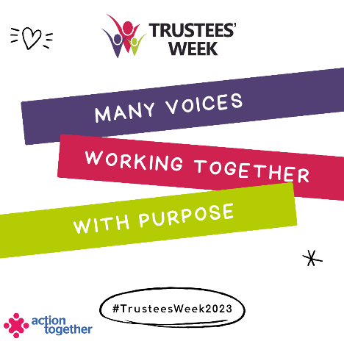
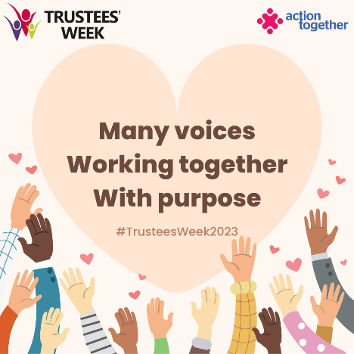
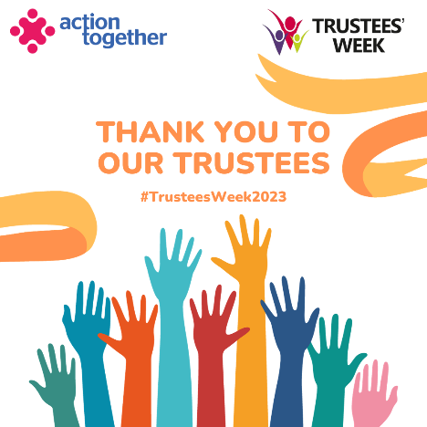

A little bit about Action Together
Action Together CIO is the infrastructure organisation for the voluntary, community, faith and social enterprise (VCFSE) sector in Oldham, Rochdale, and Tameside. We connect people with what’s happening in their community, develop community ideas into action, strengthen local organisations, and provide strategic influence for the charity and voluntary sector. Membership of Action Together is free and open to any VCFSE organisation in Oldham, Rochdale, or Tameside.
Our work is organised into these core themes:
- Volunteering
- Development
- Partnership
- Collaboration
- Investment
Action Together is a registered charity (No.1165512).

To find out more, visit www.actiontogether.org.uk or call 0161 339 2345.

