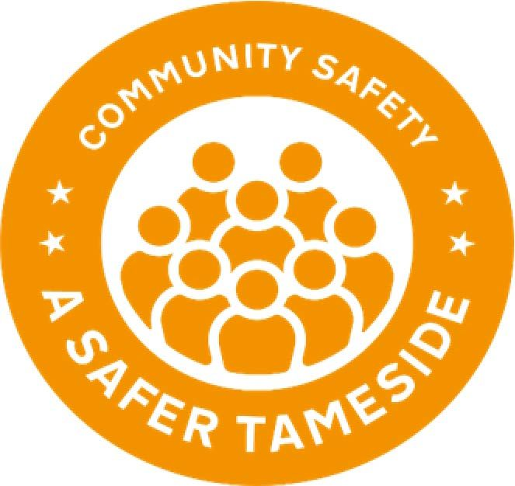
Community Safety Partnerships – Building Stronger Communities

Tameside Community Inspiration & Innovation Fund
Project Application Form 2023-2024

Please read the Guidelines document prior to application, ensuring you meet the grant criteria. All area event dates are listed, along with drop-in grant application help and support sessions available to you. All sections of your application form need completing and need to be received by 31st March 2023 16:00 hrs deadline. Any applications received after this date will not be considered and if incomplete will delay the processing of your application which may be returned to you. Community Safety Partnership, on behalf of the funders GMCA, reserve the right to check the eligibility of groups applying for a grant and therefore, may ask for extra information. Grants are up to a maximum £2,000 please only apply for what you need giving other groups an opportunity. Your bid must demonstrate clearly what the funding is for and include a brief outline of any training sessions. Any large/expensive equipment must be discussed with the project Officer prior to application and appropriate Insurance must be in place. The grant agreed must be spent on what it was awarded for and by 31st March 2024, failure to do so may result in the group being asked to replay the grant in full
Section 1: Organisational details

1.1 Contact details

Name of organisation:
Main contact:

Position in the group:

Contact address for the group:

Contact Tel:

E-mail:

Website:
Facebook: Twitter:
Organisation start date:

  - What is the legal / charitable status of your group?
(Please note we cannot accept groups that are not fully Constituted or accept groups representing on your behalf)
☐ Constituted Group
☐ Registered Charity - Registered Charity Number ……………….
☐ Registered Company CIC - Registered Company Number ………………

1.3 What are the main aims of your organisation, your key services and the geographical area you cover?

Section 2: Project Details

2.1 What is the name of the project or activity you are seeking funding for?

2.2 Which of the Priorities will your project or activity meet? Please tick all that apply.
Preventing/Reducing Youth Anti-social Behaviour
Keeping Neighbourhoods Safe
Reducing Poverty & Vulnerability
Strengthening & Developing Communities through Greener Spaces

2.3 What is the aim of your project/activity?
(What are you trying to achieve)

2.4 Why is your Project Needed?

2.5 Who will benefit from the project?
(Please tell us who your project will help. These must be Tameside residents

How many people will benefit from the project?
2.6 Please explain how you will deliver the project – what will you do with the grant?

2.7 Where will your project be delivered?

2.8 Will you be working with other organisations?
Yes / No
(Please delete as appropriate)
If yes, please list your partners and what role they will have in the project:

2.9 Timescales – When will your project start and finish? (Projects must be completed and delivered by 31st March 2024.)
Start: |  | End:

2.10 What changes or difference will your project make?
(Please describe the outcomes of your project activities – what changes will happen to your area and/or to the people you have helped? How will it impact on local community)

2.11 How will you monitor the progress and measure the success of the project?
(e.g. How will you make sure your project goes according to plan? How will you manage finances and how will you measure if it has made a difference e.g. feedback from people, photographs etc?)

Section 3: Financials

3.1 Please provide a detailed breakdown of how you will spend the grant

Budget heading  (e.g. Room hire) | Breakdown  (How have you worked out your costings?) | Amount requested
TOTAL

3.2 Please provide details of any additional funding or in-kind support that will also contribute to this project? (Please detail how much match funding there is for the project and whether this is money or volunteer time or free resources) Volunteer free time free resources towards the project
Section 4: Signatures

Conditions of grant

If successful in full or part we confirm that we accept the following conditions:

- We will only spend the grant money in accordance with our grant application form. If there is a need to change the use of the grant, relocate or move equipment, we will request permission from TMBC Community Safety partnership as soon as possible
- We will repay any money unspent during the project lifetime to Community Safety Partnership
- We will acknowledge this funding on all publicity relating to the project
- We acknowledge responsibility for all risk assessments (including Covid-19 secure risk assessments) and health and safety checks for the project. We can help you with your risk assessments – please contact your area Project Officer.
- We will ensure that we implement and comply with the most up to date government guidelines around being Covid secure.
- We will ensure the group makes the project as accessible as possible and agree to implement and ensure equal opportunities
- We will ensure that all volunteers and staff working with children, young people or vulnerable adults are enhanced DBS checked and adhere to Tameside’s Safeguarding Board policies and procedures.
- We will ensure we have adequate insurance to carry out the project and that volunteers, instructors and trainers are suitably qualified and trained
- We will be happy for a visit to the project for monitoring and evaluation purposes and allow the project to be used for publicity purposes
- We agree to submit an end of project evaluation report and proof of expenditure of the grant
- We understand that if we don't meet these terms and conditions our grant may be withdrawn
- We agree to mention and promote Community Safety Partnership and display the Community Safety logo on any social media/advertising of the project

Declaration
- I certify that the information contained in this application is correct. I understand that if in any way the information is not correct the application may be disqualified or any grant awarded will be payable on request.
- If the information changes in any way I will inform Community Safety Partnership as soon as possible.

Main contact for this project:
Role within organisation:
Signature:
Date:

Senior contact for the organisation (e.g. Chair, Vice-Chair or Treasurer)
Role within organisation:
Signature
Date:

Section 5: Check list

Please confirm that your organisation has the relevant supporting information required by the funder GMCA. Please note you do not need to supply this with your application. All successful applicants will be required to supply a copy of these documents as part of the grant agreement, prior to any funding being released. Payment will be paid by Tameside MBC on behalf of Community Safety

Required supporting information | Please tick
Governing document (constitution / terms of reference) that has been signed by two or more members

Bank account in organisation’s name with at least two unrelated signatories (we will require a copy of a bank statement)

Insurance if applicable public liability and employers’ liability if you employ staff

Safeguarding policy (if applicable)

Covid-19 secure risk assessment (if applicable)

Please send your completed application by email to:

sue.moorcroft@tameside.gov.uk (Ashton, Stalybridge, Dukinfield Mossley)

sharron.power@tameside.gov.uk (Longdendale, Hyde, Denton Droylsden, Audenshaw)

Funding must be spent and project completed by March 2024




