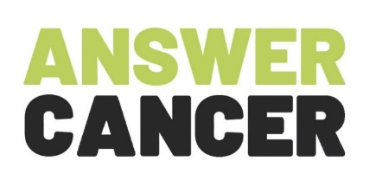
June Stakeholder Collaborative Webinar
Wednesday 24th June, 1pm - 2.15pm

Webinar AGENDA
Session
Introduction and Webinar Facilitator
Adrian Smith, Quality and Innovation Hub Lead, Answer Cancer
Panellist 1 - Answer Cancer Update
Jessica Pathak, Project Manager, Answer Cancer
Followed by Q&A
Panellist 2 – Remote and Digital Engagement Approaches
Kirit Patel, Development Worker and Michael McGearty, Network and Events Coordinator, Answer Cancer
Followed by Q&A
Panellist 3 - Screening Update
Audrey Howarth, Screening and Immunisation Manager, Greater Manchester Health and Social Care Partnership
Followed by Q&A
Making a plan
Elizabeth O Connor, Training and Development Worker, Answer Cancer
Closing Remarks
Jessica Pathak, Project Manager, Answer Cancer

