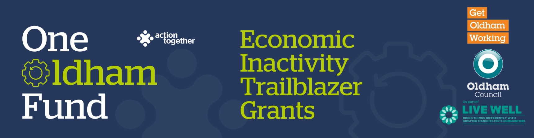

**One Oldham Fund Economic Inactivity Trailblazer Grants Application**

Please read the [guidance notes](https://www.actiontogether.org.uk/sites/actiontogether.org.uk/files/2025-09/OOF%20EI%20Trailblazer%20Grants%20Guidance%20Final.pdf) carefully before starting to complete this form

**Section One: Your Organisation**

|  |  |  |
| --- | --- | --- |
| **Name of Organisation:** |  | |
| **Companies House/Charity Reg. number (if you have one):** |  | |
| **Address of Organisation:** |  | |
| **Website / social media details:** |  | |
| **Contact Details:** | **Main Contact** | **Second Contact** |
| **Name:** |  |  |
| **Position in group:** |  |  |
| **Telephone Number:** |  |  |
| **Mobile Number:** |  |  |
| **Email address:** |  |  |

|  |  |  |
| --- | --- | --- |
|  | **Yes** | **No** |
| **Are you locally rooted or actively working in the Oldham Borough with beneficiaries from the area?** |  |  |
| **Please tick the area(s) below that will benefit:** |  |  |
| * **Oldham Central St Marys, Alexandra and Coldhurst (Central)** |  |  |
| * **Chadderton, Werneth (West)** |  |  |
| * **Royton, Shaw & Crompton (North)** |  |  |
| * **Saddleworth, Lees, St James, Waterhead (East)** |  |  |
| * **Failsworth, Hollinwood, Medlock Vale and Fitton Hill (South)** |  |  |
| **Are you a member of Action Together**? (if not, you will need to become a member to access this grant. You can apply to become a member [here](https://www.actiontogether.org.uk/become-member). We can help you with this.) |  |  |
| **Do you have a governing document?** |  |  |
| **Do you have a bank account in the organisation’s name requiring at least two unrelated signatories?** |  |  |
| **Do you have at least three people on your board or committee who are not related?** |  |  |
| **Are you a non-profit organisation where all surplus is re-invested back into the community?** |  |  |
| **Does your project involve working with vulnerable children and / or at risk adults?** |  |  |
| **Has your organisation completed a Quality In Action Award with Action Together?** |  |  |

**Section Two: Your project**

|  |  |  |  |
| --- | --- | --- | --- |
| **Which of the following funding streams are you applying for?**  Please refer to the [guidance notes](https://www.actiontogether.org.uk/sites/actiontogether.org.uk/files/2025-09/OOF%20EI%20Trailblazer%20Grants%20Guidance%20Final.pdf) for a more detailed explanation. You can apply for multiple streams on this application. | | | |
| Community Led Employment Support (maximum amount £10,000) | | |  |
| Volunteering into Employment (maximum amount £3,000) | | |  |
| **What is the name of your project?** |  | | |
| **What is your idea?**  **We would like to know how your project will strengthen your capacity to deliver holistic, community – led support that enables residents to improve their health, wellbeing and economic activity.**   * *Please give us a brief summary of your ideas and how you arrived at them.* * *What, where and when will the activities be and how was your community involved in coming up with the ideas?* * *Please also explain how this will link with each of the priorities that you have identified above.* * *We will ask you for more details about what change this will make and how you will show that later.* * *You may also send us a short video or some pictures to support your application. If you wish to send a video please contact* [*funding@actiontogether.org.uk*](mailto:funding@actiontogether.org.uk) *as it is not always possible to send this by e mail.* | | | |
|  | | | |
| **Which of the following communities will benefit from your project?**  **Your project must benefit economically inactive individuals, but we are also keen to understand specific demographics within this cohort that you will be looking to support.**  (please tick up to 3 of the main communities that you will be supporting ) | | | |
| Young adults | |  | |
| Adult | |  | |
| Older people | |  | |
| Families | |  | |
| Men | |  | |
| Women | |  | |
| LGBTQIA+ | |  | |
| People with disabilities | |  | |
| Communities experiencing racial inequalities | |  | |
| Faith groups | |  | |
| Other groups (please specify below) | |  | |
|  | | | |
| **When will your project take place?**  Please include an approximate start and end date.  All projects must be completed by no later than 31 May 2026. | | | |
|  | | | |
| **What changes or difference do you think your project will make to the people taking part?**  Please provide this information separately for each strand of the fund that you have applied for. | | | |
|  | | | |
| **How will you able to tell whether the above changes have happened?**  How will you track the progress of your project? Again, please provide this information separately for each strand of the fund you have applied for. | | | |
|  | | | |

|  |  |  |  |
| --- | --- | --- | --- |
| **Please provide a breakdown of how you will spend the grant**  If you are applying for more than one strand please identify the spending under each strand separately in your breakdown.  Please refer to the [guidance notes](https://www.actiontogether.org.uk/sites/actiontogether.org.uk/files/2025-09/OOF%20EI%20Trailblazer%20Grants%20Guidance%20Final.pdf) to check the maximum amounts that you can apply for for each strand and the types of things that can and cannot be funded  If it is easier for you, can provide your breakdown on a separate document such as a spreadsheet | | | |
| Item | Breakdown (how have you worked out your costings, for example no. of hours x hourly rate, no. of sessions?) Where available, please provide copies of quotes or links to the item online for larger items of expenditure | | Amount Requested |
|  |  | |  |
|  |  | |  |
|  |  | |  |
|  |  | |  |
|  |  | |  |
|  |  | |  |
|  |  | |  |
|  |  | |  |
|  |  | |  |
|  |  | |  |
|  |  | |  |
|  |  | |  |
|  |  | |  |
|  |  | |  |
| **Total amount of grant requested?** | | | **£** |
| **Total cost of project** | | | £ |
| **If relevant where is the rest of the money coming from?** | | | |
|  | | | |
| **How did hear about this grant? (please tick as appropriate)** | | | |
| Action Together Whatsapp group | |  | |
| Action Together Funding Page on website | |  | |
| Action Together Funding Bulletin | |  | |
| From my Community Development Worker | |  | |
| Other (please provide details): | |  | |

**Section Three: Supporting Documents**

**If you have not recently received funding from Action Together please provide a copy of the following documents that you have.** If they are not easily available they can be sent after your application. Dependant on the nature of your set up or activities we may need to help you to get these in place if you don’t already have them. We will need to see copies of these documents before funding can be released.

**If you have recently received funding from us we will look at the supporting documents that you have previously provided, and will only ask for further information where necessary.**

|  |
| --- |
| **Required supporting information** |
| A copy of your governing document |
| Details of a bank account in organisation’s name with at least two unrelated signatories (we will require a copy of a bank statement) |
| Insurance details (if applicable) (public liability and employers’ liability) |
| Safeguarding policy (if applicable) |
| If your project involves building work please provide copy quotes, evidence of your right to occupy the building and, if necessary, a copy of the building owners’ permission to carry out the work and planning permission. |

**Section Four: Grant Declaration**

1. I certify that the information contained in this application is correct and I am authorised to sign this application. I understand that if in any way the information is not correct, the application may be disqualified, or any grant awarded may be repayable on request.
2. If the information changes in any way I will inform Action Together as soon as possible.

|  |  |
| --- | --- |
| **Main contact for this project:** |  |
| Role within organisation: |  |
| Enter name to confirm agreement (instead of a signature) |  |
| Date: |  |

|  |  |
| --- | --- |
| **Other senior contact for the organisation** |  |
| Role within organisation: |  |
| Enter name to confirm agreement (instead of a signature) |  |
| Date: |  |

Please send this application and any supporting documents to[**funding@actiontogether.org.uk**](mailto:funding@actiontogether.org.uk)