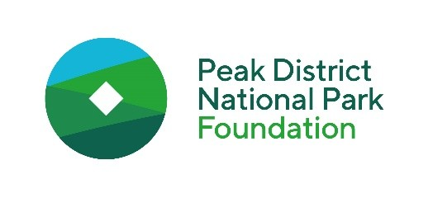

**Connect Fund application for grants up to £500**

We're working to make the Peak District a thriving place for nature and people. Our Connect Fund grants are designed to remove barriers for disadvantaged and marginalised communities to access, understand and enjoy the park. This includes but is not limited to: low-income families, people with disabilities and ethnically diverse communities.

Please complete the form and send to [hello@peakdistrictfoundation.org.uk](mailto:hello@peakdistrictfoundation.org.uk). Applications are reviewed 5 times a year, and we will contact you using the details you provide.

Please carefully read the requirements on the [Connect Fund webpage](https://www.peakdistrictfoundation.org.uk/connect-fund/) before applying to make sure you are eligible for the fund. You can read more about our vision and current projects on our website peakdistrictfoundation.org.uk.

|  |
| --- |
| Name of applicant |
|  |
| Name of associated organisation |
|  |
| Contact email address |
|  |
| Contact phone number |
|  |
| Contact address |
|  |
| Date of application |
|  |

|  |
| --- |
| Tell us about your organisation and the work you do. |
|  |
| Tell us about the project you’d like us to support. Please include **who** it will support, **how many people** it will support, and **where** **exactly** in the Peak District you will visit. |
|  |
| What difference will this project make? |
|  |
| When do you expect to deliver your project? |
|  |

|  |
| --- |
| How much funding are you requesting? |
|  |
| When do you need the funding by? |
|  |
| If this grant is only partially funding your project, please tell us where the rest of your funding has come from. |
|  |

Please tell us how you would use the funding in the table below.

|  |  |  |
| --- | --- | --- |
| Expense (transport costs, meals, etc.) | Details of expense (mode of transport, number of passengers, locations from/to, number of meals, etc.)  **If you have been sent a quote from a supplier, please send this with your application.** | Estimated cost |
|  |  |  |
|  |  |  |
|  |  |  |
|  |  |  |
|  |  |  |
| Total |  | £ |

|  |
| --- |
| How did you hear about the Connect Fund? (If online, please specify the website) |
|  |
| If you have discussed your project with a member of staff from the Peak District National Park, please include their details here.  *Please note - you do not need to speak to anyone before applying, but if you have, it’s helpful for us to know* |
|  |

If you are awarded funding, we ask you to acknowledge the support of the Foundation on your website, social media and in any printed leaflets, flyers etc.

We will also ask you to **evaluate your project once it’s taken place** and to send us any feedback and pictures from your trip with appropriate permissions for us to share online and on social media. *We have child and adult permission forms we can send you on request if needed.*