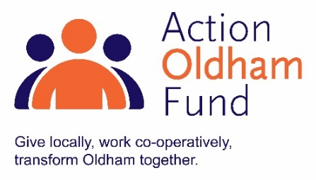
Action Fund Oldham Micro Grant 2019
(up to £1,000)
Application Form
Please complete the application form below.
Section One: Your organisation
Name of Organisation:
Address of Organisation:

Contact Details: | Main Contact | Second Contact
Name:
Position in group:
Telephone Number:
Mobile Number:
Email address:
Address (including postcode):

 |  |  | Yes | No
Are you based or working in the Oldham Borough with beneficiaries from the area?
Are you a member of Action Together?
Do you have a Governing Document?
Do you have an evidenced income of less than £100,000 a year?
Will your project finish within 12 months from receiving the fund?
Do you have a bank account in the organisation’s name with at least two unrelated signatories?
Are you a non-profit organisation where all surplus is re-invested back into the community?
Have you received Action Oldham Project Funding in the previous financial year?

Section Two: Your project
What is the name of your project?
What is your idea / what will you do with the grant?
We would like to know how you got the idea for this project and who will be running it, do you have the right people and skills? What are the activities taking place, where and when will this happen and how does this fit into Action Oldham Fund’s priorities? We would like to know about your beneficiaries and if you are working in partnership with anyone else.
Maximum of 500 words.
What changes or difference will your project make and how will you measure and prove this?
For example, you could count numbers of people attending regular sessions or devise case studies and feedback sheets to show that outcomes for users of a refugee centre include improved English language skills, improved confidence in accessing services and reduced isolation.
Maximum of 300 words.
How many people will directly benefit from the project?

Please provide a breakdown of how you will spend the grant
Item | Breakdown (how have you worked out your costings?) |  | Amount Requested
e.g Room hire | 12 x 2hr monthly sessions at £10 per hour |  | £240.00
Total amount requested from the Action Oldham Fund Micro Fund? |  |  | £
Total cost of project? |  |  | £
If relevant where is the rest of the money coming from?
Have you got this match funding in place already? |  | Yes / No Please delete as appropriate

Section Three: Supporting Documents
Please provide a copy of your governing document. Your application will not be processed until we receive this.
All successful applicants will be required to supply a copy of the following information as part of the grant agreement, prior to any funding being released.

Required supporting information
☐ Details of a bank account in organisation’s name with at least two unrelated signatories (we will require a copy of a bank statement)
☐ Insurance details (if applicable) (public liability and employers’ liability)
☐ Safeguarding policy (if applicable)

Section Four: Grant Declaration
- I certify that the information contained in this application is correct. I understand that if in any way the information is not correct, the application may be disqualified, or any grant awarded may be repayable on request.
- If the information changes in any way I will inform Action Together as soon as possible.

Main contact for this project:
Role within organisation:
Signature:
Date:

Other Senior contact for the organisation (e.g. Chair or Treasurer)
Role within organisation:
Signature
Date:

Please send your completed application by email to:

Email: grants@actiontogether.org.uk

The deadline for this application is Monday 18 November 2019 at 12noon

Please put “Action Oldham Micro Grant Application” and the name of your organisation in the subject field of your email.
Late submissions will not be accepted.

