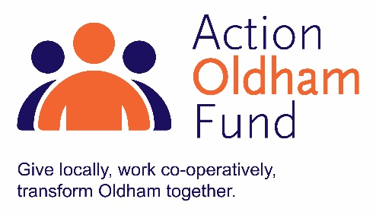
Action Oldham Fund Micro Grant 2019
(up to £1,000)
Guidance Notes
Thank you for your interest in the Action Oldham Fund Micro Grant. The Fund and its grant scheme are managed and administered by Action Together and an independent grants panel is responsible for making decisions on funding awards.
Action Oldham Fund Priorities
Working with Oldham residents supporting them to make to most of their strengths and assets by:
- enhancing skills
  - projects that support or encourage local people into work or volunteering, for example, confidence building projects, skill building programmes, self-esteem workshops;
- making improvements to wellbeing
  - projects improving physical or mental health and wellbeing, for example, starting an exercise or walking group, reading groups, workshops on health awareness projects;
- making improvements to communities
  - projects that help communities and groups become more sustainable, for example, fitting of new flooring enabling a room to be rented out, help towards innovative ideas for marketing and promoting your community asset or development of volunteers and paid staff.
Eligibility
To apply for funding, please ensure that you:
- are based or working in the Oldham Borough with beneficiaries from the area
- are a member of Action Together
- have a governing document and all profits are reinvested in your social purpose
- have an evidenced income of less than £100,000 a year
- did not receive Action Oldham Project Funding in the previous financial year
Exclusions
We will not fund:
- individuals
- social enterprises and organisations trading for profit or intending to redistribute grant awards
- statutory organisations, such as local authorities, schools and the police force
- projects seeking to promote religious or political views, or to exclusively benefit members of religious or political groups
- retrospective costs (projects/activities that are already taking place, have taken place or have been paid for)
- projects where the majority of the activity takes place outside of the Borough of Oldham
- overseas travel or activities
- contributions to larger/major appeals
Completing your application
- If you need advice or support to complete your application form, please contact one of our development team on 0161 339 2345 or email development@actiontogether.org.uk.
- Please ensure that ALL boxes on the application form are completed.
- A number of questions state a specific word count. All words over this number will be deleted before submission to the grants panel.
- To avoid any delays in processing your application please provide a copy of your governing document with your application. If you do not, your application will not be submitted to the panel.
- Applications must be received by email. A copy of your governing document can be posted but must be with Action Together by the deadline date.
Submitting your application
The deadline for applications is Monday 18 November 2019 at 12 noon. Late submissions will not be accepted.
- When your application form is complete, please return to grants@actiontogether.org.uk
- Please put “Action Oldham Micro Grant Application” and the name of your organisation in the subject field of your email.
- Successful applicants will be informed of the panel’s decision within 1 month of the deadline date.

